Javascript

***Thanks & Regards;***

|  |
| --- |
| **Amir Mustafa** |

**Modern Web** Engineer

[Tw](https://twitter.com/amir__mustafa) // [Ln](https://www.linkedin.com/in/amirmustafa1)

Mob: 8170954991 / 07001827951

1. Syntax Parser:

A program (i.e. compiler/interpreter) that reads your code and determines what it does and if its **grammar** is valid.

2. Lexical Environment:

Where something sits **physically** in the code you write. (Trick – where you write code)

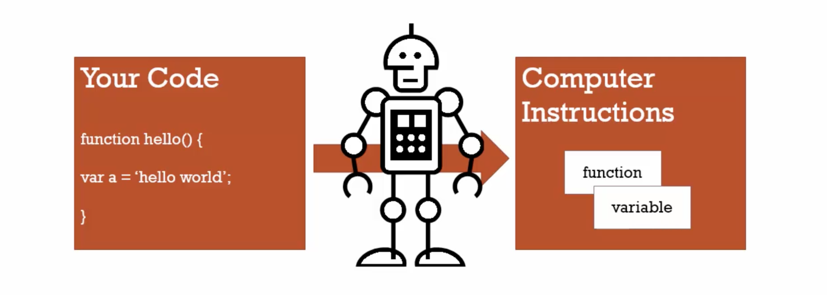

3. Execution Context (or context):

A wrapper to help manage the code where it is running. There are lots of lexical environment. Which one is currently running is managed via execution context. It contain things beyond what you’ve written your code.

When js code runs --> an execution context is created

_____________________________________________________________________________

4. Name/Value Pair:

A name which maps to the unique value. The name may be defined more than once, but only can have once value in any given context (i.e. execution context).

Eg1: variables in js:

address = ‘100 Main street’ // Key-val pair

5. Objects in JS:

A collection of key-val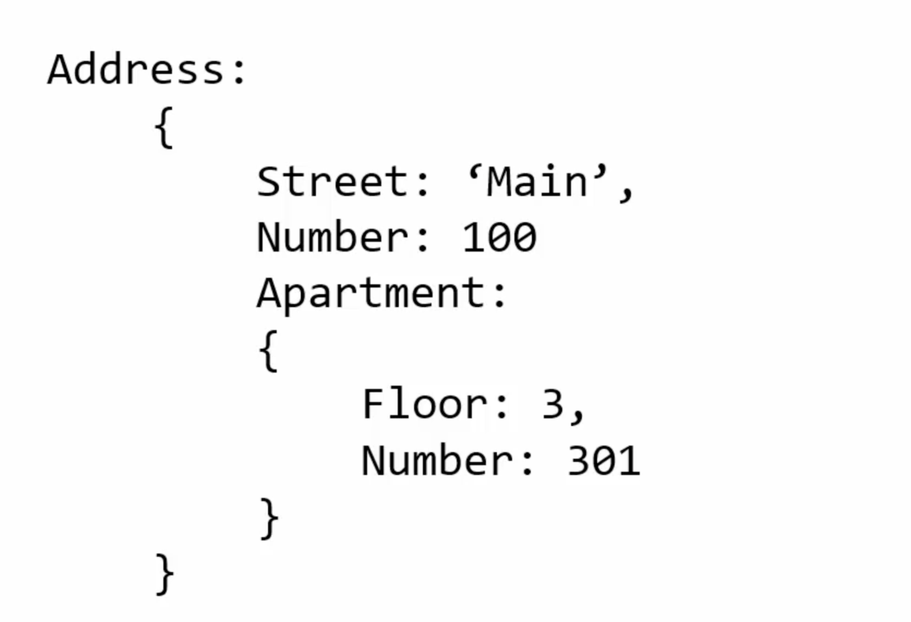 pairs

6. Global Environment & Global Object:

Global Execution Context – available anywhere in the code

The js engine creates this execution variable for us – **Global object** and a special variable **this** variable. So even with empty code when you hit index.html with app.js --> in console --> **this (enter)** --> obj is created auto by execution context

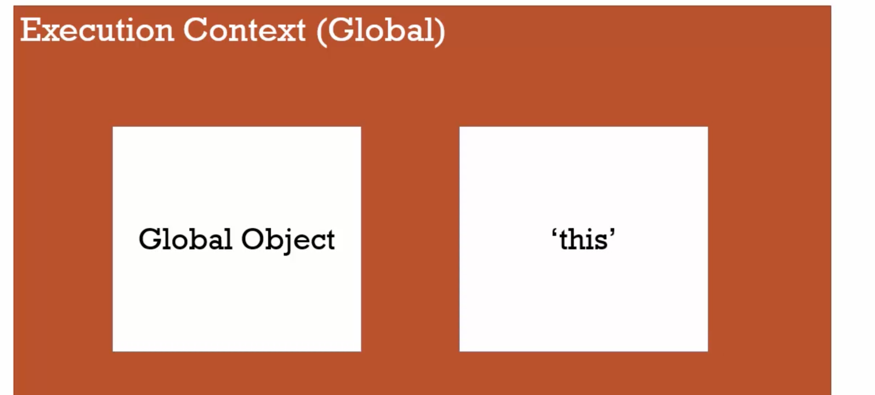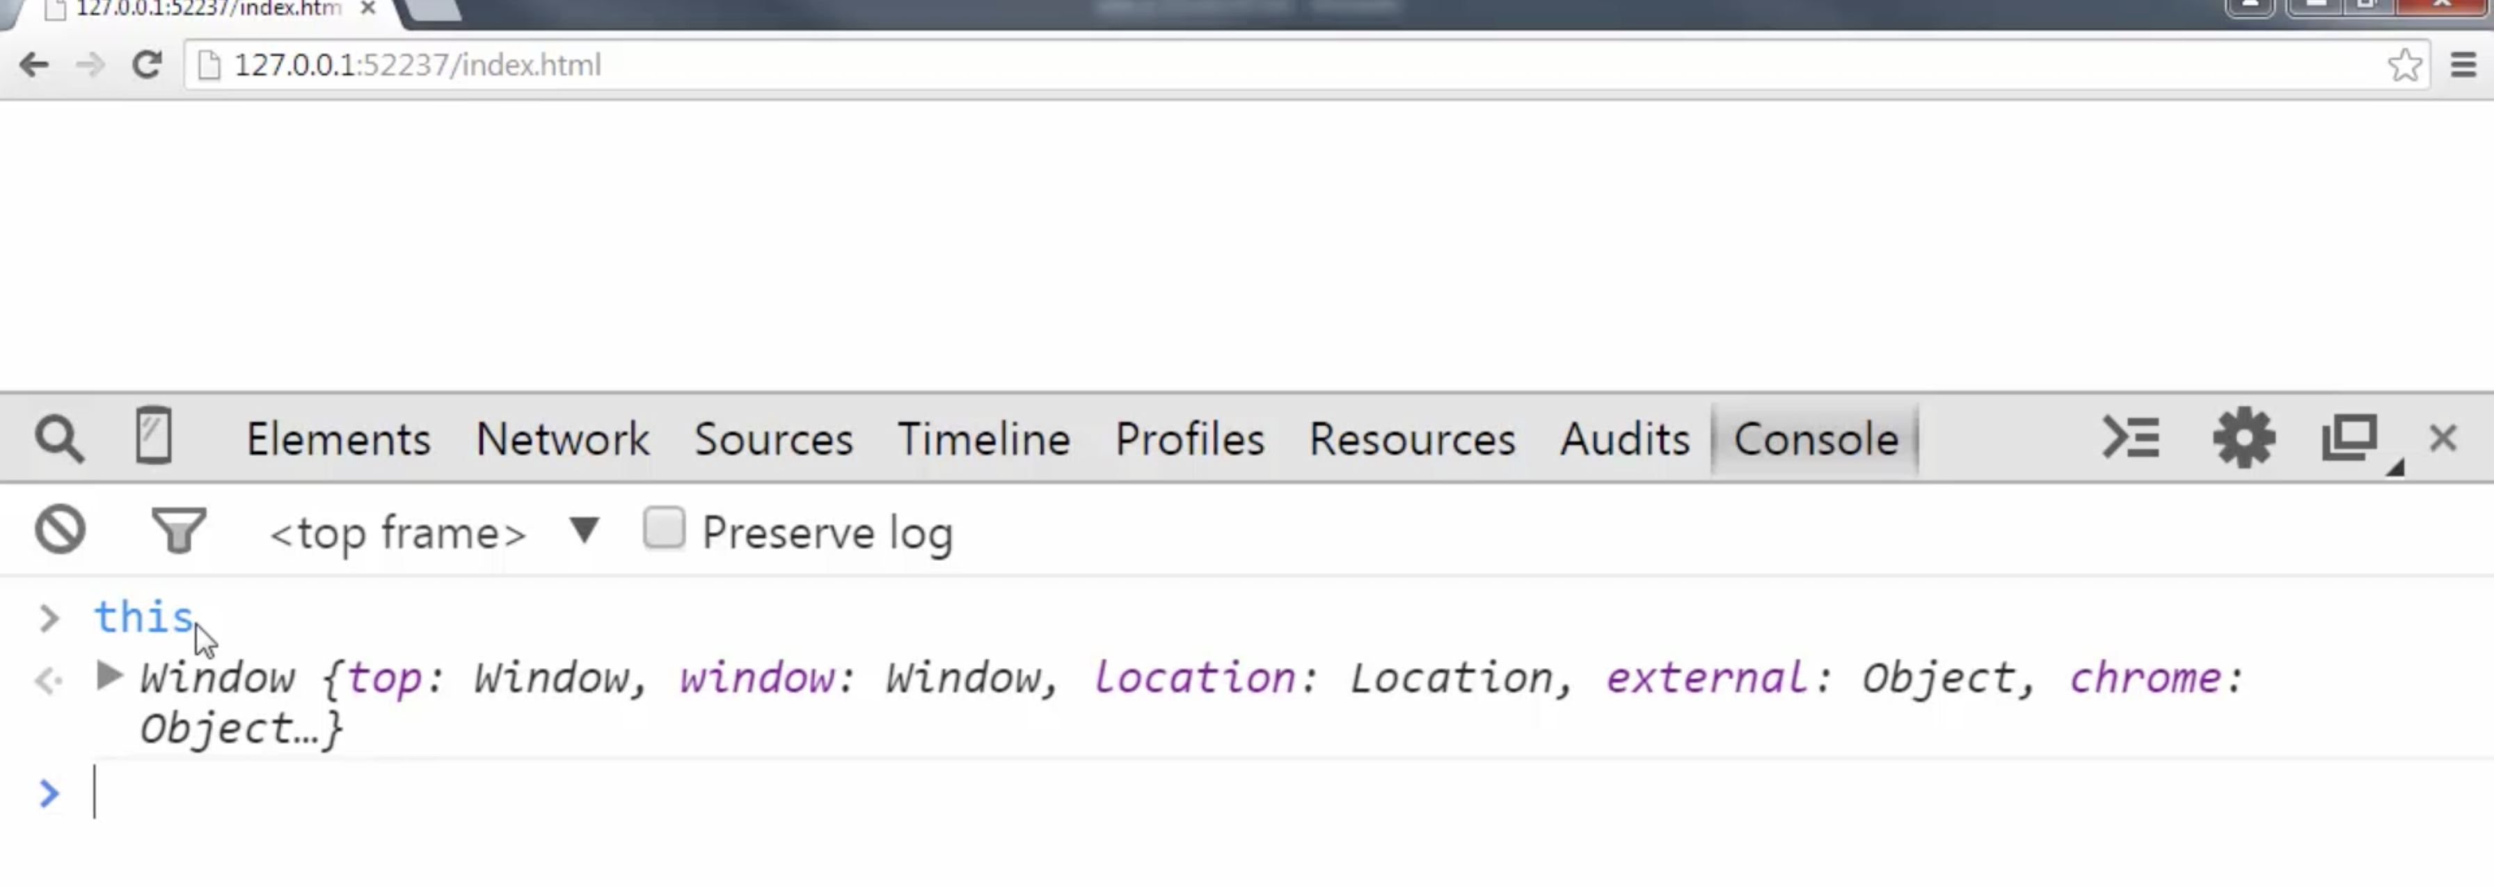

b. windows – this is also a global object (This is diff for different browser tab)

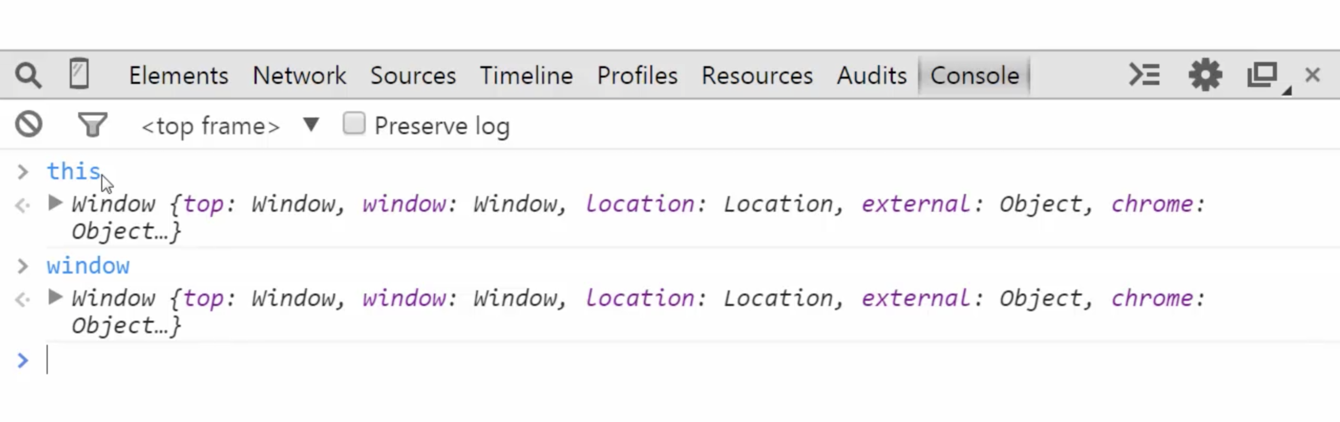Conclusion – There will always be a global object – whether js, node js (maybe diff from js) etc.

this = window (global level)

TRICK – Global – not inside the function

c. When you write some code (either – variable/function – but it should not be inside defined function):

It gets attached to the window

app.js

var a = 'Hello World';

function b() {

}

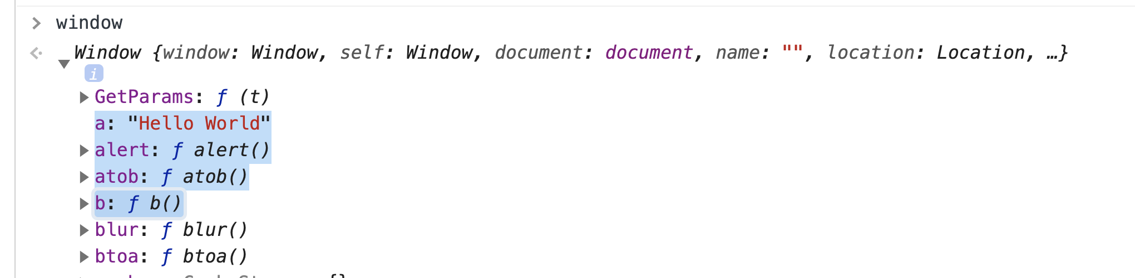

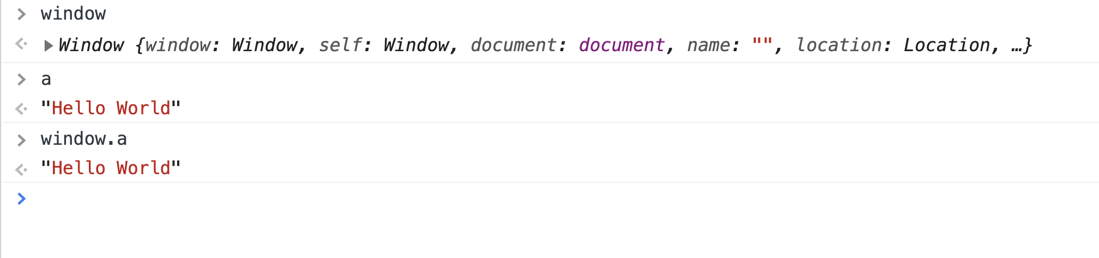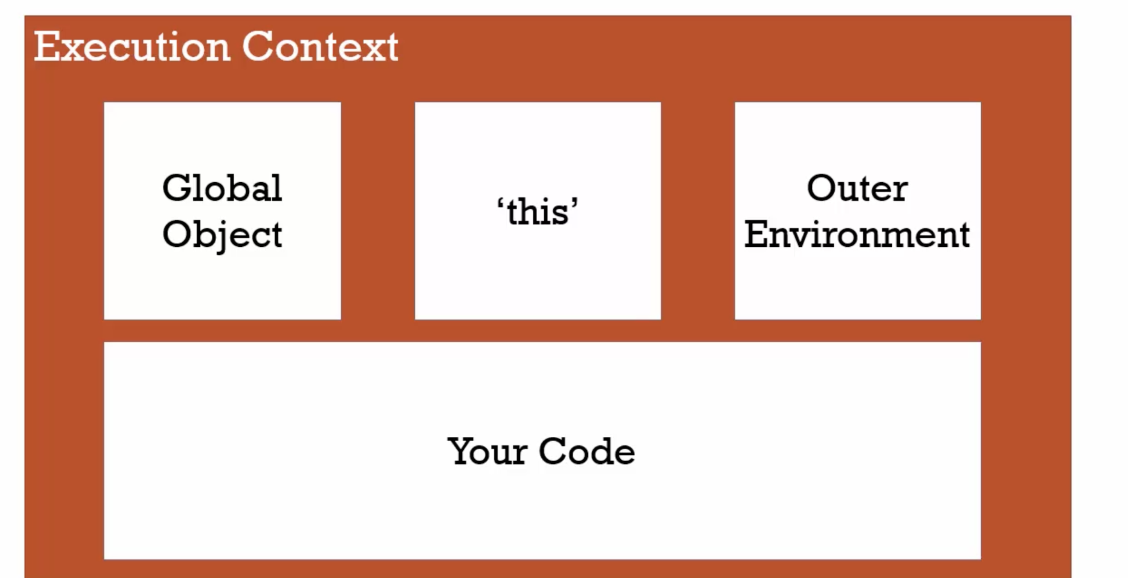7. Creation and Hoisting

___________________________________________________________________________

7. Creation and Hoisting – Execution Context

Eg1

var a = 'Hello World';

function **b**() {

console.**log**('b is called');

}

**b**();

console.**log**(a);

O/P: Called as expected

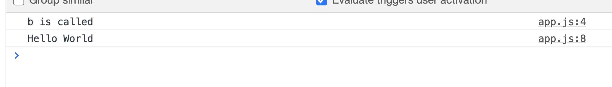

Eg2

**b**();

console.**log**(a);

var a = 'Hello World';

function **b**() {

console.**log**('b is called');

}

O/P:

function = called (instead of giving error)

variable = undefined (instead of throwing error)

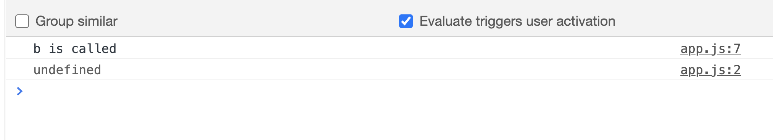

Conceptually, for example, a strict definition of hoisting suggests that variable and function declarations are physically moved to the top of your code, but this is not in fact what happens. Instead, the variable and function declarations are put into memory during the compile phase, but stay exactly where you typed them in your code.

var num; // Declaration

num = 6; // Initialization

Only Declaration are hoisted.

Eg3:

// Example with let:

a = 1; // initialization.

let a; // Throws ReferenceError: Cannot access 'a' before initialization

Eg4:

// Example with const:

a = 1; // initialization.

const a; // Throws SyntaxError: Missing initializer in const declaration

Eg5:

// Example 1

// Only y is hoisted

x = 1; // Initialize x, and if not already declared, declare it - but no hoisting as there is no var in the statement.

console.log(x + " " + y); // '1 undefined'

// This prints value of y as undefined as JavaScript only hoists declarations

var y = 2; // Declare and Initialize y

TRICK- with var only hoisting works

Ref - <https://developer.mozilla.org/en-US/docs/Glossary/Hoisting>

Execution Context works in 2 steps = creates instance --> setup memory for hoisted variable/functions.

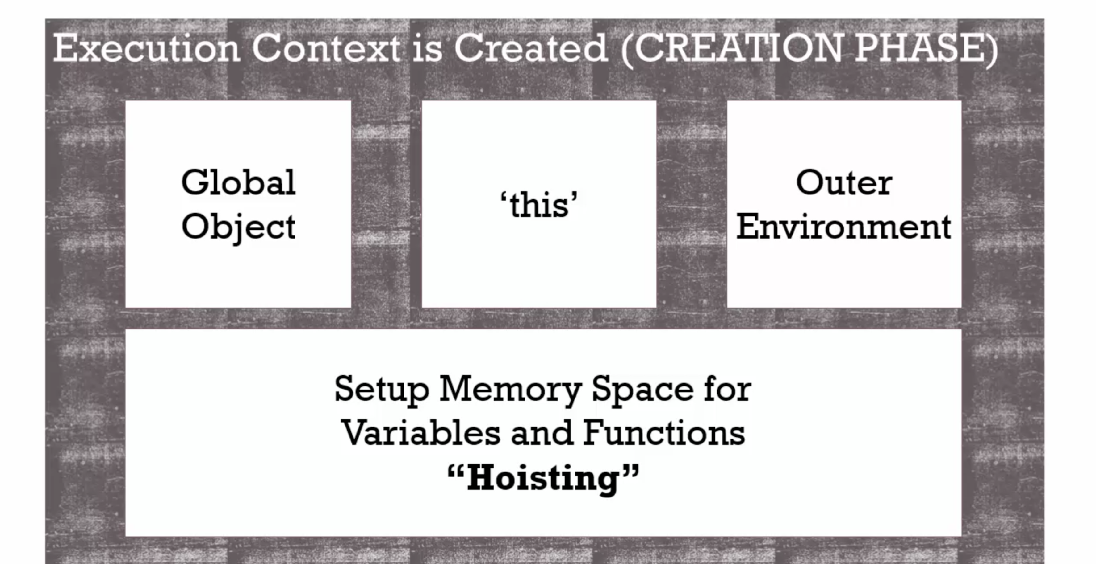

Best Practice: (i.e. Do not use hoisting concept)

Eg1 : Always invoke function / variable after declaring

var a = 'Hello World';

function **b**() {

console.**log**('b is called');

}

**b**();

console.**log**(a);

________________________________________________________________________

8. JavaScript and undefined

undefined is the special key which states that value for variable is not set

var a;

if(a === undefined){

console.**log**('a is undefined!');

} else {

console.**log**('a is defined!');

}

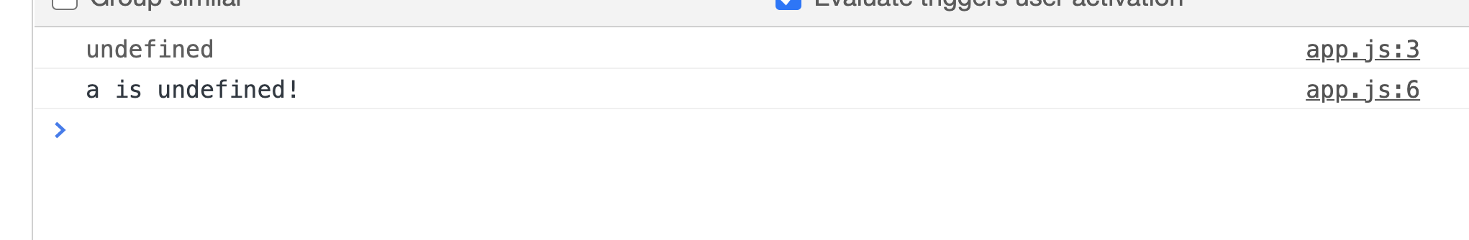9. Execution Context – Code Execution:

Execution context has two stage as discussed:

a. creation phase – where global object, this variable etc.

b. execution phase – here our code runs/compiled line by line

10. Single Threaded and Synchronous Execution:

**a. Single Threaded:** One command at a time. JS runs one command at a time.

**b. Synchronous Executions:** One at a time and in order.

11. Function Invocation and the Execution Stack:

**Innvocation** – calling a function (or running a function – adding parenthesis in js)

--> Till now we have seen only Global execution context.

--> When a function is executed, a new execution context is created and will be on top of stack

--> a and b function will already in memory in creation phase. Executes in execution phase.

--> latest function pointer will be on the top.

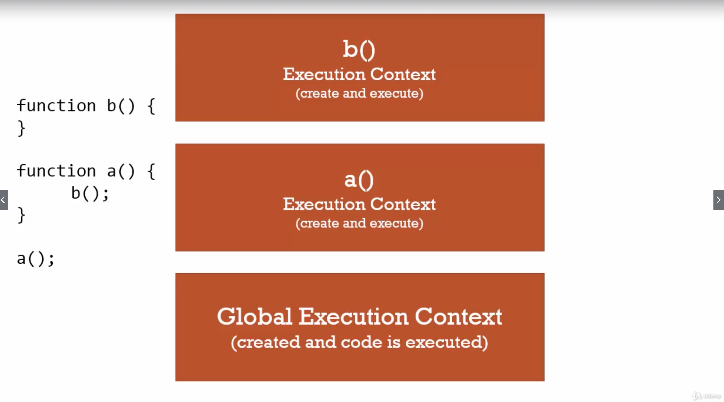.

12. Functions, Context and Variable Environment:

**Variable Environment –** Where the variable lives and how they relate to each other in memory.

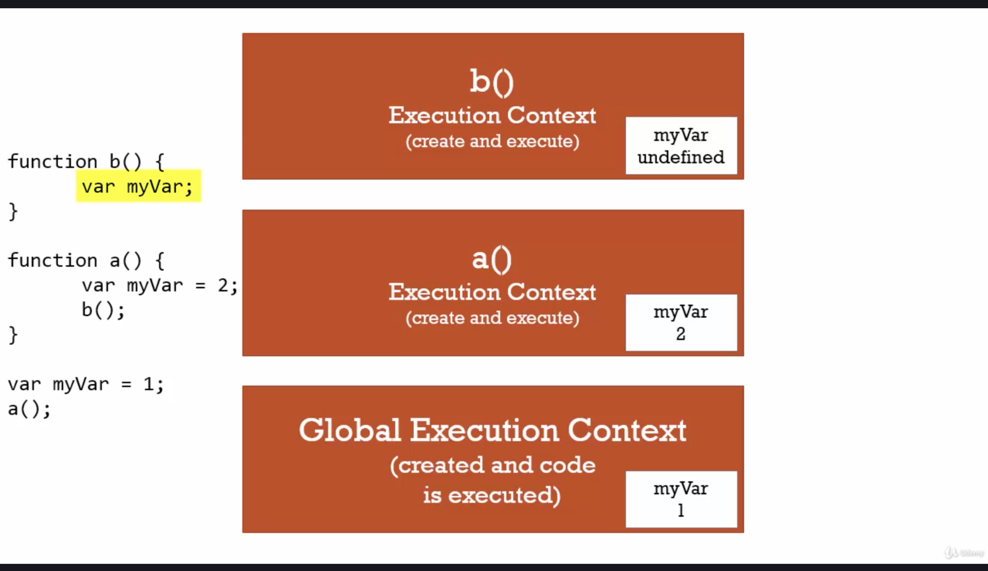Each myVar sits in its own execution context.

13. The Scope Chain:

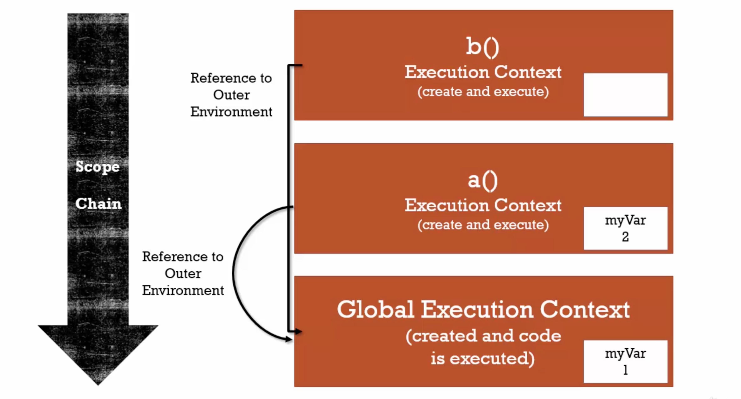Eg1:

function **b**() {

console.**log**(myVar); // this refer global context

}

function **a**() {

var myVar = 2;

console.**log**(myVar);

}

var myVar = 1;

console.**log**(myVar);

o/p - 1

.

All functional context reference to its outer environment (i.e. global context). In case missing variable it searches in outer variable.

**Scope** – where can I access variables

**Chain** – links to the outer environment

Eg2: Change the lexical scope of function b. As b was sitting physically inside a therefore now referencing to a.

function **a**() {

function **b**() {

console.**log**(myVar);

}

var myVar = 2;

**b**();

}

var myVar = 1;

**a**();

o/p – 2

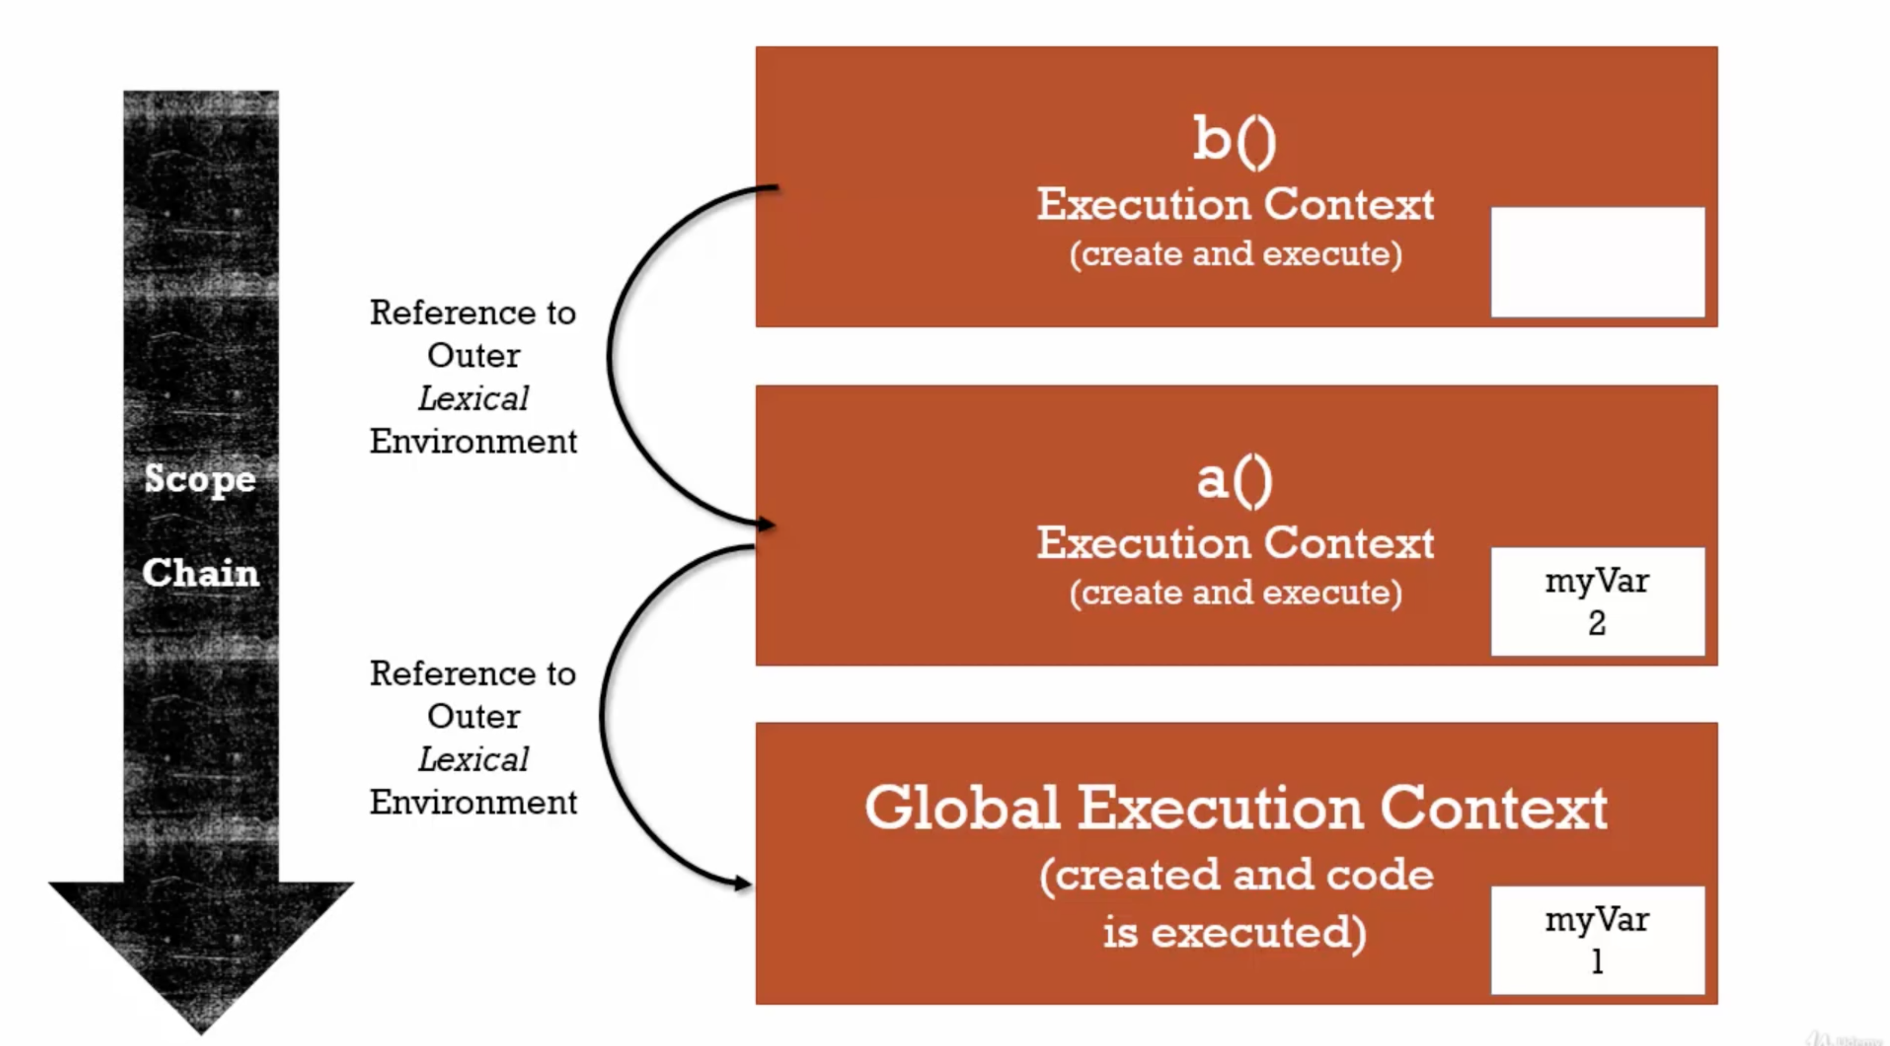.

14. Scope, ES6 and let

Scope: Where a variable is available in your code. It also checks if it’s truly the same variable or a new copy.

Let: This follows block scoping. Not we cannot use it before declaring. (i.e. no hoising with let)

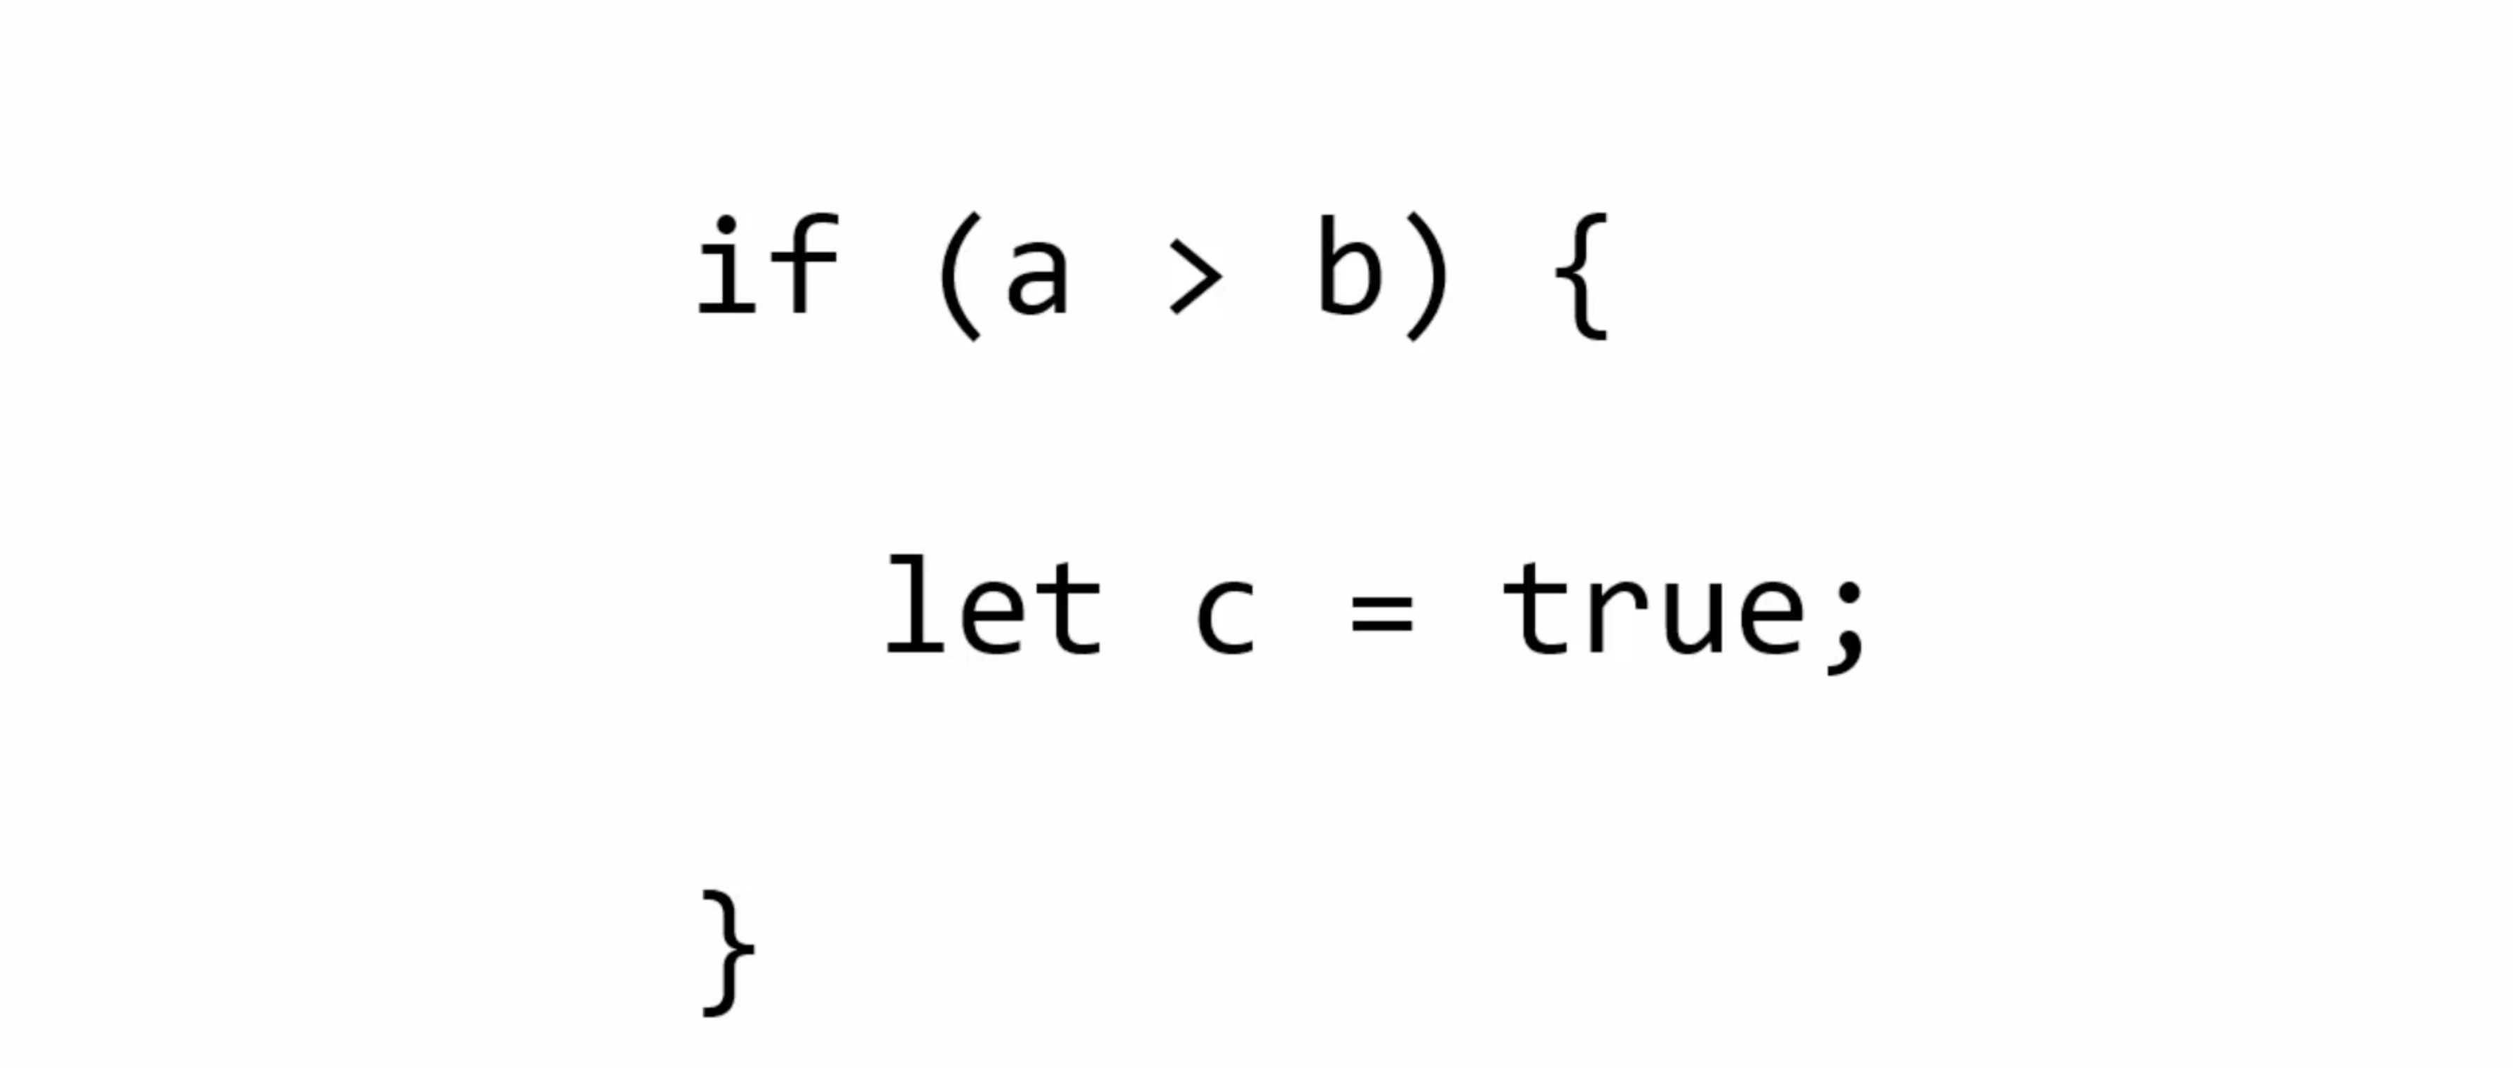

TRICK: if we run let in loop. It will get a different memory each times a loop is running.

15. Asynchronous Callbacks

Ascynchronous: More than one at a time

JavaScript is synchronous. Inside browser there are other engines as well which runs asnchronously with JS engine.

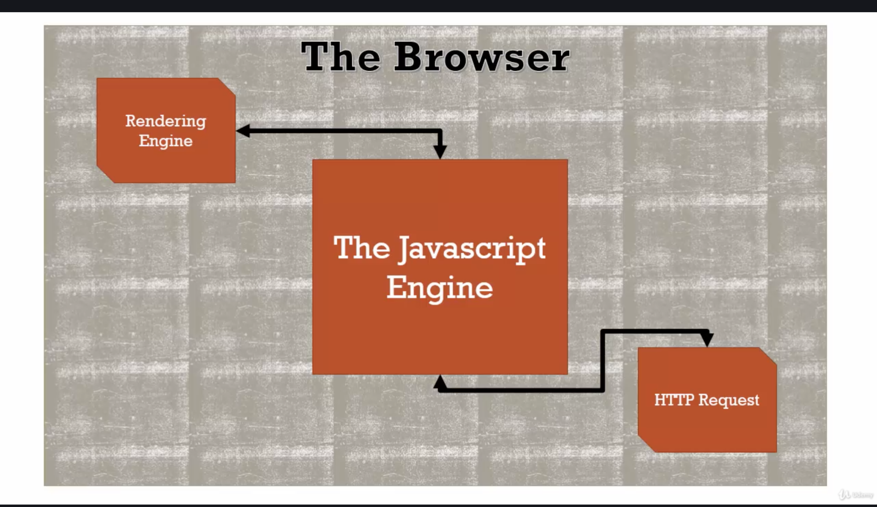.

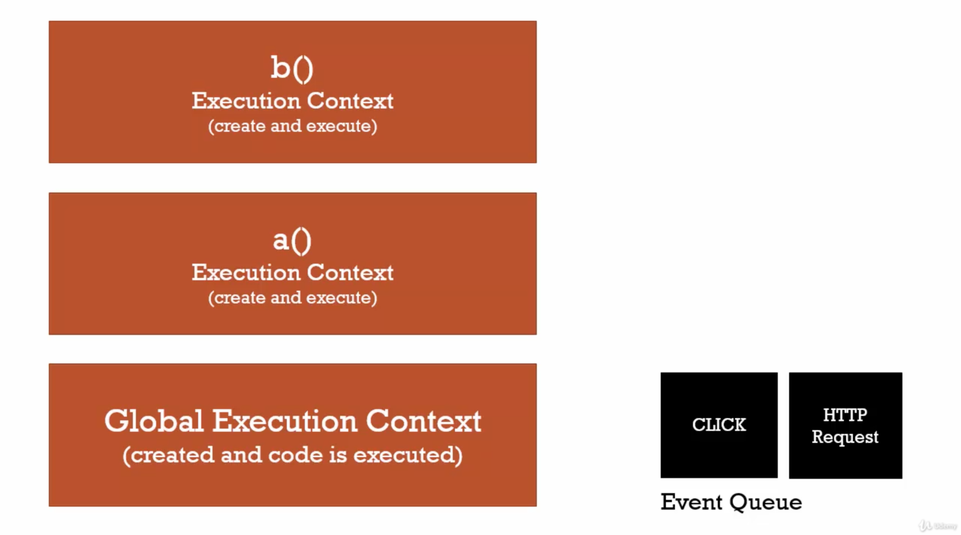.

**Event Queue –** There is something called event queue. When JS execution finishes. This queue runs. It has various possible events running like click.

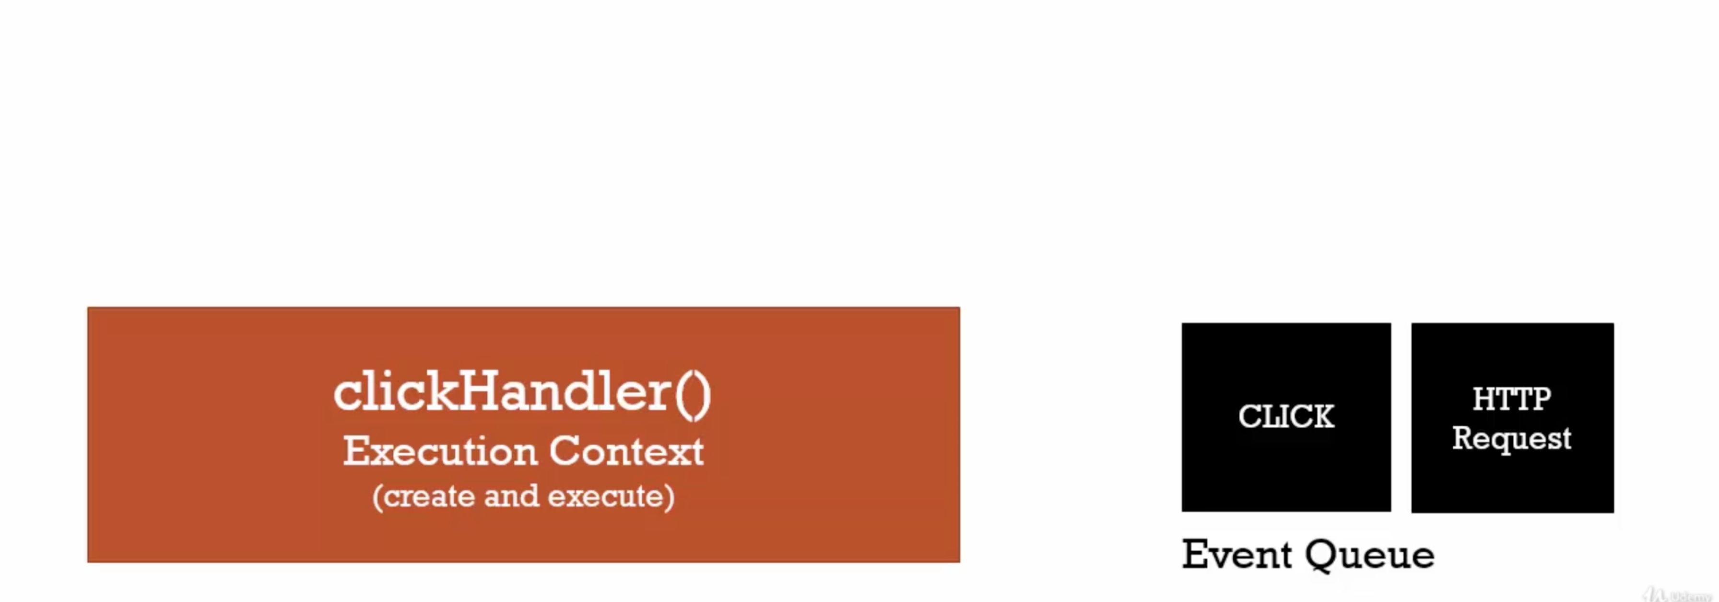.

Finally after js execution this runs and moves out of the stack.

function **waitHandler**() {

var ms = 3000 + new **Date**().**getTime**();

while(new **Date**() < ms){} *// for delay of 3 secs*

console.**log**('function finished');

}

function **clickHandler**() {

console.**log**("click event");

}

*// listen for click event*

document.**addEventListener**('click', **clickHandler**); *// Event Queue last*

**waitHandler**(); *// 1st function context runs*

console.**log**('execution finished'); *// 2nd global context*

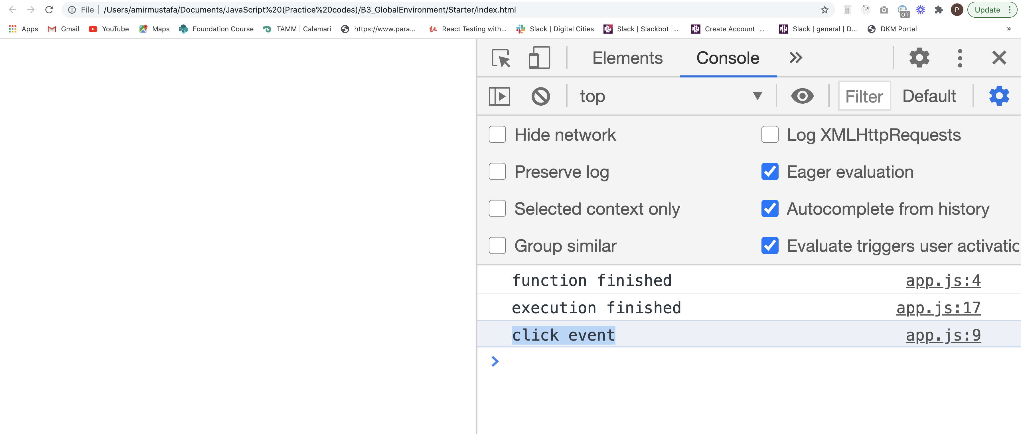TRICK – Any event which happens outside the JS engine is placed in Event Queue which executes in the end.

Event Queue also stack also woks in order eg. First click, HTTP in stack. So it executes in the same order.

Conclusion: Asynchronous is possible in JS. That is what works outside the JS Engine.

16. Types and JavaScript:

Dynamic Typing: You don’t tell the engine what type of data a variable holds, it figures it out while your code is running.

Variables can hold different type of values because its all figures our while code is running.

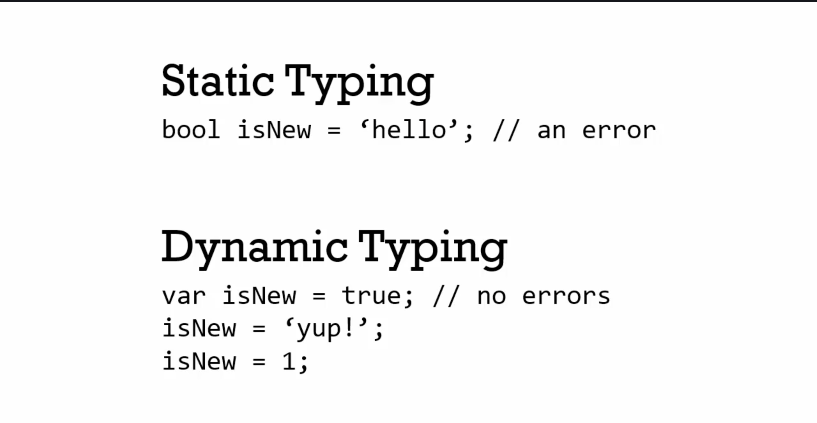.

Dynamic typing – JS, PHP

Static Typing – Java, C#

17. Primitive Types (total 6 available):

Primitive – A type of data that representative **single value** (i.e. not an object)

These are of six types:

**a. undefined** - It represents lack of existence. You should’nt set a variable to this. In simple words defined and never declared.

**b. null** – It represents lack of existence. You can set a variable to this.

**c. boolean** – true or false

**d. number** – JS ony has one type i.e. floating type

There are no other types like – int, decimal etc like we see in PHP.

**e. string** – a sequence of characters (both ‘’ and “” can be used)

**f. symbol** – Used in ES6 (the next version of javascript). Will discuss later.

18 Operators

--> Its is a **special function** that is syntactically (written) differently

--> Generally operator takes two parameter and return one result.

--> Infix notation i.e. 3 + 4 instead of +(3,4) //prefix notation call

19. Operator Precendence and Associativity:

Operator Precendence –

--> Which operator function gets called first

--> Functions are called in order of precendence (Higher precedence wins)

Associativity -

--> What order operator functions get called in:

Left to right (left associativity)

Right to left (right associativity)

When function have same precedence.

Eg.

console.**log**(3 + 4 * 5); *// 3 + 20*

*// expected output: 23*

Rules Link - <https://developer.mozilla.org/en-US/docs/Web/JavaScript/Reference/Operators/Operator_Precedence>

var a = 2, b=3, c=4;

a = b = c;

console.**log**(a, b, c); *// O/p - all 4 as left to right associativity*

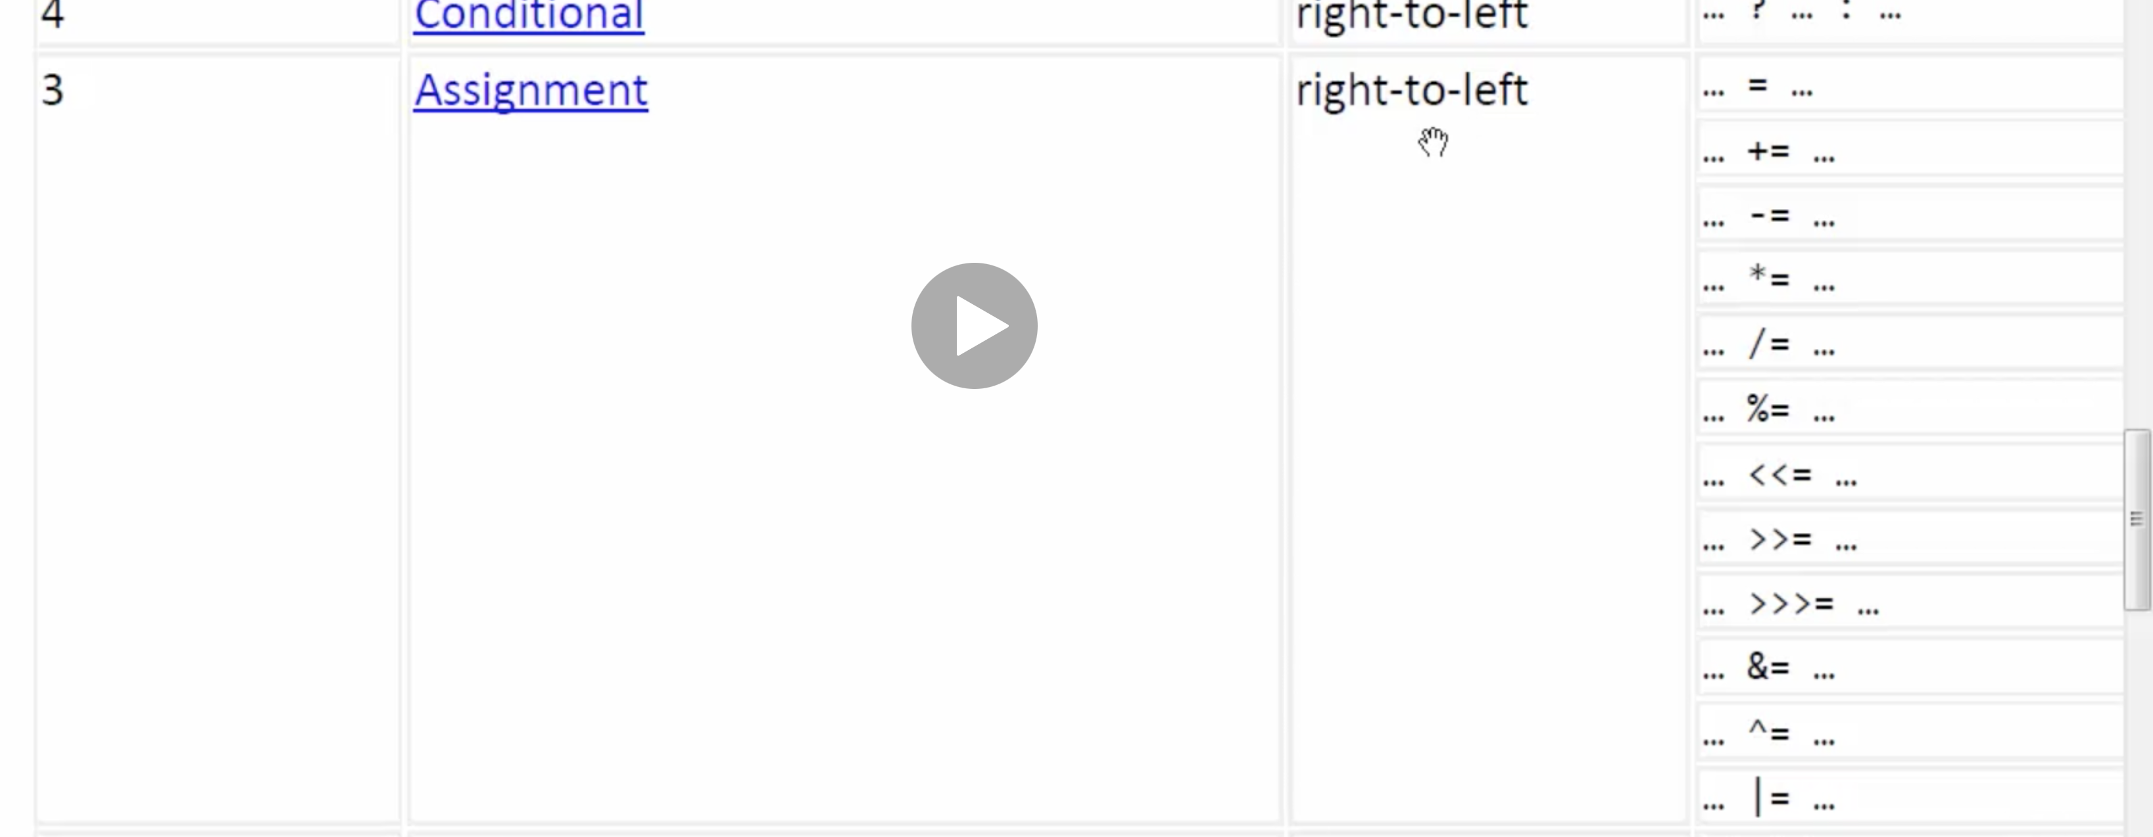.

20 Coercion:

--> Converting a value from **one type to another.**

--> This happens quite often in Javascript because it is **dynamically typed.**

Eg1;

var a = 1 + '2'; // 1 is coerced to string (JS engine is smart - best guess)

console.**log**(a); *// O/P: 12*

console.**log**(typeof a); *//string*

This can be implicit coercion and explicit coercion

String(123) // explicit

123 + '' // implicit

Link - [https://www.freecodecamp.org/news/js-type-coercion-explained-27ba3d9a2839/#:~:text=Type%20coercion%20is%20the%20process,Symbol%20(added%20in%20ES6](https://www.freecodecamp.org/news/js-type-coercion-explained-27ba3d9a2839/" \l ":~:text=Type coercion is the process,Symbol (added in ES6)).

Eg2:

true + false // 1

12 / "6" // 2

"number" + 15 + 3 // 'number153'

15 + 3 + "number" // '18number'

[1] > null // true

"foo" + + "bar" // 'fooNaN'

'true' == true // false

false == 'false' // false

null == '' // false

!!"false" == !!"true" // true

['x'] == 'x' // true

[] + null + 1 // 'null1'

[1,2,3] == [1,2,3] // false

{}+[]+{}+[1] // '0[object Object]1'

!+[]+[]+![] // 'truefalse'

new Date(0) - 0 // 0

new Date(0) + 0 // 'Thu Jan 01 1970 02:00:00(EET)0'

21 Comparison Operators:

console.**log**(1 < 2 < 3); *// true*

*// as < operator is left to right --> true < 3 --> 1 < 3 , hence true*

*< - left to right associativity*

console.**log**(3 < 2 < 1); *// true*

*// as < operator is left to right --> false < 1 --> 0 < 1 , hence true*

**TRICK:**

**To check what a number is coerced to in dev tools, use Number()**

**Number**(false) *// 0 // coerces to its number form*

**Number**('3') *// 3 // coerces to its number form*

Number(undefined) // NaN

Number(null) // 0

console.**log**(3 == 3); *// true*

console.**log**(3 == '3'); *// true*

console.**log**(false == 0); *// true*

console.**log**(null == 0); *// false (wierd JS), but Number(null) = 0 i.e. does not coerce to 0 in equality*

console.**log**(null < 5); *// true (wierd JS), but Number(null) = 0 i.e. does not coerce to 0 in equality*

var a = false;

console.**log**(a == 0); *// true*

console.**log**('' == 0); *// true*

console.**log**('' == false); *// true*

**TRICK: *To stop coercing number use ===, !== (strict equality, strict inequality etc.)***

***Good Practice: use === in most cases, if you consciously want to coerce val, then only use ==***

*Link (object comparison list)* [**https://developer.mozilla.org/en-US/docs/Web/JavaScript/Equality_comparisons_and_sameness**](https://developer.mozilla.org/en-US/docs/Web/JavaScript/Equality_comparisons_and_sameness)

22 Existence and Boolean:

--> Like Number() // for coercing to number, we have Boolean() // coercing to boolen

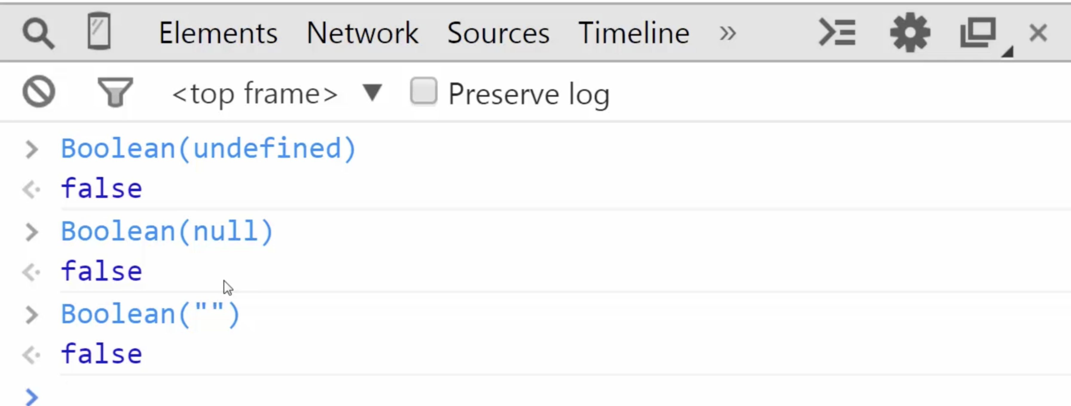

Case where Boolean coercion be used

var a; *// undefined*

if(a) { *// here boolean coerce runs ==> undefined --> 0, hence will not run*

*//*

}

One issue:

Boolean(0) = false; // it is a value still 0

var a = 0;

if(a){ // false

console.**log**("Something is there.");

}

Solution Fix:

var a = 0;

**// this technique is used in good js frameworks – Trick always use like written below:**

if(a || a===0){ // true – as precedence of === is greater than ||

console.**log**("Something is there.");

}

23. Default Value:

TRICK: use ||

console.**log**(true || false); *// true*

console.**log**(undefined || 'hello'); *//hello*

console.**log**('hi' || 'hello'); *// hi*

console.**log**(0 || 1); *// 1*

So instead of giving true or false, JS will try to take **that first value which will coerce to true**

eg. Number (‘hello’); //true

Number (1); // true

Eg:

function **greet**(name) {

console.**log**('Hello' + name);

}

**greet**(); *// Hello undefined*

*Solution:*

*function* ***greet****(name) {*

name = name || 'Amir'; *// default value*

console.**log**('Hello ' + name);

}

**greet**(); *// Hello Amir*

***greet****(‘Tony’); // Hello Tony*

***greet****(0); // Hello Amir (Wierd one with 0)*

NOTE: || is having more precedence over =

therefore a = a || ‘default value’; // therefore default value will coerce first

________________________________________________________________________________

24. Framework Aside: Default Value:

Framework or library is a piece of code is stacked with bunch of codes and can b e reused.

Observe below snippet:

index.html

<html>

<head>

<meta *http-equiv*="Content-Type" *content*="text/html" *charset*="utf-8"/>

</head>

<body>

<script *src* = "lib1.js"></script>

<script *src* = "lib2.js"></script>

<script *src*="app.js"></script>

</body>

</html>

app.js

console.**log**(libraryName);

lib1.js

var libraryName = "Library 1";

lib2.js

var libraryName = "Library 2";

O/P: Library2

So no different execution context is created, all code is stacked in the order it is loaded,   
libraryName is created in Global execution context.

Lib2 – overwrite libraryName of the first one

Solution:

As global execution is already created in lib1.js. We will check in lib2.js

lib2.js

window.libraryName = window.libraryName || "Library 2";

O/P: Library1

TRICK – Whenever in framework window.something is written, it is checking global execution context.

________________________________________________________________________________

Objects And Functions

25. Object and The DOT

Object is the collection of name-value pair contained in memory.

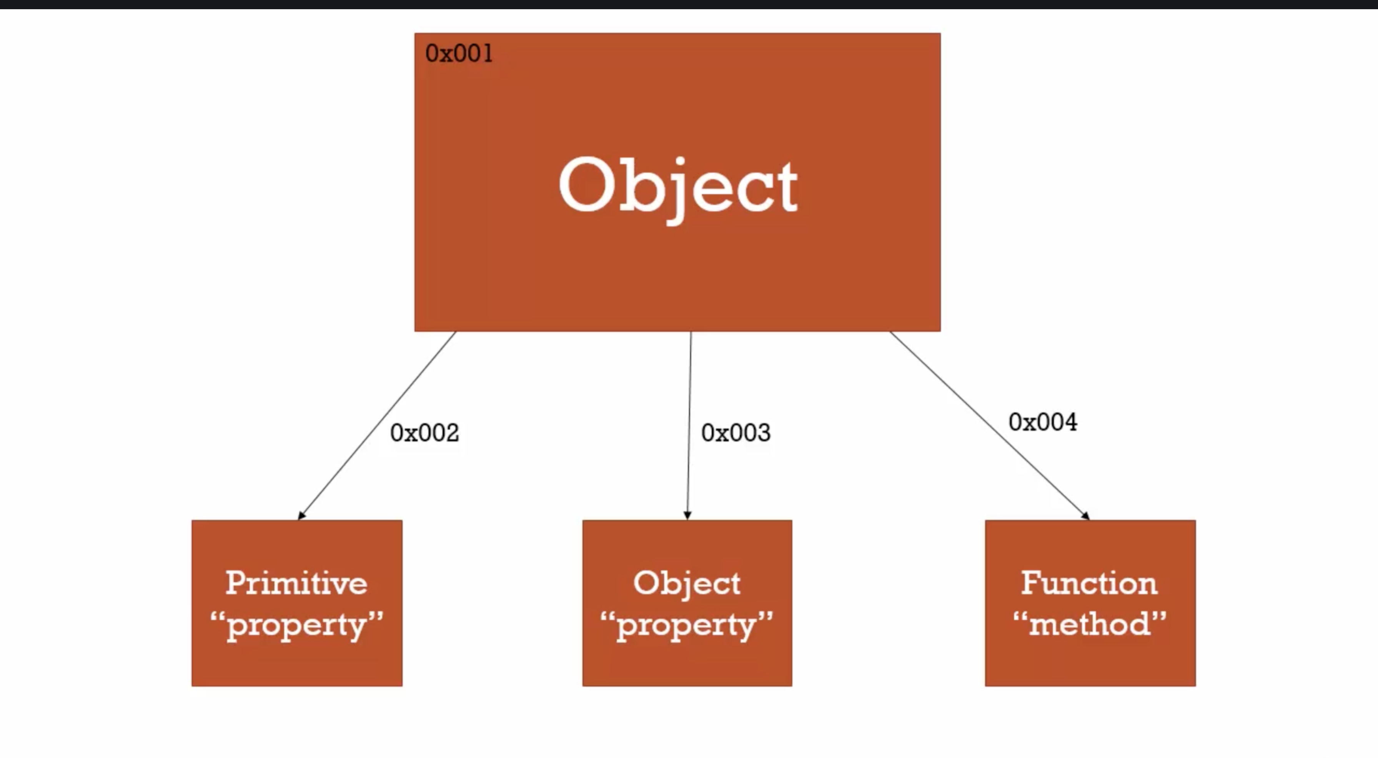

Eg1: Method 1 – Computed Member Access i.e. []

var person = new **Object**();

*// Computed Member Access (Object precedency 3rd from top, Associativity - left to right)*

person["firstname"] = "Tony";

person["lastname"] = "Alecia";

var firstNameProperty = "firstname";

console.**log**(person);

console.**log**(person[firstNameProperty]);

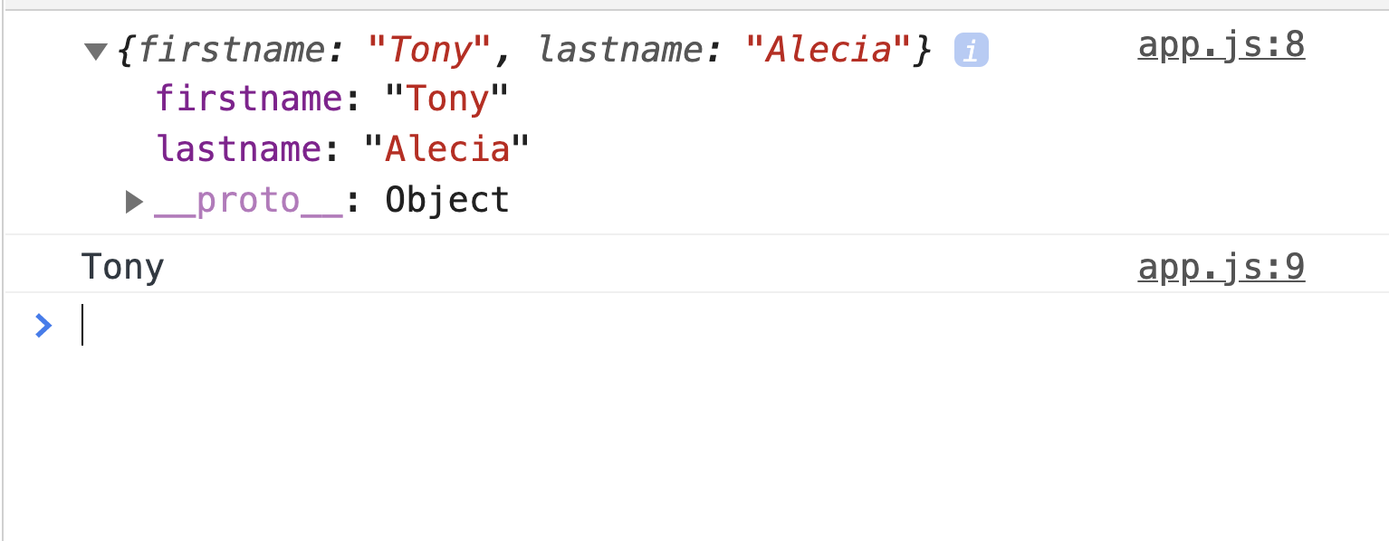

Eg2. Second way to access function – DOT (Preferred Way)

*// Member Access (Object precedency 2nd from top, Associativity - left to right)*

console.**log**(person.firstname); // Tony

*console.****log****(person.lastname); // Alecia*

--> We can also create another object inside the object

*var person = new* ***Object****();*

person["firstname"] = "Tony"; *// Computed Member Access (Object precedency 3rd from top - left to right)*

person["lastname"] = "Alecia";

var firstNameProperty = "firstname";

console.**log**(person);

console.**log**(person[firstNameProperty]);

console.**log**(person.firstname); *// Member Access (Object precency 2nd from top - left to right)*

person.address = new **Object**();

person.address.street = "#100 Hutton Road";

person.address.city = "New York";

person.address.state = "NY"

console.**log**(person);

console.log(person.address.street);

console.log(person[‘address’][‘street’])

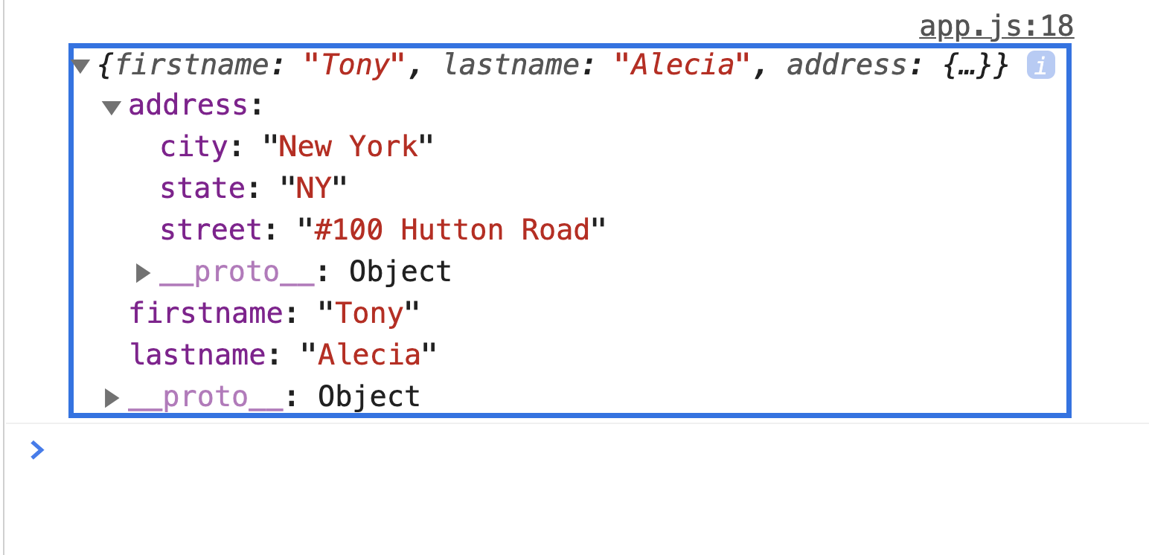.

26. Objects and Object Literals:

var person = {}; *// Object Literal Way*

console.**log**(person);

var person = {firstname: 'Amir', lastname: 'Mustafa'} *// Object Literal Way*

console.**log**(person);

var person = new **Object**(); *// Basic way*

person.firstname = 'Amir';

person.lastname = 'Mustafa';

Eg2:

var person = {

firstname: 'Amir',

lastname: 'Mustafa',

address: {

street: '#20 111 Main Street',

city: 'New York',

state: 'NY'

}

}

console.**log**(person);

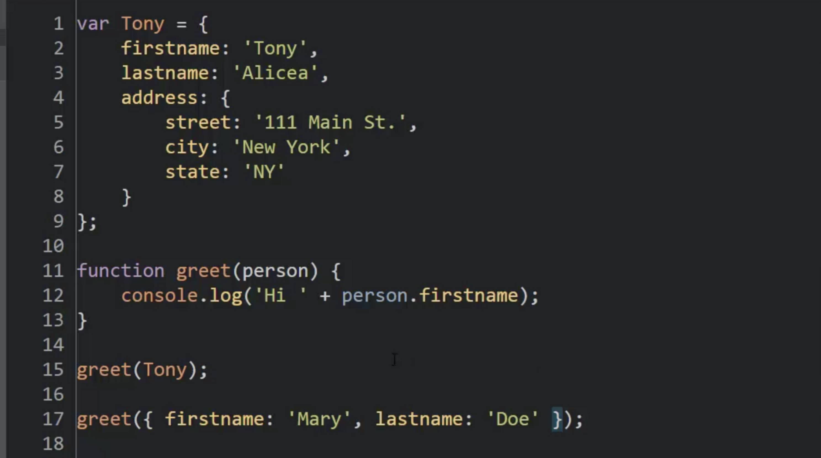.

Also we can mix and match:

eg

Tony.address2 = {

street: ‘333 Second street’

}

Behind the scene, JS engine converts into same in memory:

a. whether we use object literal

b. or Basic way

c. or dot notation

27. Faking Namespace

Namespace: A container for variables and functions. Typically to keep variables and functions with the same name seperate

--> JavaScript does not have namespace concept like PHP or Java.

--> So we can fake it with Objects

Eg1:

var greet = 'Hello!'; *// eng*

var greet = 'Hola'; *// spanish*

console.**log**(greet); // last one will override

Eg2:

var english = {};

var spanish = {};

english.greet = 'Hello';

spanish.greet = 'Hola';

Eg3:

var english = {};

var spanish = {};

english.greet = "Hello";

spanish.greet = "Hola"; *// throw error and . left to right associativity (greetings is undefined)*

*// We cannot create chains in fly*

*// spanish.greetings.greet = "Hola"; // throw error and . left to right associativity (greetings is undefined)*

==> undefined.greet ==> hence error

spanish.greetings = {}; *// first create object*

spanish.greetings.greet = "Hola again!"

console.**log**(spanish);

Eg4:

var english = {};

var spanish = { greetings:{} };

english.greet = "Hello";

spanish.greet = "Hola"; *// throw error and . left to right associativity (greetings is undefined)*

*// We cannot create chains in fly*

*// spanish.greetings.greet = "Hola"; // throw error and . left to right associativity (greetings is undefined)*

*// ==> undefined.greet ==> hence error*

*// spanish.greetings = {}; // instead of defining here we can directly define in object literal*

spanish.greetings.greet = "Hola again!"

console.**log**(spanish);

______________________________________________________________

28. JSON and Object Literals:

--> Earlier we used to send in XML format (i.e. SOAP). This costs lots of memory as name was written twice

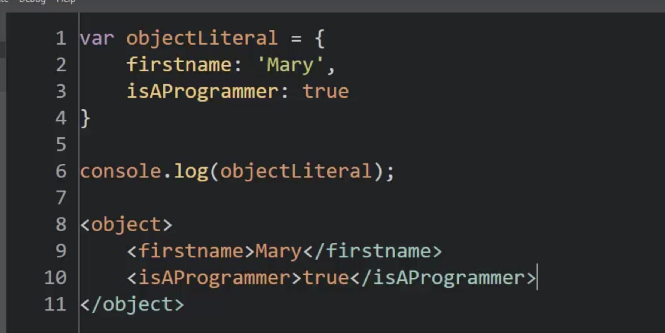

--> JSON is inspired from Object Literals:

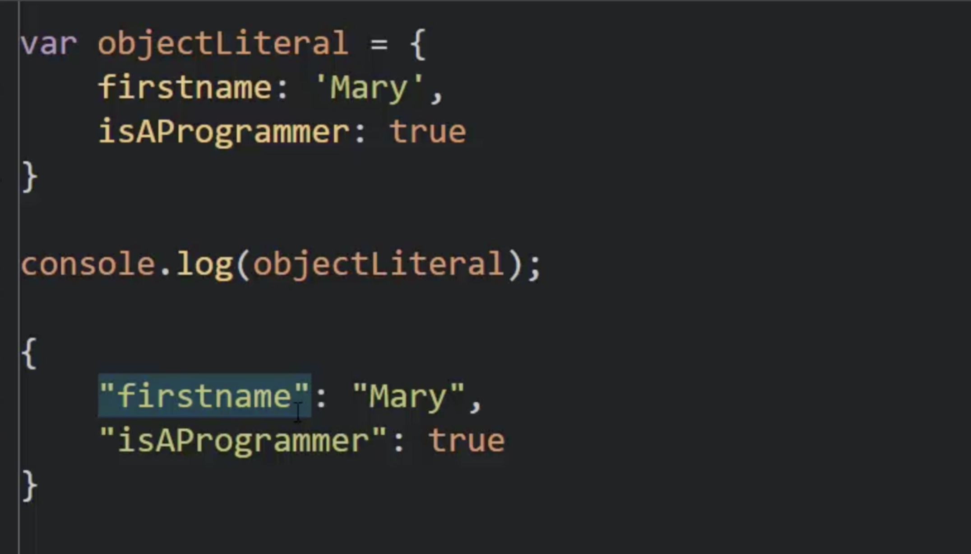.

*// Converts Objects to JSON*

var english = {

name: "Tony",

isProgrammer: true

};

var englishJSON = JSON.**stringify**(english);

console.**log**(englishJSON); // JSON

*// Converts JSON to Object*

var englishJSON = '{ "name": "Tony", "isProgrammer": true }';

var english = JSON.**parse**(englishJSON);

console.**log**(english); // JS Object or Object Literal

TRICK:

JSON always prints in **black** in console (a string)

JS Object prints in **coloured** format

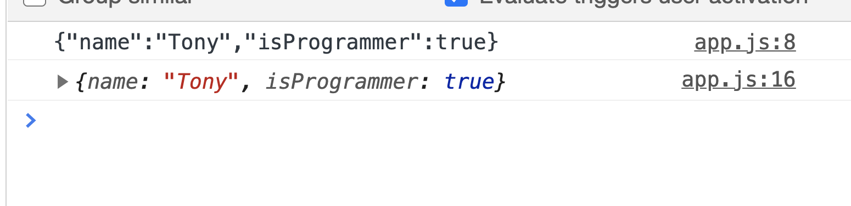

29. Functions are Objects:

--> In JS, functions are first-class functions.

First Class Functions: Everything you can do with other types, you can do with functions. Assign then to variables, pass them around, create them on the fly.

i.e all feature of normal object + some properties

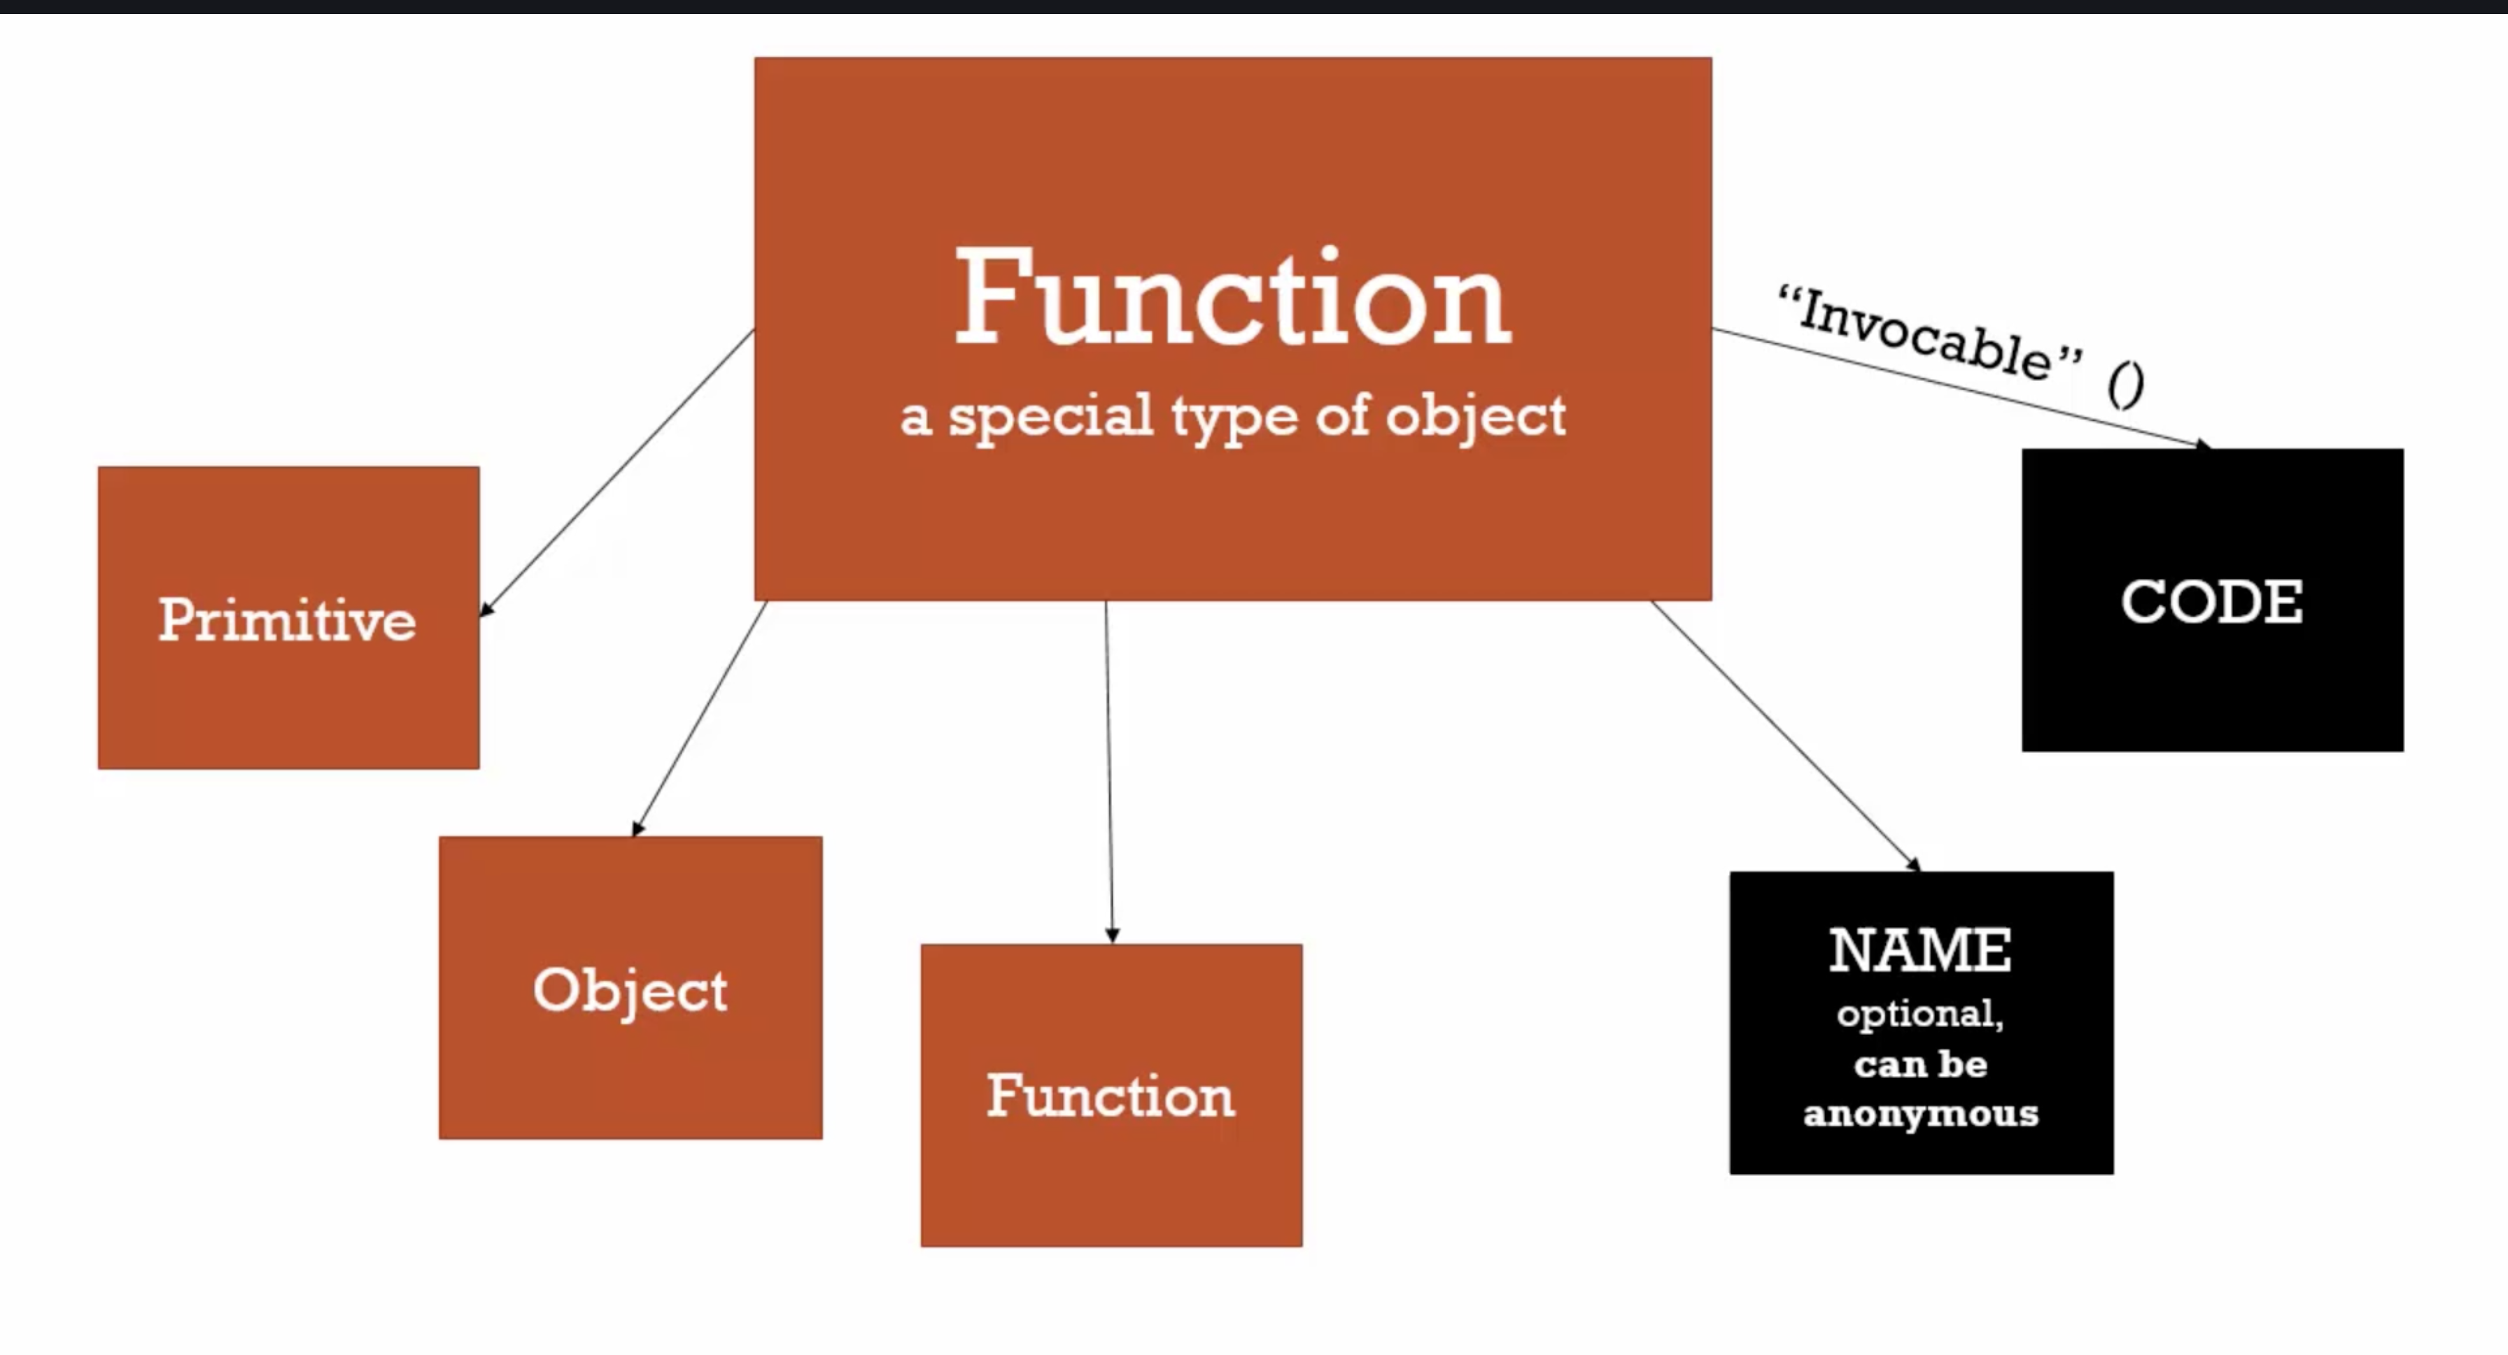.

Eg:

function **greet**() {

console.**log**('hello');

}

**greet**.language = 'english'; // setting properties in objects

console.**log**(**greet**); *// prints function*

console.**log**(**greet**.language); *// english - can also be used like objects*

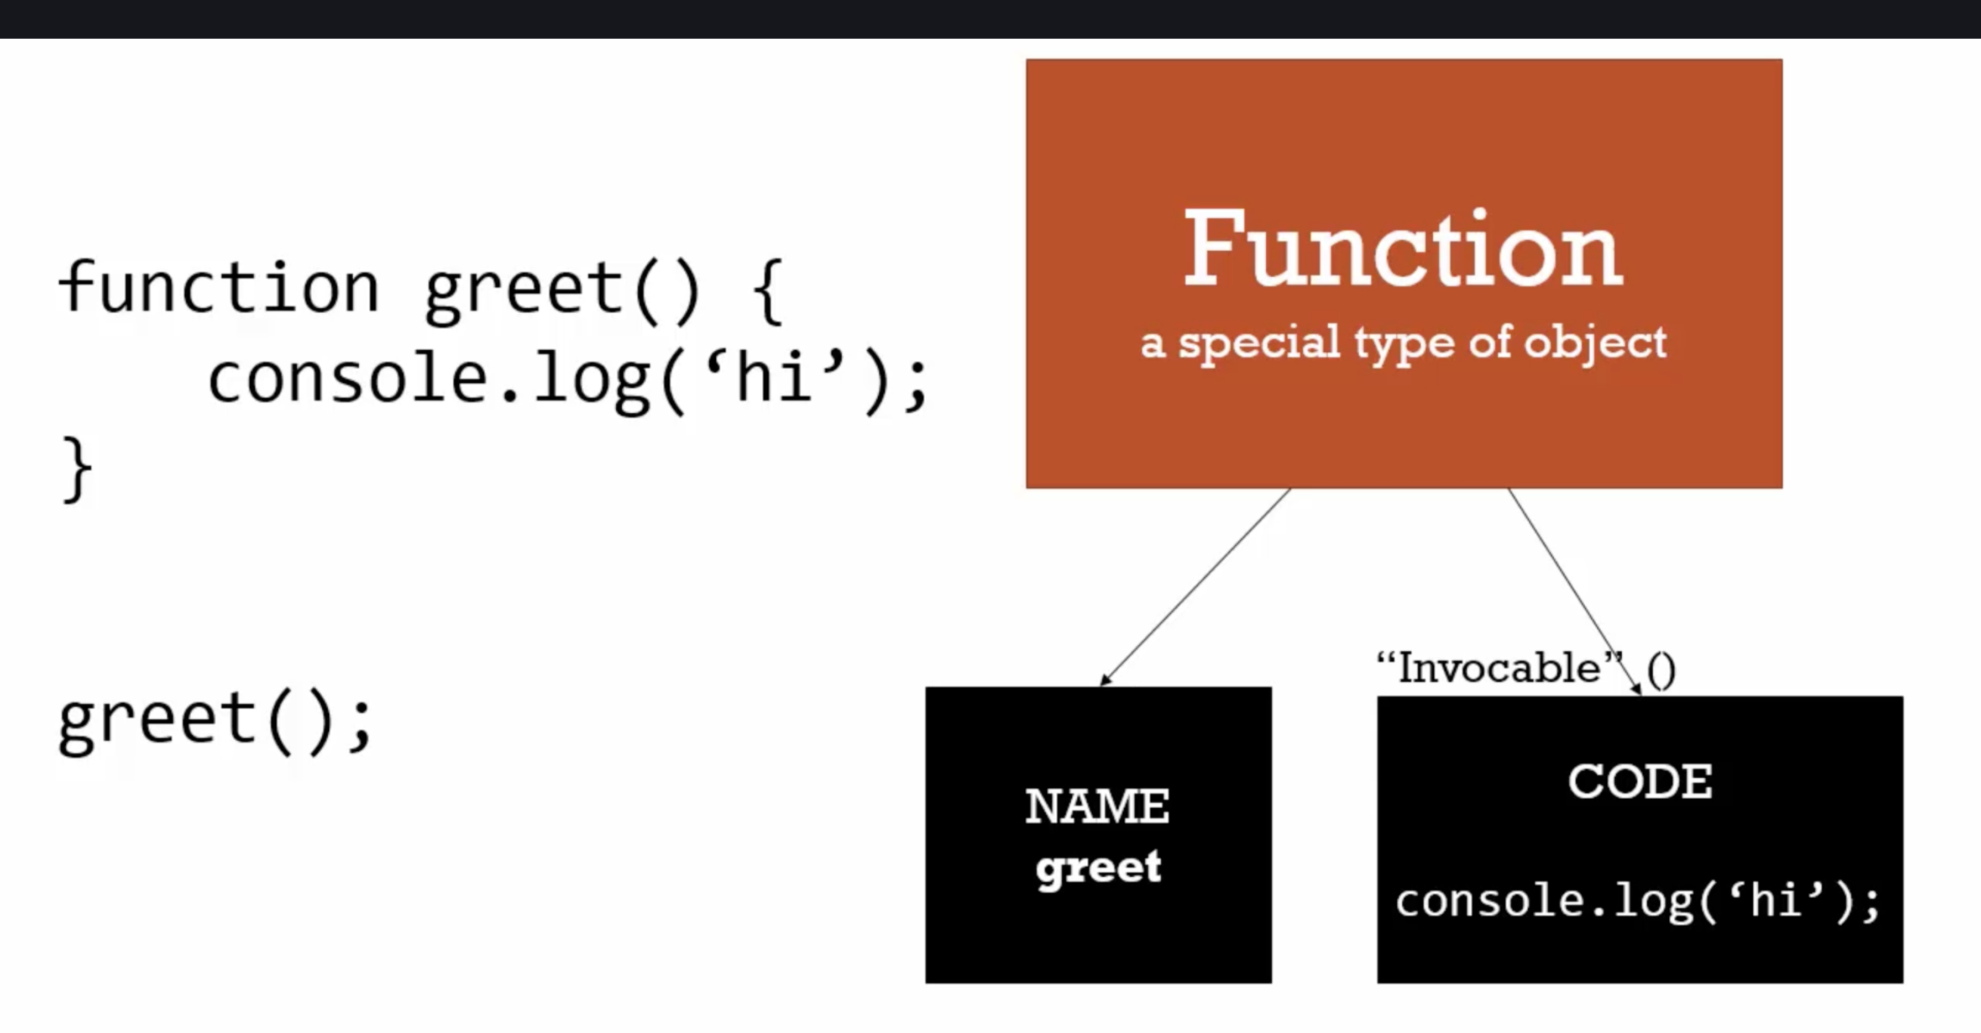.

--> In JS, functions are objects

29. Functions Statements and Function Expression:

Expression: A unit of code that results in a value. It doesn’t have to save in a variable.

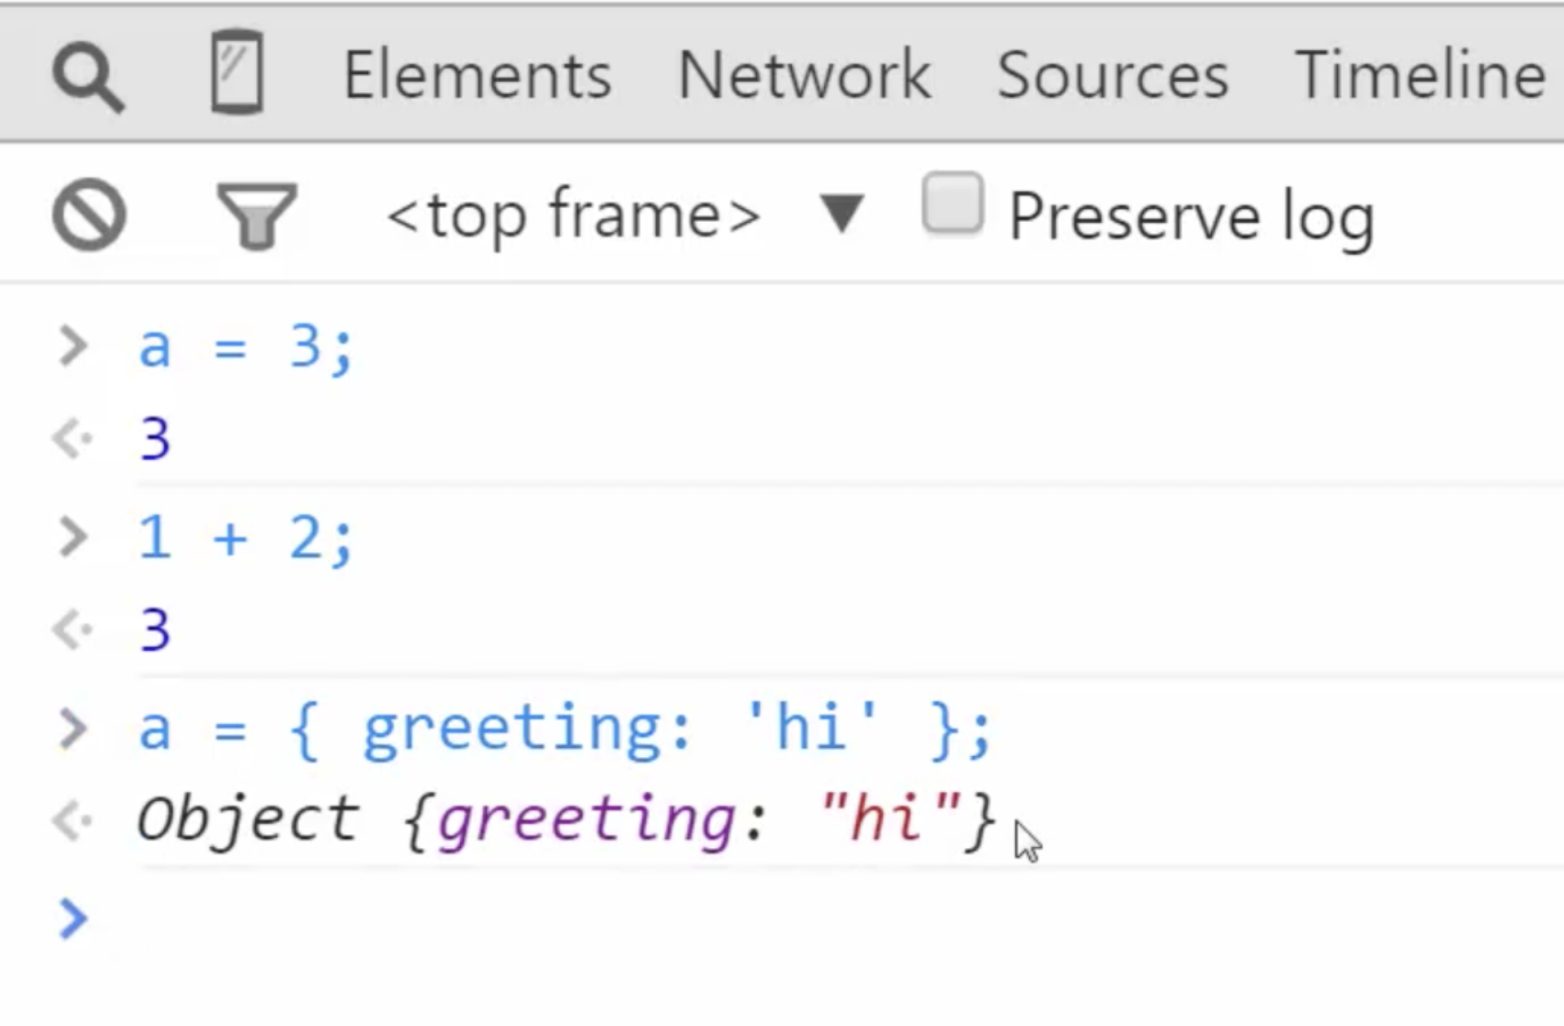.

Statement: It does some work eg. if(a==3){ //code } // statement

Expression: It returns some value, eg. A === 3 //returns val i.e. true or false // expression

Function statement:

**greet**(); *// supports hoisting - can be called before declaration*

function **greet**() {

console.**log**('hello'); // no returning – just some work is done

}

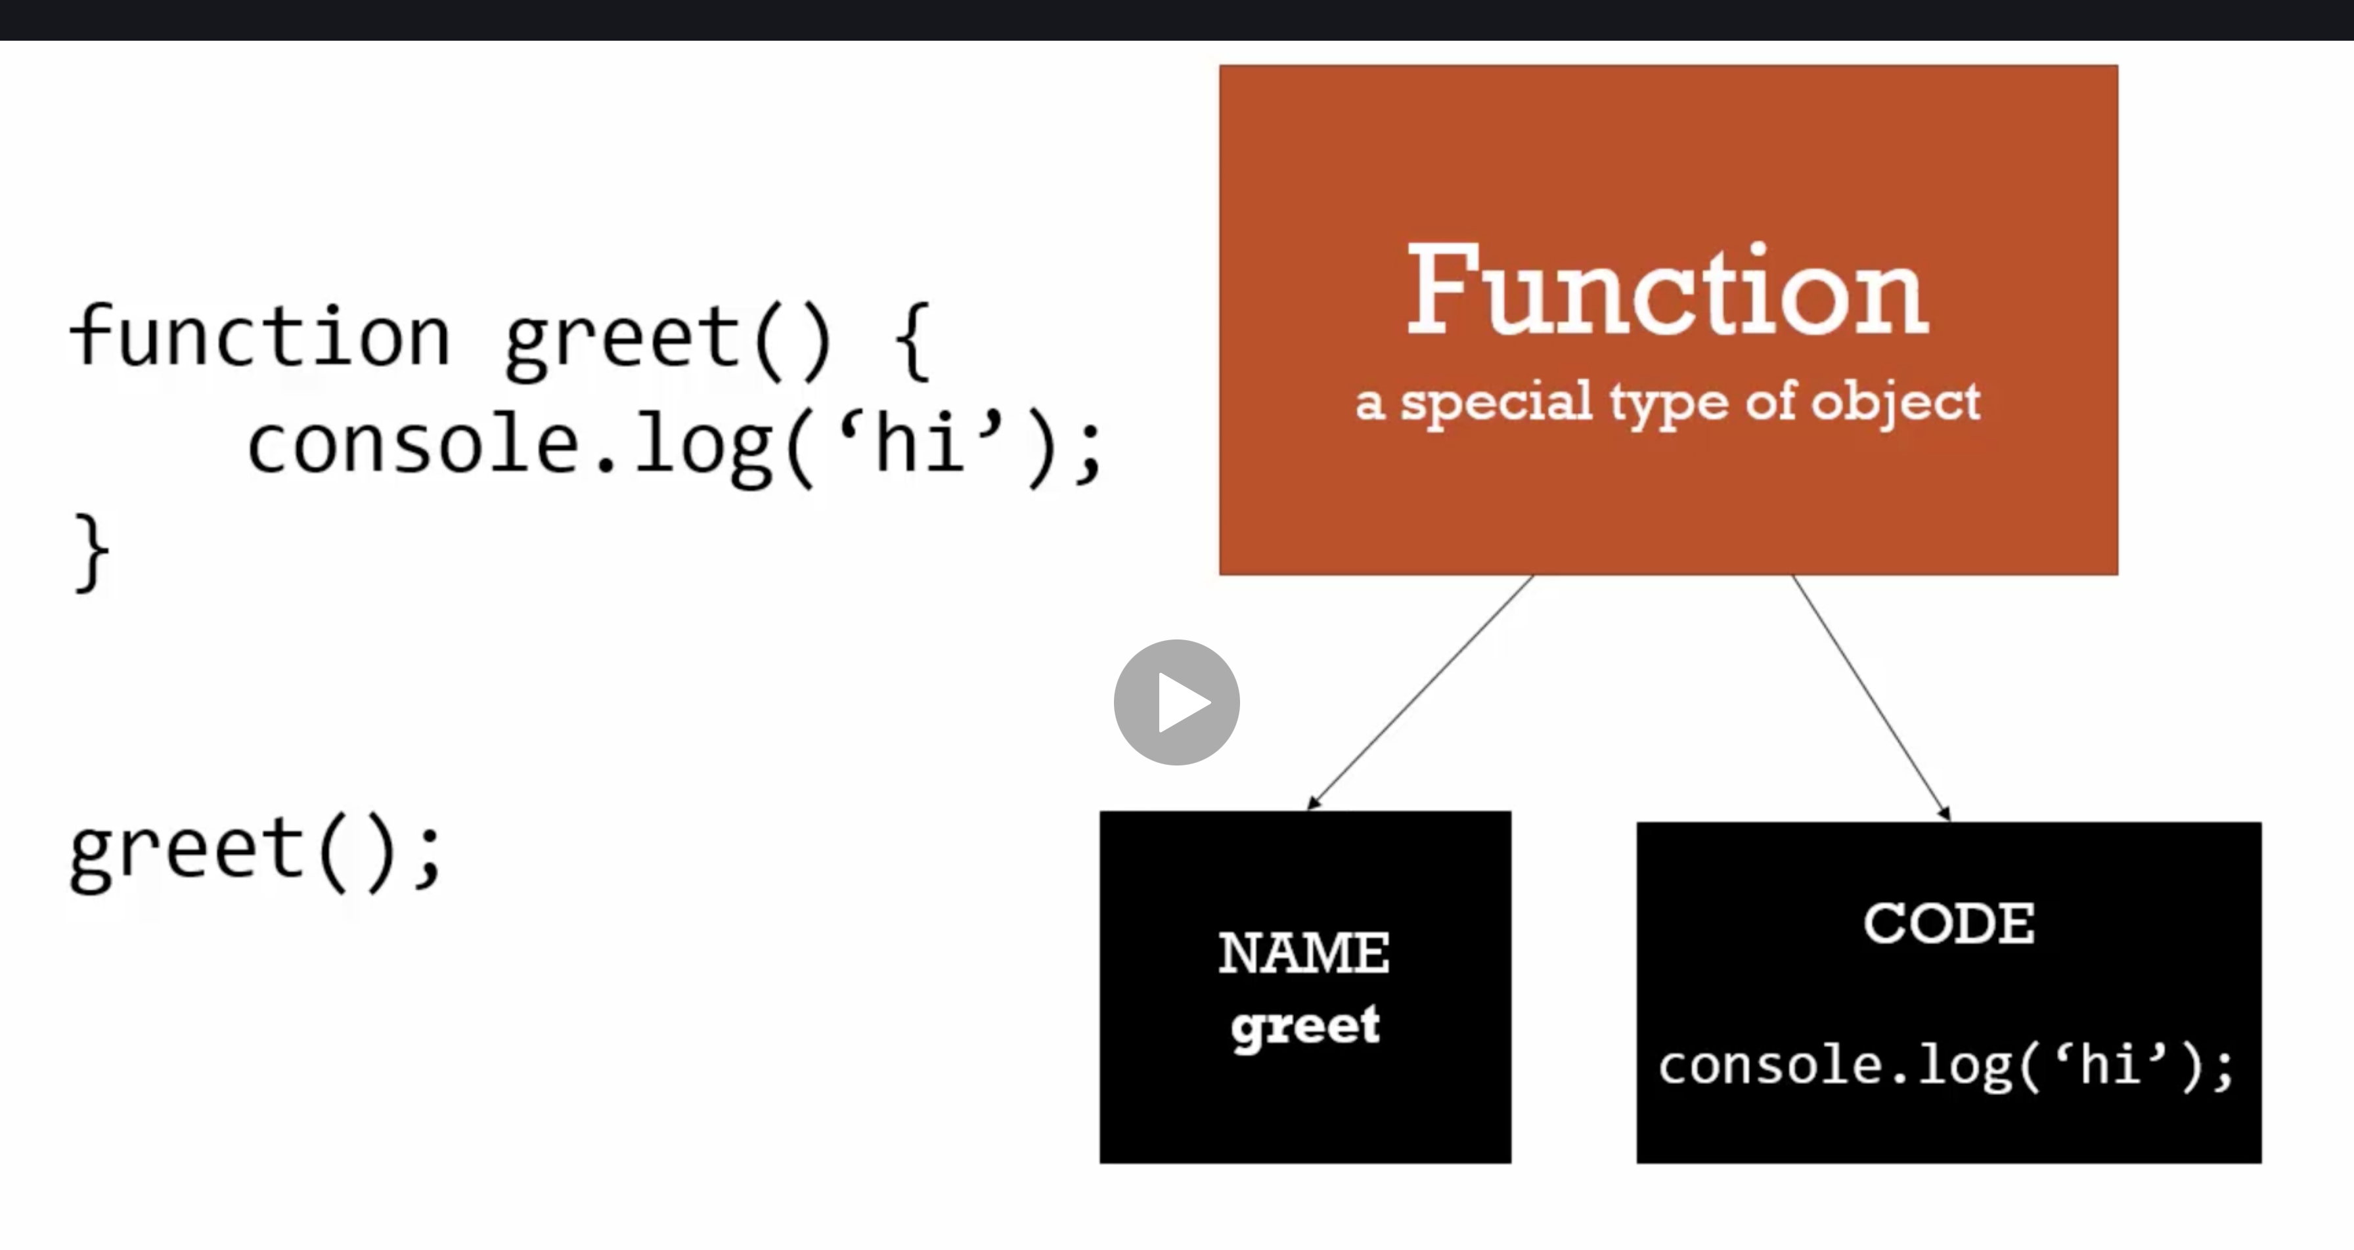.

Function Expression:

--> As functions are objects in js.

--> It can be assigned to variable. No need for name and can be used variable address of memory.

Eg.

var **anonymousGreet** = function() {

console.**log**('hello anonymous');

}

**anonymousGreet**();

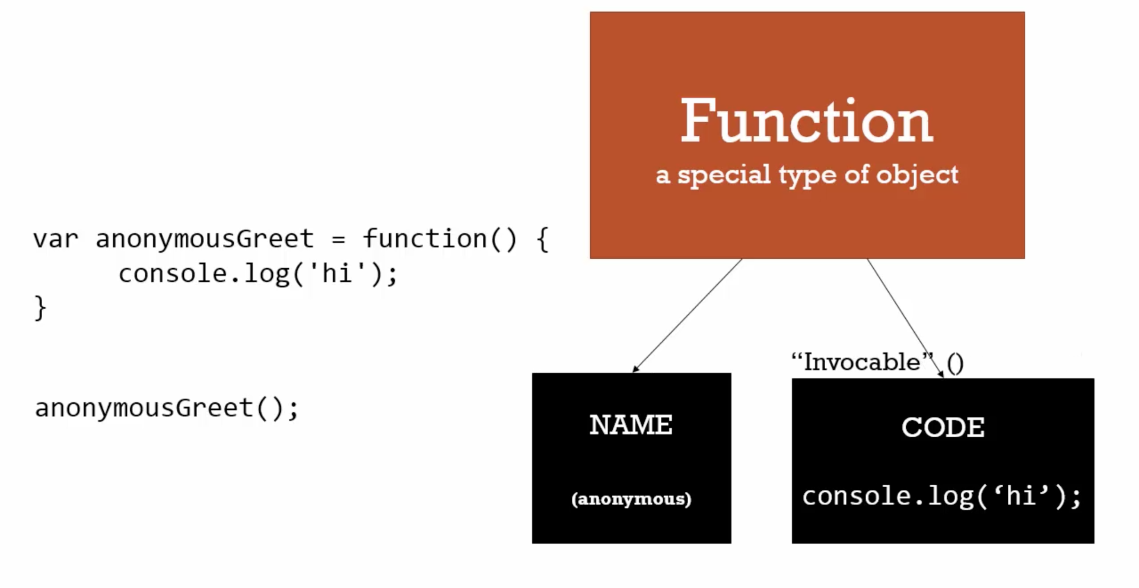.

NOTE: hoisting does not support with function expression. It works only with function statement.

**anonymousGreet**(); *// hoisting - does not support with function expression*

var **anonymousGreet** = function () {

console.**log**('hello anonymous');

}

//Error msg: app.js:7 Uncaught TypeError: anonymousGreet is not a function

Eg

a.

function **greet**(data) {

console.**log**(data);

}

**greet**('testData');

b.

*// Pass object in function*

function **greet**(data) {

console.**log**(data);

}

**greet**({greet: "Hola!"});

c.

*// Strange: We can pass function in calling - behaves like object literals*

function **greet**(data) {

console.**log**(data); *// prints entire caller function*

**data**(); *// prints i.e. hi from invoke*

}

// we can pass functions as functions are 1st class objects

**greet**(function() {

console.**log**('hi from invoke')

});

Conclusion:

1. Function Statement – hoisted

2. Function Expression – never hoisted (throws undefined error).

3. {}, function - can be passed in function.

_________________________________________________________________________

30. Conceptual Aside: By Value vs By Reference:

By Value:

In js when you assign

a = 5;

b = a;

(or pass a function)

so a value is stored in one address in memory.

**Copy of a value is stored in another address in memory.**

This duplication/copying of value is called by value

i.e. both pointing to two different address in memory

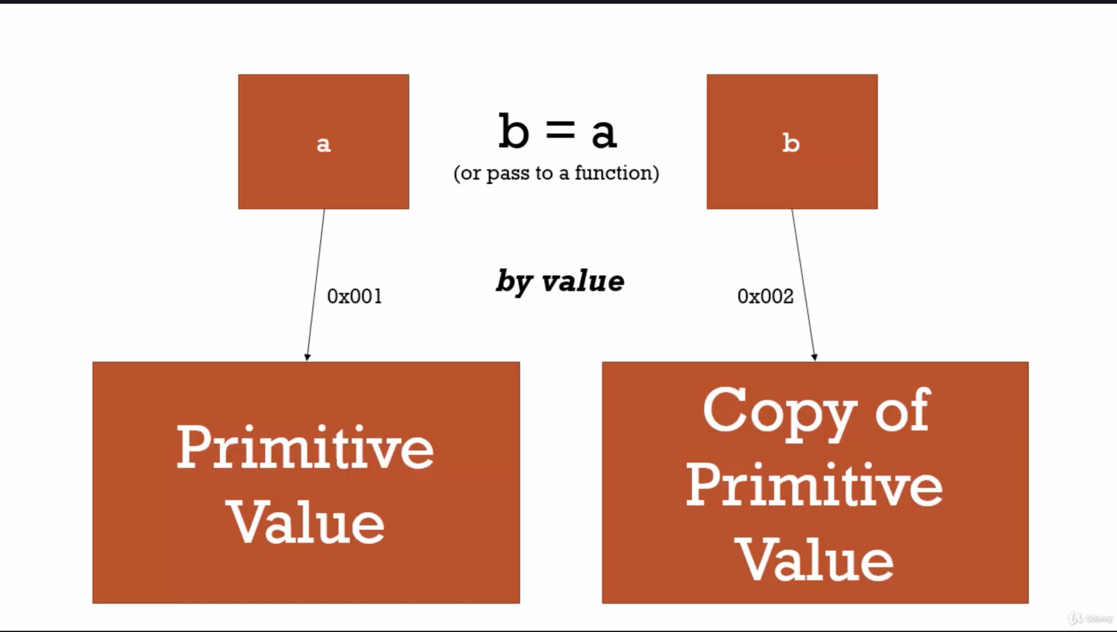

By Reference:

When we assign an object to another variable, instead of copying in new memory it references to the address in memory.

All objects when assigned to another variable works in references

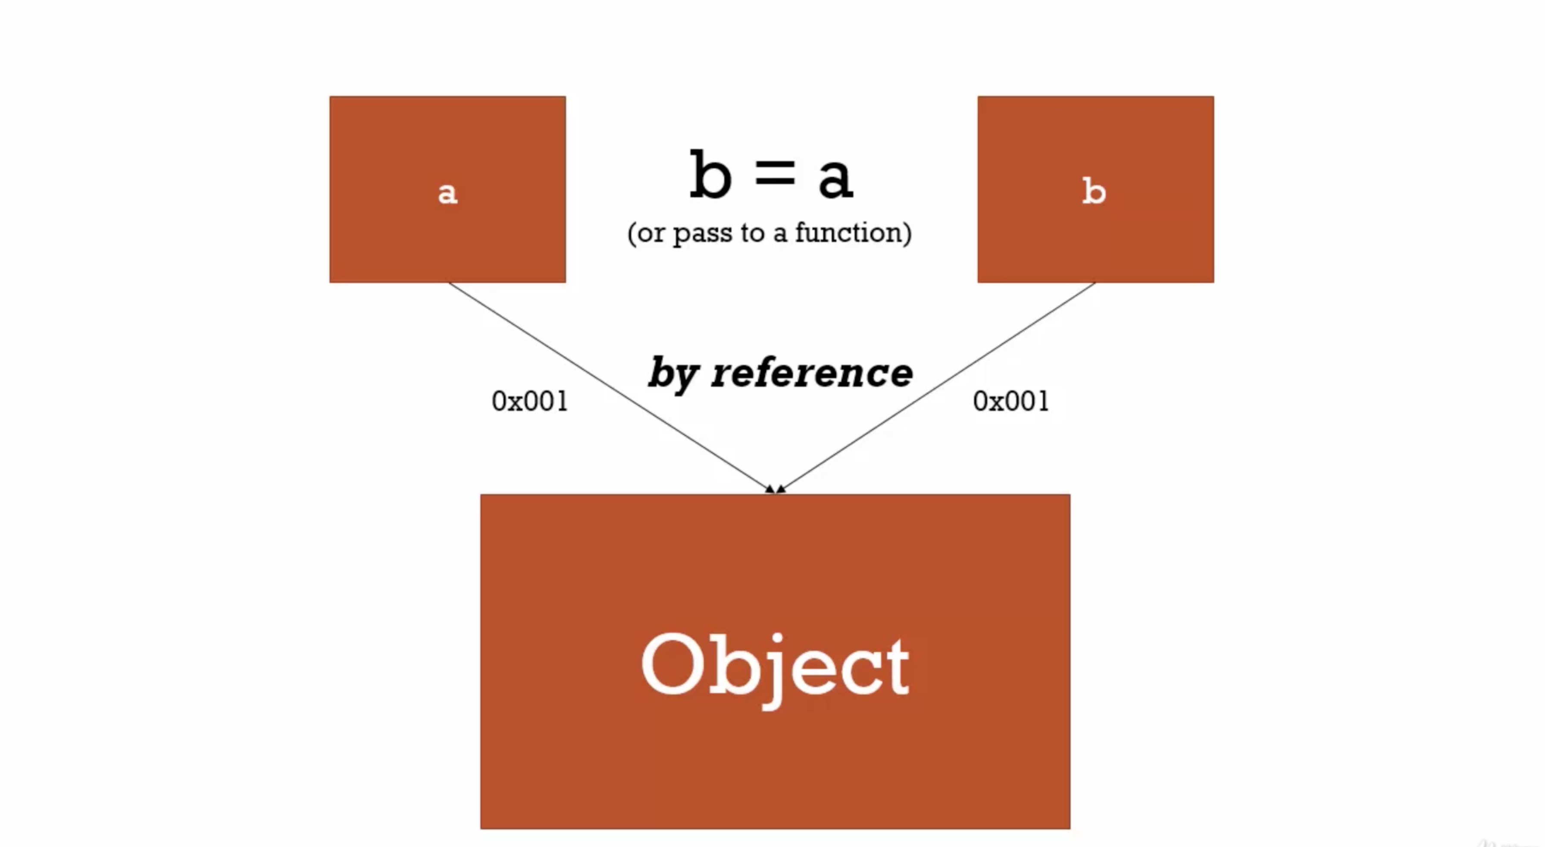.

Mutate – change something/objects

Eg.

*// By value (primitive)*

var a = 3;

var b;

b = a;

a = 2;

console.**log**(a); *// 2*

console.**log**(b); *// 3 (as both are stored in different address)*

Eg2.

*// By reference (all objects - including functions)*

var c = {greeting: "Hola!"};

var d;

d = c;

c.greeting = "Hello"; *// do not try c = {greeting: "Hola!"}, it means setting a new memory -->*

console.**log**(c); *// 2*

console.**log**(d); *// 3 (as both are stored in different address)*

Special Case – Where reference does not apply with obj

*var c = {greeting: "Hola!"}; // this creates brand new space in memory, so never update like this*

Eg3.

// By reference (all objects - including functions)

*// By reference - passing objects to functions*

function **extendedGreet**(obj) {

obj.greeting = "Namaste";

}

**extendedGreet**(d);

console.**log**(c); *// Namaste*

console.**log**(d); *// Namaste*

TRICK:

1. All primitive data is works with **by value** i.e. even after mutating one will not affect its copy

2. **All objects is by reference** – so mutating one will affect others also here.

31 Object, Functions and this:

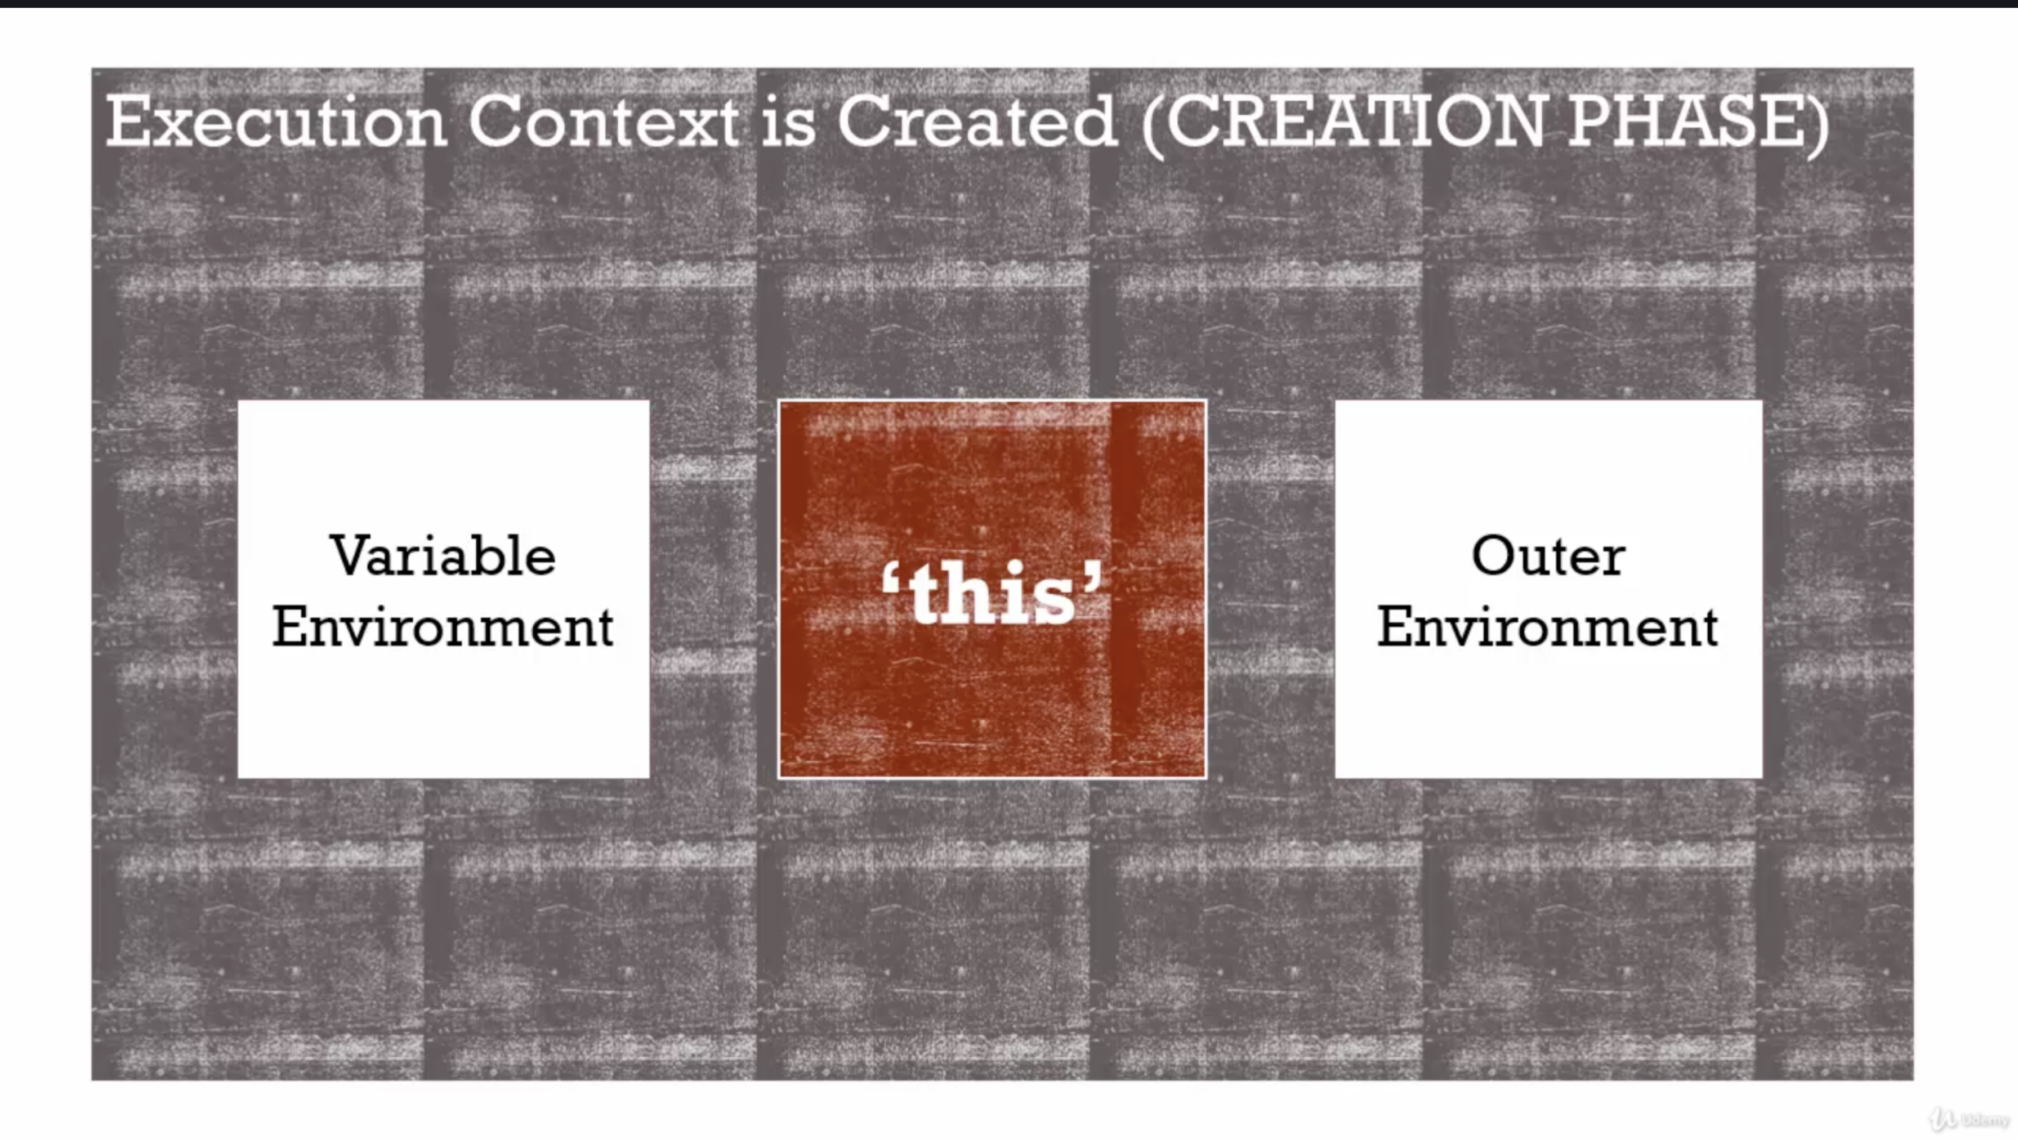.

Reminder:

--> When function sits in memory which has two properties – name and code (this section runs when code is invoked)

--> When code is invoked function’s execution context is created. It has own variable, if not found search outer till global environment.

--> this variable is created automatically when a function is called.

**this** will be pointing to different scenarios based on way function is called.

*// Eg1*

console.**log**(this); *// CALLING IN GLOBAL: this points to windows*

*// Eg2*

function **a**() {

console.**log**(this); *//CALLING IN FUNCTION : this points to windows (global)*

}

**a**();

*// Eg3*

var **b** = function() {

console.**log**(this); *//CALLING IN FUNCTION EXPRESSION: this also points to windows*

}

**b**();

*// Eg4: as this points to window we can also do strange things:*

function **a**() {

console.**log**(this); *// this points to windows*

this.newVariable = 'Hola Amir!';

}

**a**();

console.**log**(newVariable); *// similar to window.newVariable or newVariable*

BEWARE: when this is updated in function, it is creating/overriding in global variable

NOTE: Inside an object – if value is **primitive** – property, if value is **function** - method

Eg. This is very powerful, we can mutate object property as per requirement.

var c = {

name: "c named object",

**log**: function() {

*// this.name = "Updated c object"; // updates name property of this object*

console.**log**(this);

}

}

c.**log**(); *// this will point to the function only (its properties and methods) - object literals*

Eg2. There is one bug with JS. When a **function** is defined inside a **method** of **object literal**. This operator points to global object other than the object properties. SO be careful

var c = {

name: "c named object",

**log**: function() {

this.name = "Updated c object"; *// updates name property of this object*

console.**log**(this);

var **setname** = function(newName) {

this.name = newName;

*// this will update global variable instead of this object variable/property*

}

**setname**("Updated again c object");

}

}

c.**log**(); *// this will point to the function only (its properties and methods) - object literals*

c.name; // Updated c object

and not // Updated again c object

TRICK: Always inside function use below trick:

some people use **self** or **that**

*// Eg:*

var c = {

name: "c named object",

**log**: function() {

var self = this;

self.name = "Updated c object"; *// updates name property of this object*

var **setname** = function(newName) {

self.name = newName; *// this will update global variable instead of this object variable/property*

}

**setname**("Updated again c object");

console.**log**(self); // this will have **updated name property**

}

}

c.**log**(); *// this will point to the function only (its properties and methods) - object literals*

32 Conceptual Aside – Array – Collection of Anything

Way1 – var arr = new Array(); // Basic Way

Way2 – var arr = []; // Array Literal Syntax

JavaScript is dynamically typed. It can store all types of data in one go.

var arr = [1,2,3];

*// As Arrays are dynamically types in JS*

var arr = [

1,

false,

{

name: 'Amir',

address: 'Asansol'

},

function(name) { *// function expression*

console.**log**("Hello " + name);

}

];

console.**log**(arr);

console.log(arr[3](arr[2].name)); // calling the function and passing name from obj literal

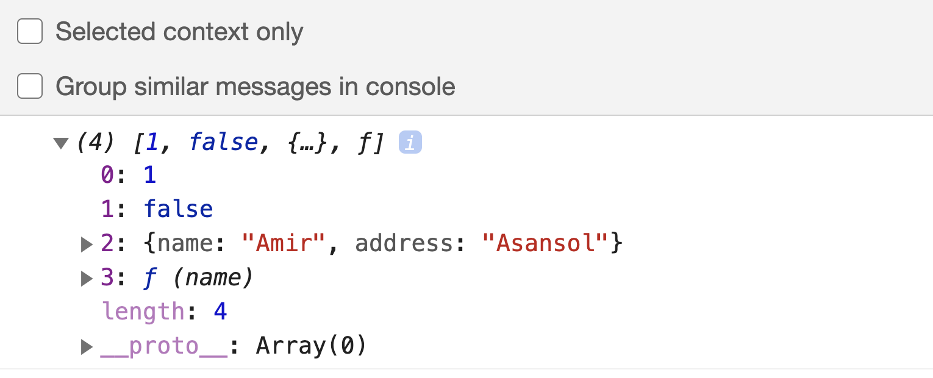.

33 Arguments and Spread

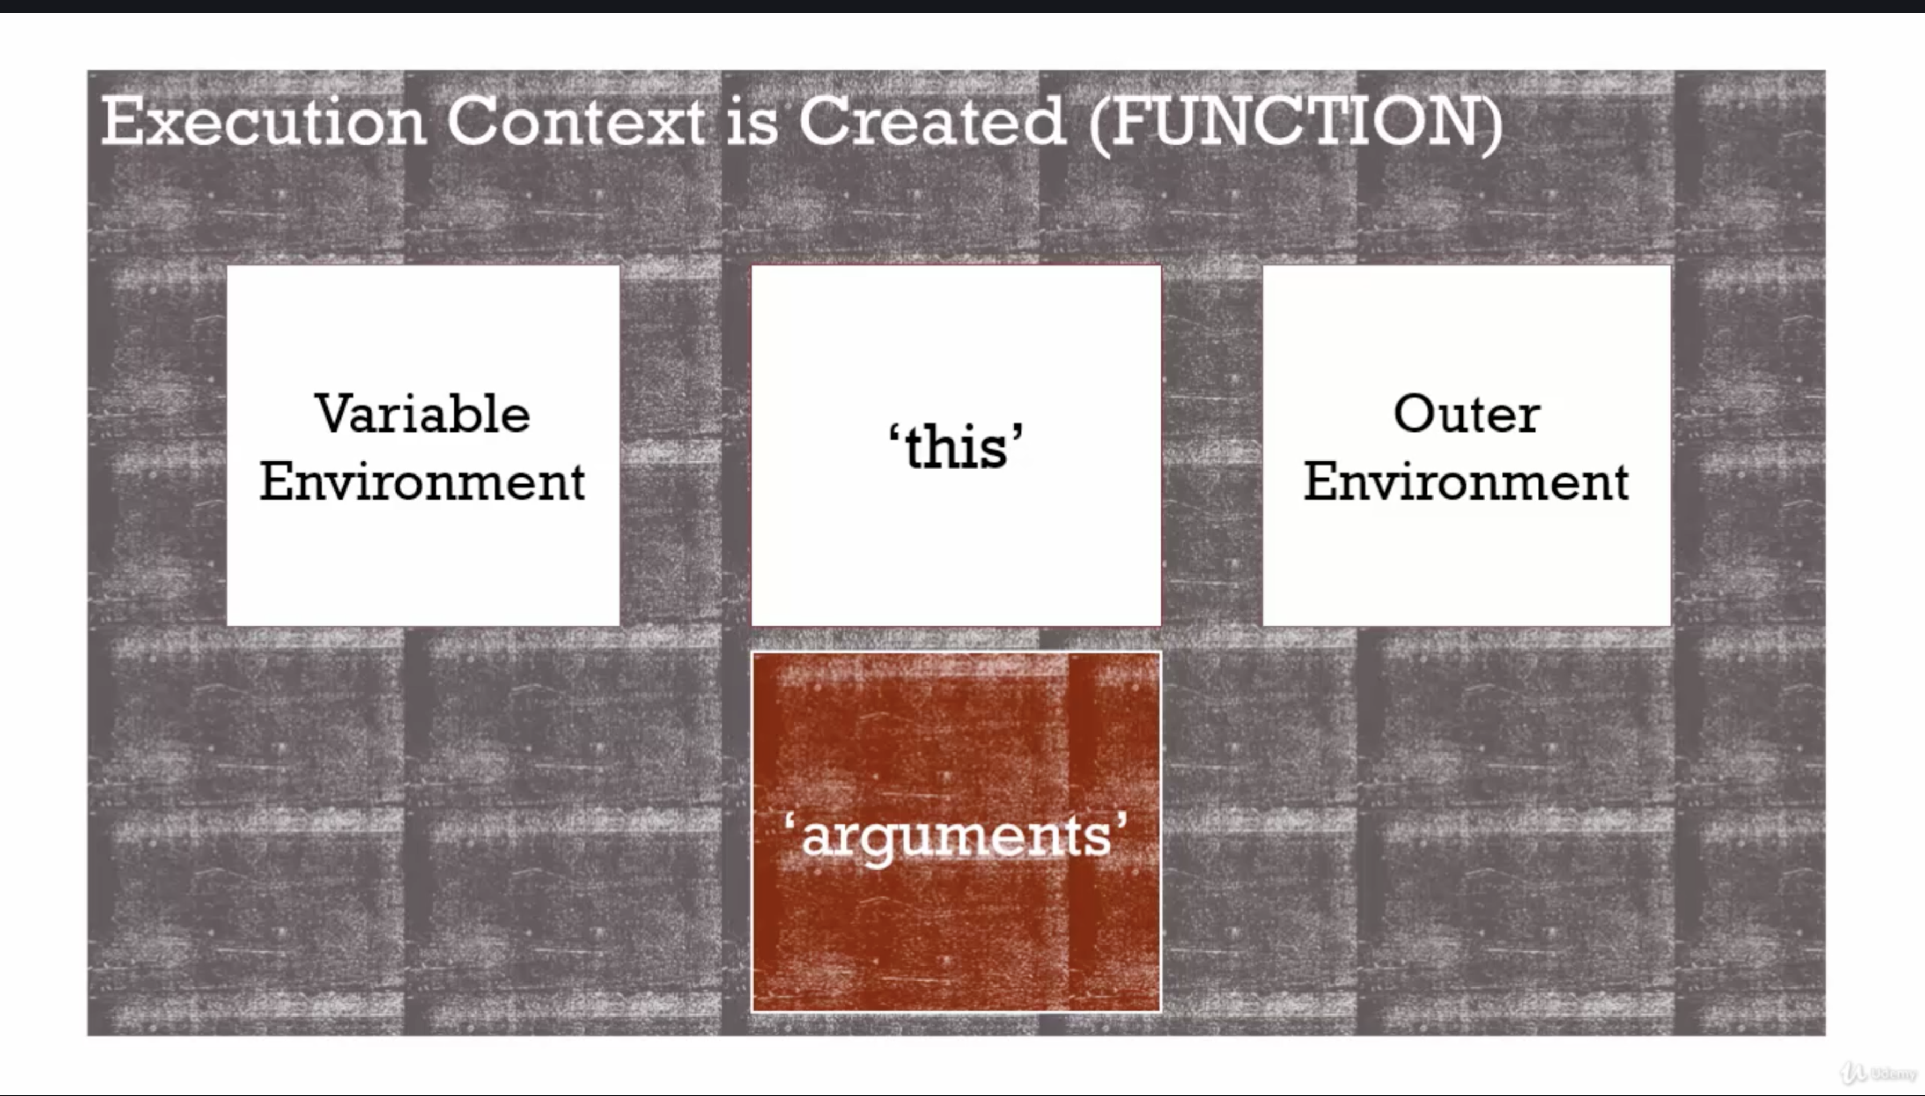.

--> Argument – in ES5 whatever is passed in functions, methods (used in most framework)

--> Spread – In next version of JavaScript, spread is used. Similar to

argument + some other functionalities.

--> Arguments contains list of all the values of all the parameters you pass to a function.

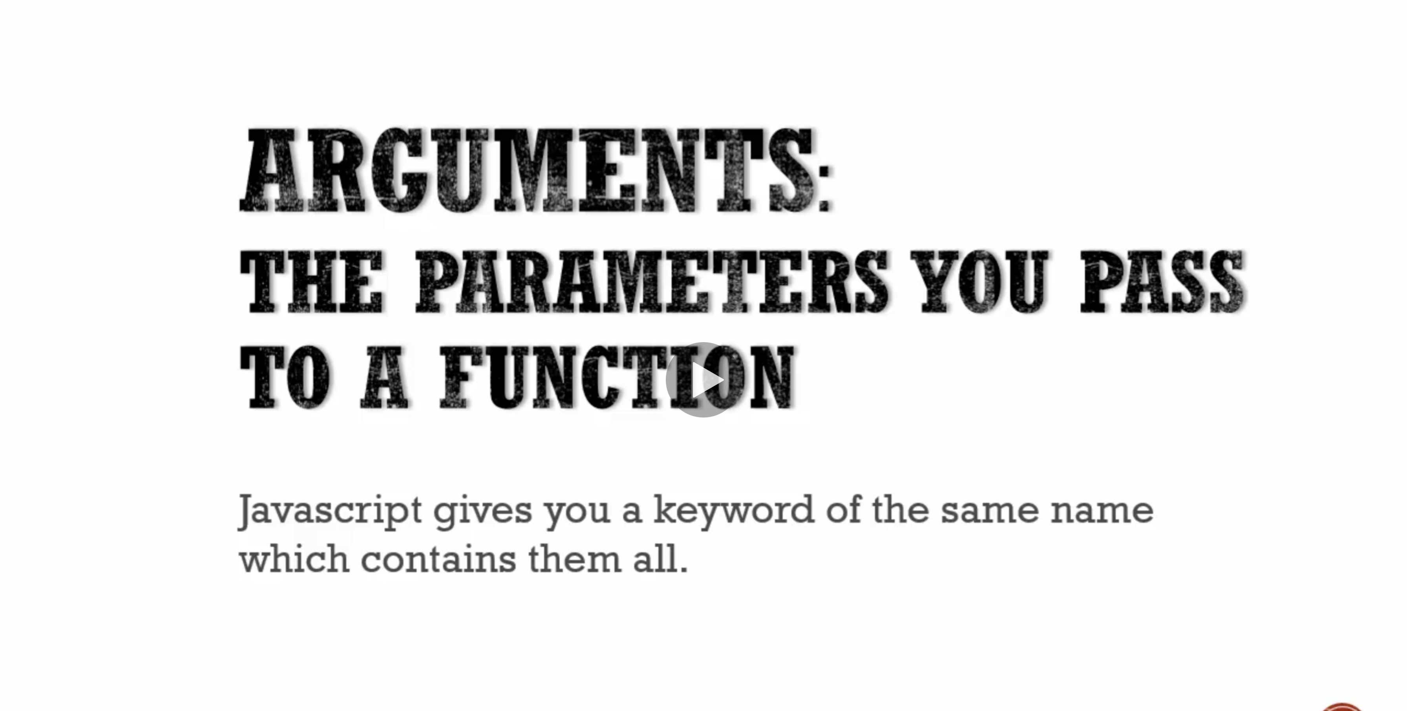

.

Eg1:

function **greet**(firstname, lastname, lang) {

console.**log**(firstname);

console.**log**(lastname);

console.**log**(lang);

console.**log**("-------------------------");

}

**greet**();

**greet**('Amir'); *// arg is assigned from left to right order*

**greet**('Amir', 'Mustafa');

**greet**('Amir', 'Mustafa', 'en');

In ES6 = we can assign default val here

function **greet**(firstname, lastname, lang = “en”) {}

In ES5:

function **greet**(firstname, lastname, lang = “en”) {

lang = lang || “en”

}

NOTE: Special parameter called **arguments** contains **all the values passed.**

function **greet**(firstname, lastname, lang) {

lang = lang || "en";

console.**log**(firstname);

console.**log**(lastname);

console.**log**(lang);

console.**log**(arguments); *// special parameter by JS which contains all passed parameter*

console.**log**("-------------------------");

}

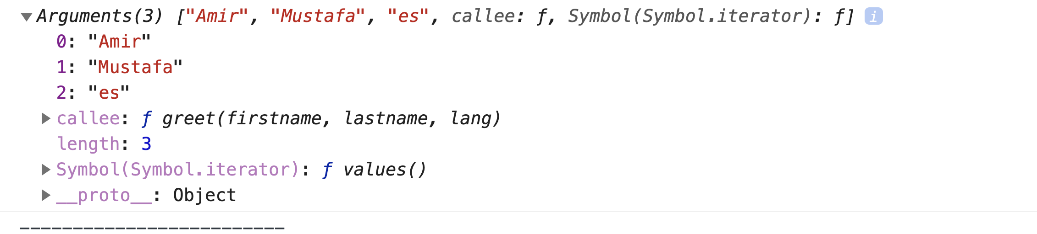.

Note this is not array, but array like. It gives enough facilities to work like array.

Eg

function **greet**(firstname, lastname, lang) {

if(arguments.length === 0){

console.**log**('Missing parameters!');

return;

}

console.**log**(firstname);

console.**log**(arguments); *// special parameter by JS which contains all passed parameter*

}

greet(); // Missing parameters!

console.**log**(arguments[0]); *// 1st value of parameters*

Eg With Spread operator

*function* ***greet****(firstname, lastname, ...others) { // Spread concept*

console.**log**(firstname);

console.**log**('Others = ', others);

}

*// firstname, lastname will be stored in their variable, others will have stacked in array*

**greet**('Amir', 'Mustafa', 'es', 1, 2, 3, 4, 5);

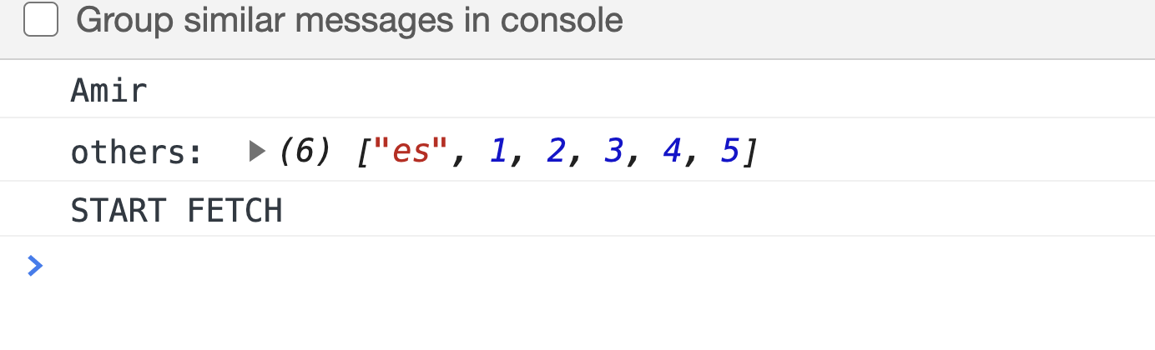.

34. Framework Aside – Function Overloading

Function Overloading: Calling same function/method with different parameters1

i.e. with different parameter function behaves differently

Function Overriding: Calling same function in child class with same number of argument.

--> JavaScript does not support Overloading because of its hoisting feature and also as functions are objects.

--> This can be achieved, as functions are first-class objects. We make use of JS default feature.

Eg.

function **greet**(fname, lname, lang) {

lang = lang || 'en';

if(lang === 'en'){

console.**log**("Hello " + fname + ' ' + lname);

}

if(lang === 'es'){

console.**log**("Hola " + fname + ' ' + lname);

}

}

function **greetEnglish**(fname, lname) {

**greet**(fname, lname, 'en');

}

function **greetSpanish**(fname, lname) {

**greet**(fname, lname, 'es');

}

**greetSpanish**("Amir", "Mustafa");

**greetEnglish**("Amir", "Mustafa");

35. Syntax Parser:

--> The code you write is **not directly run** on your computer

--> There is **intermediate program between your code and computer** that **translate** your code into which computer can understand.

--> **JS engine** in your browser has this, whose **one of the element is Syntax Parser**

--> Syntax Parser runs the **code character by character** using **valid sets of rules** and anticipate valid characters.

--> All the above happens before your code is executed. Your code can changed by syntax parser.

________________________________________________________________________________

36. Dangerous Aside: Automatic Semicolon

--> Syntax parser guesses the syntax

for eg when you write **return** (hit enter), it automatically injects ; in the end before executing.

Rule1: Always put your own ; (specially in case of return)

Eg1:

function **getPerson**() {

return // treats like return;

{

firstname: "Amir"

}

}

console.**log**(**getPerson**()); *// return undefined - Syntax persor puts after return key i.e. return;*

O/p: undefined

Eg2:

function **getPerson**() {

return {

firstname: "Amir"

}

}

console.**log**(**getPerson**()); *// works – we get object*

*As syntax parser reads line by line after enter it puts auto semicolon there*

TRICK:

Always put function, if , loops starting bracket in same line

_______________________________________________________________________

37. Whitespace

JavaScript is very libral when comes to white space. Use how much you want

eg:

var

*// firstname of the object*

firstname,

*// lastname of the object*

lastname,

*// language of the object*

lang;

var person = {

*// firstname of the object literal*

firstname: "Amir",

*// lastname of the object literal*

lastname: "Mustafa"

}

console.**log**(person.lastname);

Syntax Parser ignored all the whitespace and comments

Rule: Make your code readable, comment whereever necessary

37. Immediately Invoked Function Expression (IIFE)

*// IIFE*

var **greeting** = function(name) {

return 'Hello ' + name;

}('Amir');

console.**log**(greeting);

*// Regular Function Expression*

var **greeting** = function(name) {

return 'Hello ' + name;

}

console.**log**(**greeting**('Amir'));

Eg2:

'I am a string'; *// Passes without Error*

3; *// Passes without Error*

*//function statement cannot be written anonyomusly – Throws Error*

function (name) {

console.**log**( "Hello " + name );

}

*// Solutions: Grouping like (3*2)+1*

*// Grouping operator has always expressions and not statements*

(function (name) {

console.**log**( "Hello " + name );

})();

(function (name) {

console.**log**( "Hello " + name );

}());

38. IIFE and why it is useful

--> Suppose there is a variable defined before IIFE. Both are defined in different execution context. Hence no override.

Eg.

greet.js

var greet = "Hola ";

index.html

<script *src* = "greet.js"></script>

<script *src*="app.js"></script>

app.js

*// IIFE*

(function(name) {

var greet = "Hello ";

console.**log**(greet + name); // function’s execution context

}('Amir'));

console.**log**(greet); // outside will pick from global Execution context

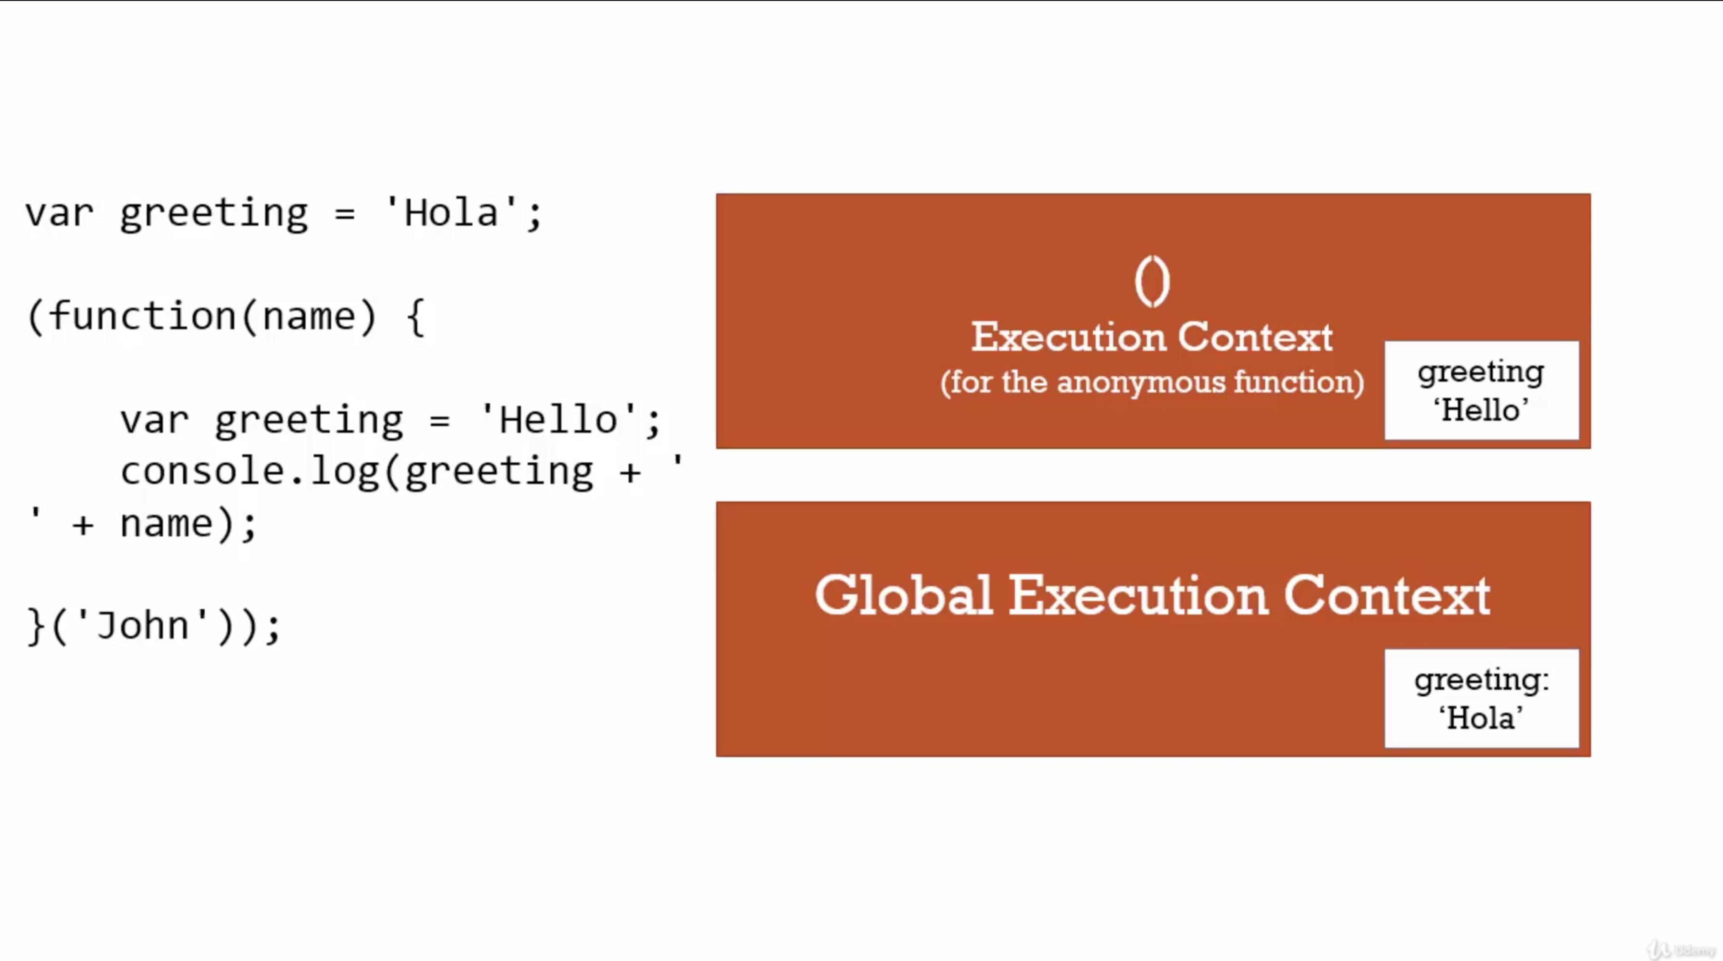.

NOTE:

1. Most of important framework starts with (function(){ //code }())

2. So accidently you cannot override global variable.

3. if puposely you want to override global variable:

// IIFE

(function(global, name) {

global.greet = "Hello ";

console.**log**(greet + name);

}(window, 'Amir'));

console.**log**(greet);

O/p

Hello Amir

Hello // this time we have overrided global variable from Hola to Hello

39. Closures:

Eg1

function **greet**(whattosay) {

return function(data) {

console.**log**(whattosay + ' ' + data);

}

}

**greet**('Hola')('Amir'); *// Way 1*

var sayHi = **greet**('Hola');

**sayHi**('Amir'); *// Way 2 - Its stills work*

--> Way 1 works

--> Way 2 should not have worked as execution context of greet() is deleted. The reason it works because, though execution context is deleted, memory is not. When SayHi() is created a new execution context is created which points to the outer variables through Scope chain.

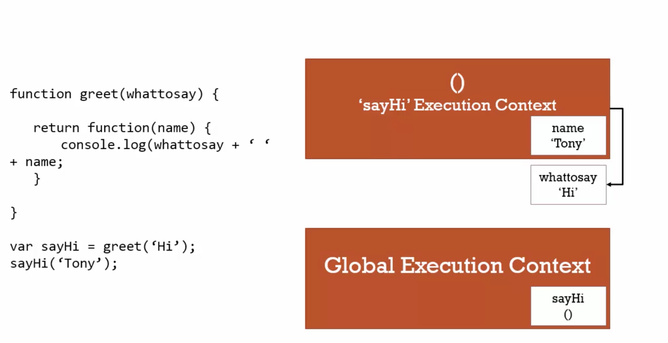.

--> **Closure** is a **feature of JS**. When a function is invoked in function. The inner function has reference/access to variables (memory) of outer variables even though it’s execution syntax is removed.

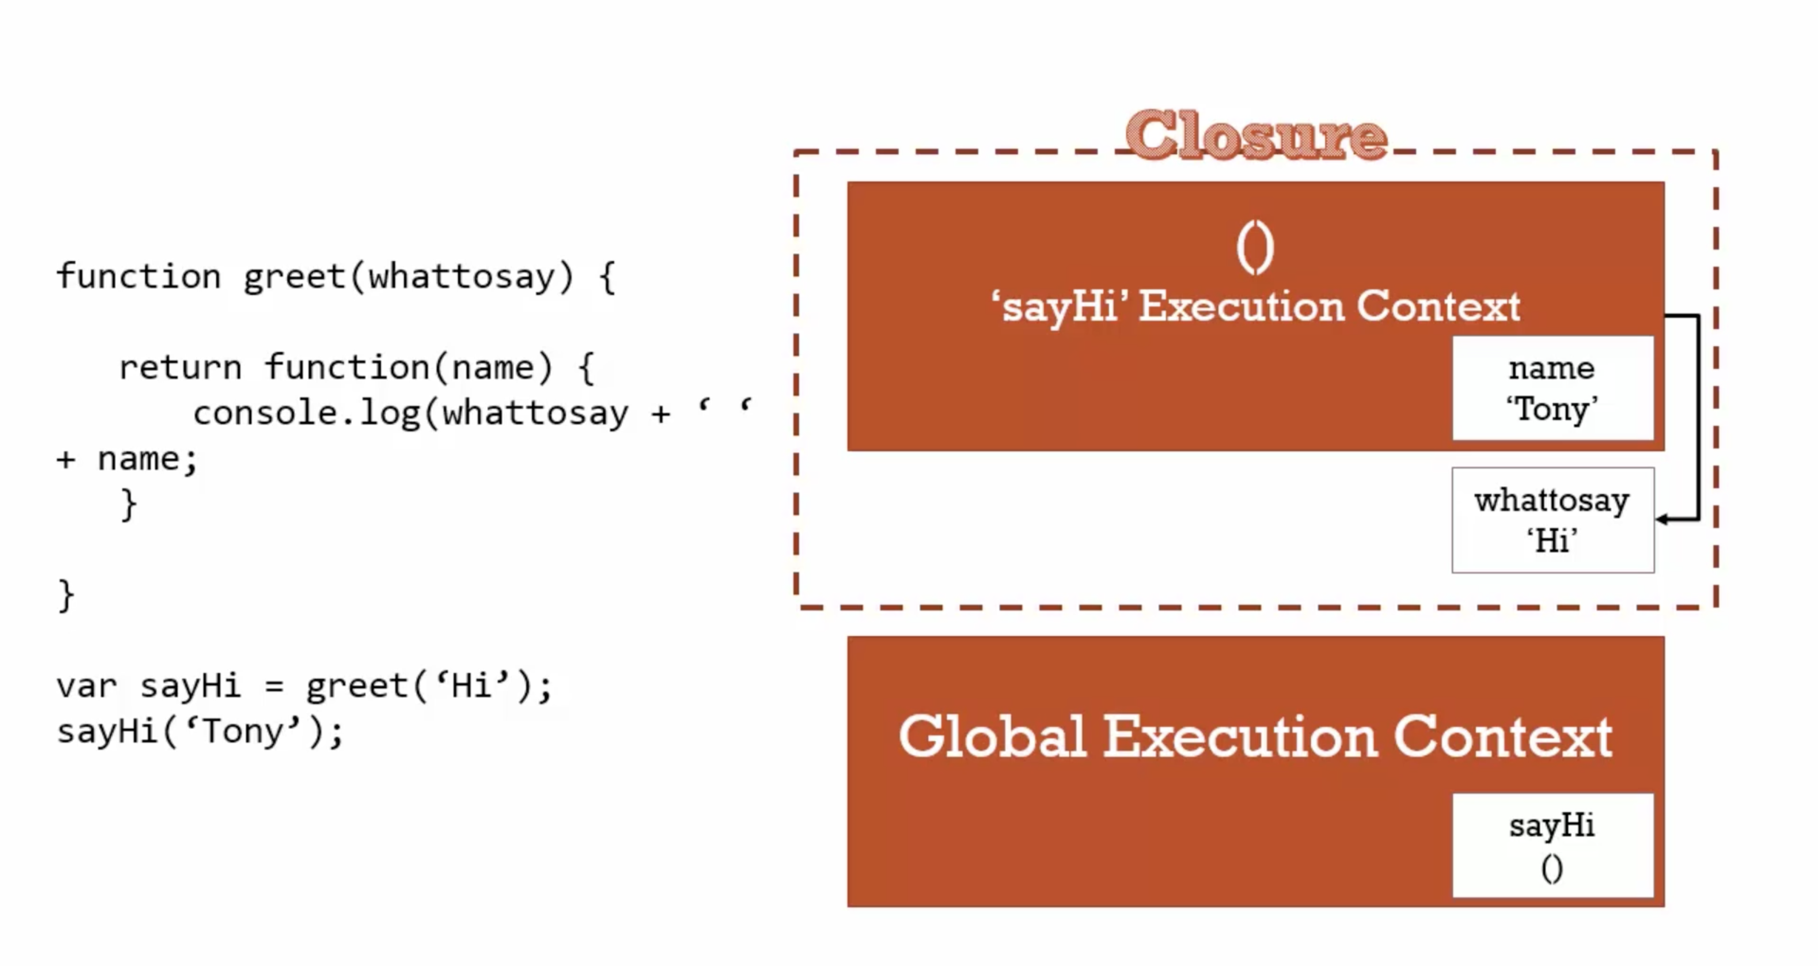--> So variable in inner function has access to outer function variables.

--> It doesn't matter whether outer function is finished running or not.

--> JS engine creates closure. We just take advantage of it.

Eg2:

function **buildFunction**() {

var arr = [];

for(var i=0; i<3; i++) {

arr.**push**(function() {

console.**log**(i);

});

}

return arr;

}

*// Function might be created earlier, but it is executed now - all three points to latest value of i in memory – latest in memory is i=3*

var fs = **buildFunction**();

fs[0](); // 3

fs[1](); // 3

fs[2](); // 3

--> Normally people will think o/p is 1, 2, 3

LOGIC – Though function is created earlier. It is executed later. So latest value of i in memory at the time of invoke is 3

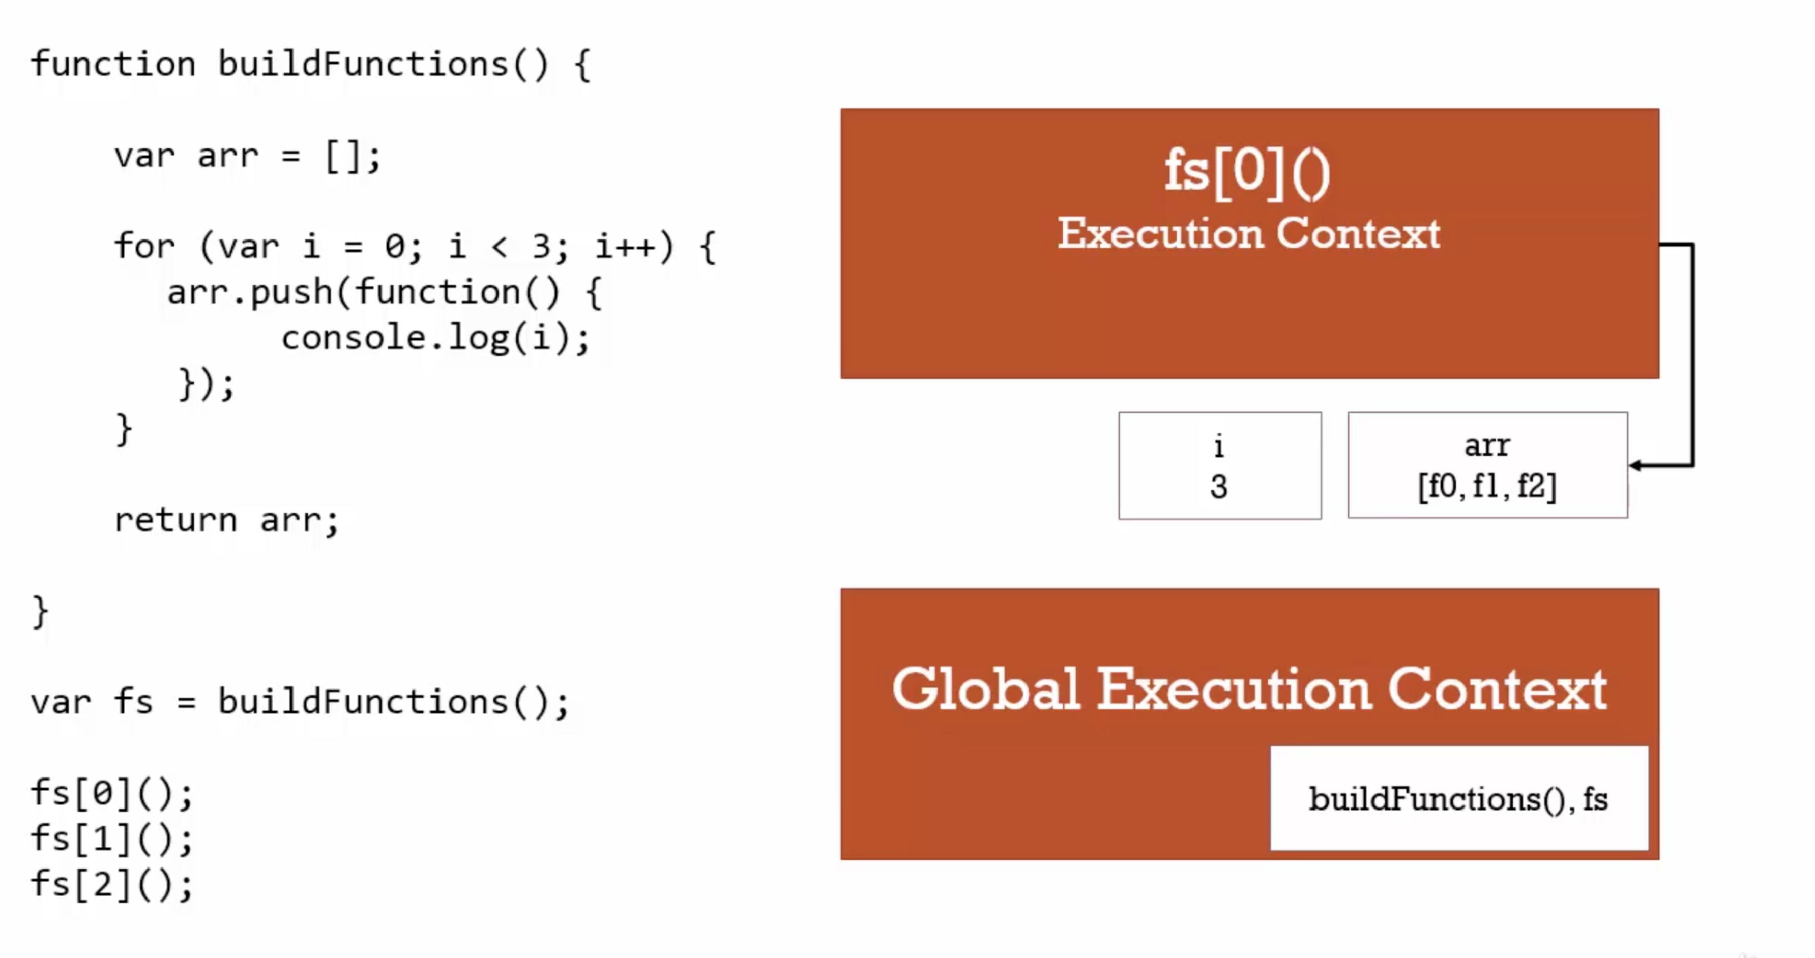.

--> When value stored in memory in execution context when loop runs.

--> So latest value of i in memory is 3. When function execution finishes, execution context is removed but memory remains and because js closure variable data is accessible at the time of invoking them (all three).

Eg3:

function **buildFunction**() {

var arr = [];

for(let i=0; i<3; i++) { // let is block scoped in memory – hence new address – 0,1,2

arr.**push**(function() {

console.**log**(i);

});

}

return arr;

}

var fs = **buildFunction**();

fs[0](); // 0

fs[1](); // 1

fs[2](); // 2

TRICK: When we use

a. let we get o/p – 1, 2, 3

b. var --------- - 3, 3, 3

--> So closures is nothing but inner function has access to outer function’s variables or free variables (like eg arr=[];)

Eg4: If we want to achieve same with ES5 – IIFE

function **buildFunction**() {

var arr = [];

for(var i=0; i<3; i++) {

arr.**push**(

(function(j) { // We will return a function inside IIFE

return function () {

console.**log**(j);

}

}(i))

);

}

return arr;

}

*// Function might be created earlier, but it is executed now - all three points to latest value of i in memory*

var fs = **buildFunction**();

fs[0]();

fs[1]();

fs[2]();

Function Factories:

--> A function which manages multiple functions

Eg 1.

function **makeGreet**(lang) {

return function (firstname, lastname){ *// lang is accessible here because of closures*

if(lang === 'en') {

console.**log**('Hello ' + firstname + ' ' + lastname);

}

if(lang === 'es') {

console.**log**('Hola ' + firstname + ' ' + lastname);

}

}

}

var greetEnglish = **makeGreet**('en');

var greetSpanish = **makeGreet**('es');

**greetEnglish**('Amir', 'Mustafa'); // every function call creates its execution context

**greetSpanish**('Nasir', 'Mustafa');

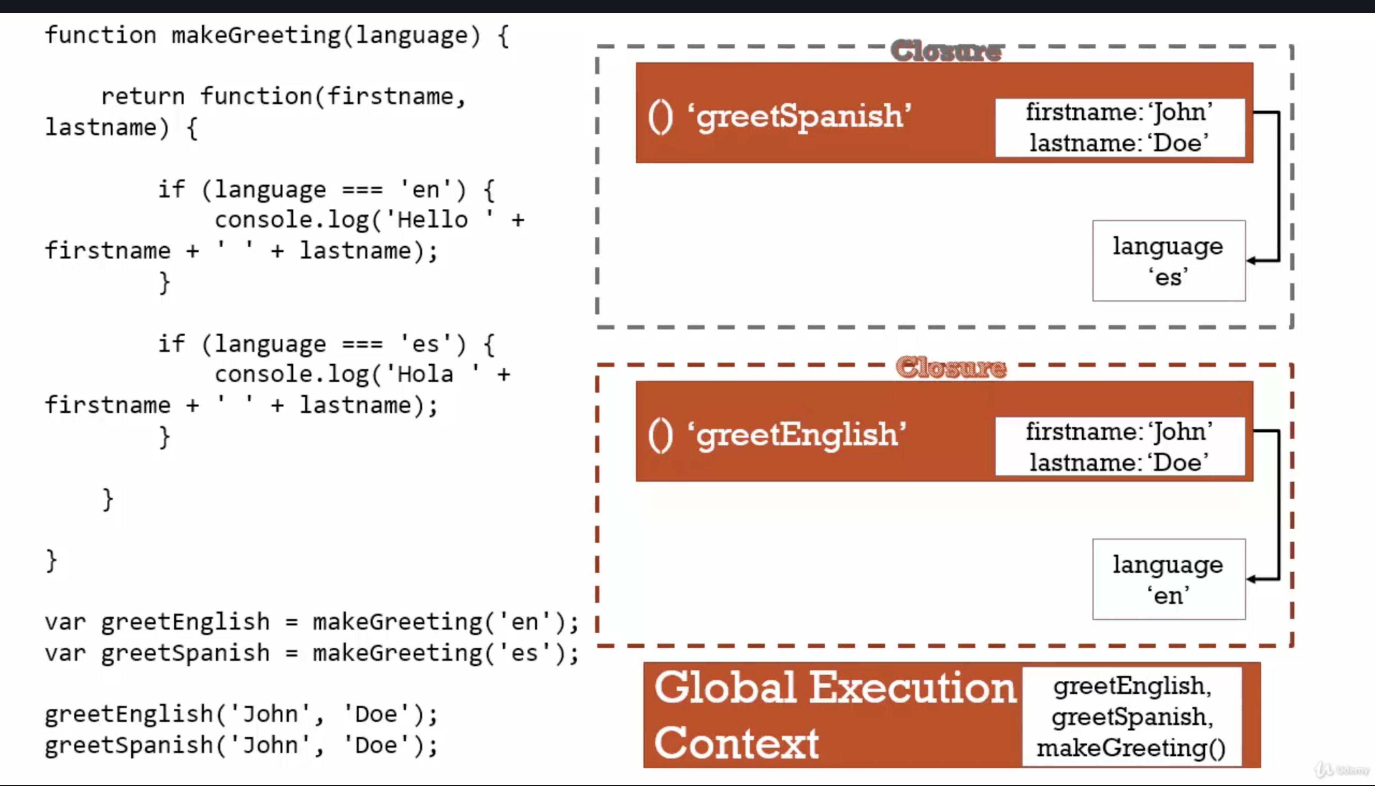.

Eg2:Async calls - setTimeout

function **sayHiLater**(name) {

var greeting = 'Hi!';

**setTimeout**(function (){

console.**log**(greeting + ' ' + name); *// name is accessed through closures*

}, 3000);

}

**sayHiLater**('John');

Eg3: jQuery

**$**('#id').**click**(function() { *// closures - function inside a function*

*// Do something*

});

So highlighted portion is called callback function

Big Word Alert:

Callback Function:

--> A function you give to another function, to be run when another function is finished

--> So after main function is executed --> it calls the function you gave.

Eg.

function **tellMeWhenDone**(callback) {

var a = 1000;

var b = 2000; *// Some work*

console.**log**('Main function executed...')

**callback**();

}

**tellMeWhenDone**(function() { // Callback function is always passed as args

console.**log**('callback executed...');

});

O/P:

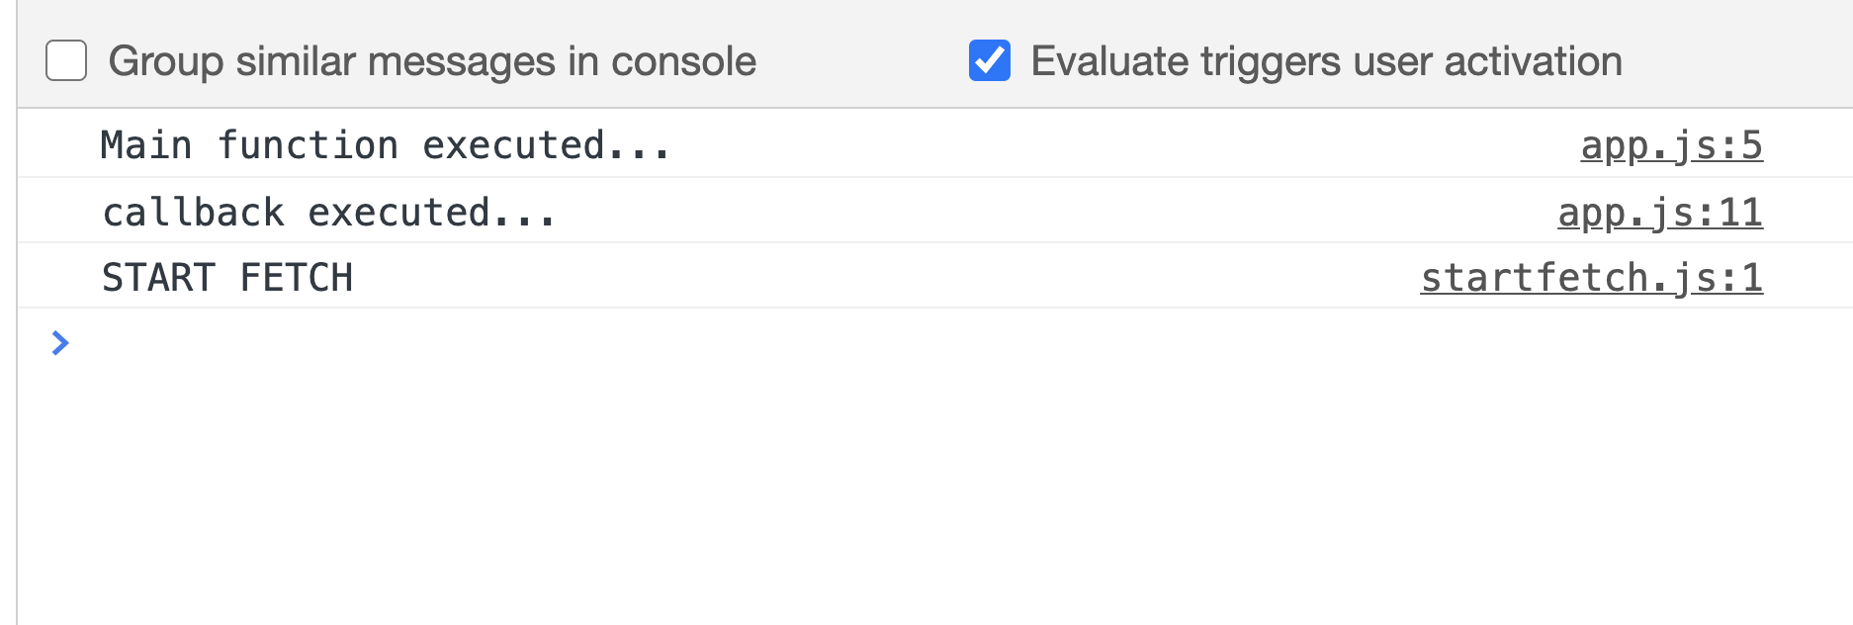.

40 call, bind and apply:

--> We know this object points differently in different situation.

--> For methods inside objects literal, it points to object otherwise global variable.

--> For changing this object pointing we use all three

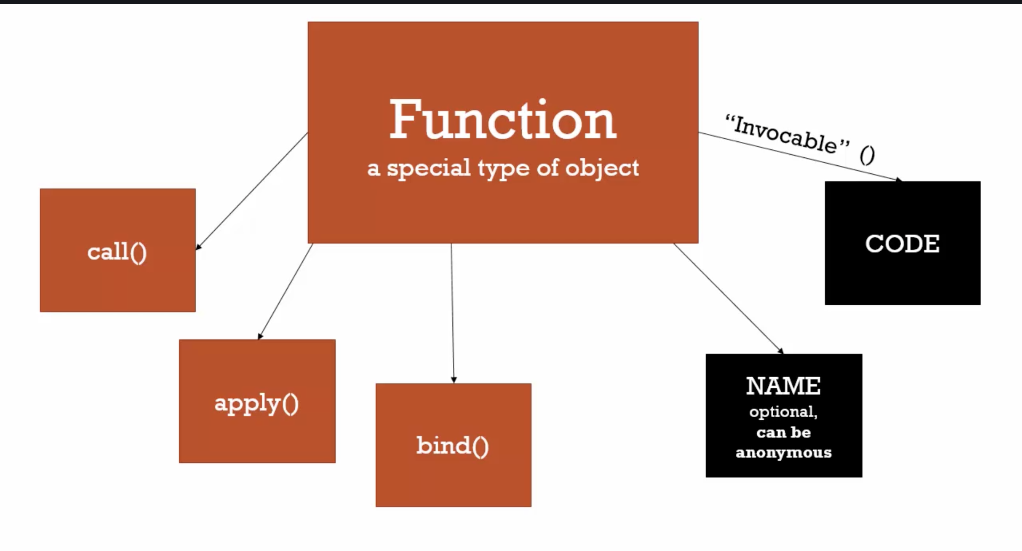.

Eg1

var person = {

firstname: "Amir",

lastname: "Mustafa",

**getFullname**: function() {

var fullname = this.firstname + ' ' + this.lastname;

return fullname;

}

}

function **someFunction**(lang1, lang2) { *// Some other function wants to use getFullname*

console.**log**(this);

console.**log**('Logged in: ', this.**getFullname**());

}

*// someFunction(); // this object will point to global variables – hence error*

*// So Binding made this object point to the person object instead of global object*

var someFunctionCopy = **someFunction**.**bind**(person);

**someFunctionCopy**(); *// this will point to person object*

// or var someFunction = someFunction.bind(person);

Eg2

var person = {

firstname: "Amir",

lastname: "Mustafa",

**getFullname**: function() {

var fullname = this.firstname + ' ' + this.lastname;

return fullname;

}

}

function **someFunction**(lang1, lang2) { *// Some other function wants to use getFullname*

console.**log**(this);

console.**log**('Logged in: ', this.**getFullname**());

console.**log**('Arguments: ' + lang1 + ' ' + lang2);

console.**log**('-------------------');

}

var someFunction = **someFunction**.**bind**(person); *// copies with new this point*

**someFunction**('en', 'es'); *// calls later*

**someFunction**.**call**(person, 'en', 'es'); *// copies + calls in the same time*

**someFunction**.**apply**(person, ['en', 'es']); *// copies + calls but expects passed in array and not strings*

TRICK:

1. Bind – it makes copy of function pointing **this** to object literal. Calling/Invoke can be done in future

2. Call – same as bind + invoke at the same time + passed as comma arguments

3. Apply - same as bind + invoke at the same time + passed in an array. (helpful in some maths stuff)

**someFunction() same as someFunction.call(), someFunction.bind() // All three invoking**

Eg2: Real life eg – borrowing a function (person2 has borrowed method from person)

var person = {

firstname: "Amir",

lastname: "Mustafa",

**getFullname**: function() {

var fullname = this.firstname + ' ' + this.lastname;

return fullname;

}

}

*// Real Life eg - Borrowing a function*

var person2 = {

firstname: "Hrithik",

lastname: "Roshan"

}

console.**log**(person.**getFullname**.**call**(person2)); *// o/p Hrithik Roshan*

Eg3: Currying function – here this is pointing to global only, passing some default para. Permanent copy making certain parameter default

function **multiply**(a, b) {

return a * b;

}

*// inner parameter is priority 1*

var multiplyByTwo = **multiply**.**bind**(this, 2); *// setting a = 2, this will point to windows only*

*var multiplyByThree =* ***multiply****.****bind****(this, 3); // setting a = 3, this will point to windows only*

*// var multiplyByTwo = multiply.bind(this, 2, 3); // setting a = 2,b = 3 this will point to windows only - o/p: 6*

console.**log**(**multiplyByTwo**(10, 12));

Function Currying:

Creating a copy of a function but with some preset parameters.

Very useful in mathematical situations

Trick: Bind can be used in two ways:

a. setting/sending default values in a functions

b. pointing this to a specific function or objects

41 Functional programming

// multiple by 2

var arr1 = [1,2,3];

var arr2 = [];

for(var i=0; i< arr1.length; i++) {

arr2.**push**(arr1[i] * 2);

}

console.**log**(arr2);

--> One great feature of functional programming is that instead of writing code again and again. We write code the code in a function and reuse.

--> This is not possible in other programming languages where functions are not first class

function **mapForEach**(arr, fn) {

var newArr = [];

for(var i=0; i< arr.length; i++) {

newArr.**push**(

**fn**(arr[i])

);

}

return newArr;

}

var arr1 = [1,2,3]; *// original array*

var newArr = **mapForEach**(arr1, function(item) {

return item * 3; *// we can change multiply at the time of calling*

});

console.**log**(newArr); *// final array - three times the original*

var newArr2 = **mapForEach**(arr1, function(item) {

return item > 2;

});

console.**log**(newArr2);

Eg2: If instead of passing hardcoded item > 2, we can pass dynamically

function **mapForEach**(arr, fn) {

var newArr = [];

for(var i=0; i< arr.length; i++) {

newArr.**push**(

**fn**(arr[i])

);

}

return newArr;

}

var arr1 = [1,2,3];

var **checkLimit** = function(limiter, item) { *// If we want to pass variable instead of hardcoded*

return item > limiter;

}

var arr = **mapForEach**(arr1, **checkLimit**.**bind**(this, 1)); *// we have passed default limiter = 1, using bind*

console.**log**(arr); *// checking item > 1*

Trick: Bind can be used in two ways:

a. setting/sending default values in a function

b. pointing this to a specific function or objects

Eg 3.

function **mapForEach**(arr, fn) {

var newArr = [];

for(var i=0; i< arr.length; i++) {

newArr.**push**(

**fn**(arr[i])

);

}

return newArr;

}

var arr1 = [1,2,3];

var **checkSimplified** = function(limiter) {

return function(limiter, item) { *// If we want to pass variable instead of hardcoded*

return item > limiter;

}.**bind**(this, limiter)

}

var arr = **mapForEach**(arr1, **checkSimplified**(2)); *// we have passed default limiter = 1, using bind*

console.**log**(arr); *// checking item > 1*

TRICK:

a. Pass function as an arguments.

b. Split functions in to multiple functions to write cleaner code.

NOTE: Never try to mutate original data. Try to create a new and return

Underscore JS – Observe the code of this library (Also Lodash)

Ref - <https://underscorejs.org/docs/underscore-esm.html>

Eg.

Add library in index.html file

var arr1 = [1,2,3];

var arr2 = _.**map**(arr1, function (item) { return item * 3 });

console.**log**(arr2); // this will give thrice first array

var arr3 = _.**filter**([2,3,4,5,6,7], function(item) { return item = item%2 === 0 });

console.**log**(arr3); // [2, 4, 6]

_______________________________________________________________________________________________

42. Object Oriented JavaScript and Protypal Inheritance

Inheritance – One object gets access to the properties and methods of another objects

There are two types of inheritance:

a. Classical Inheritance: (Used in Most programming language)

This is the standard type of inheritance used in most famous technology like – Java, PHP, etc.

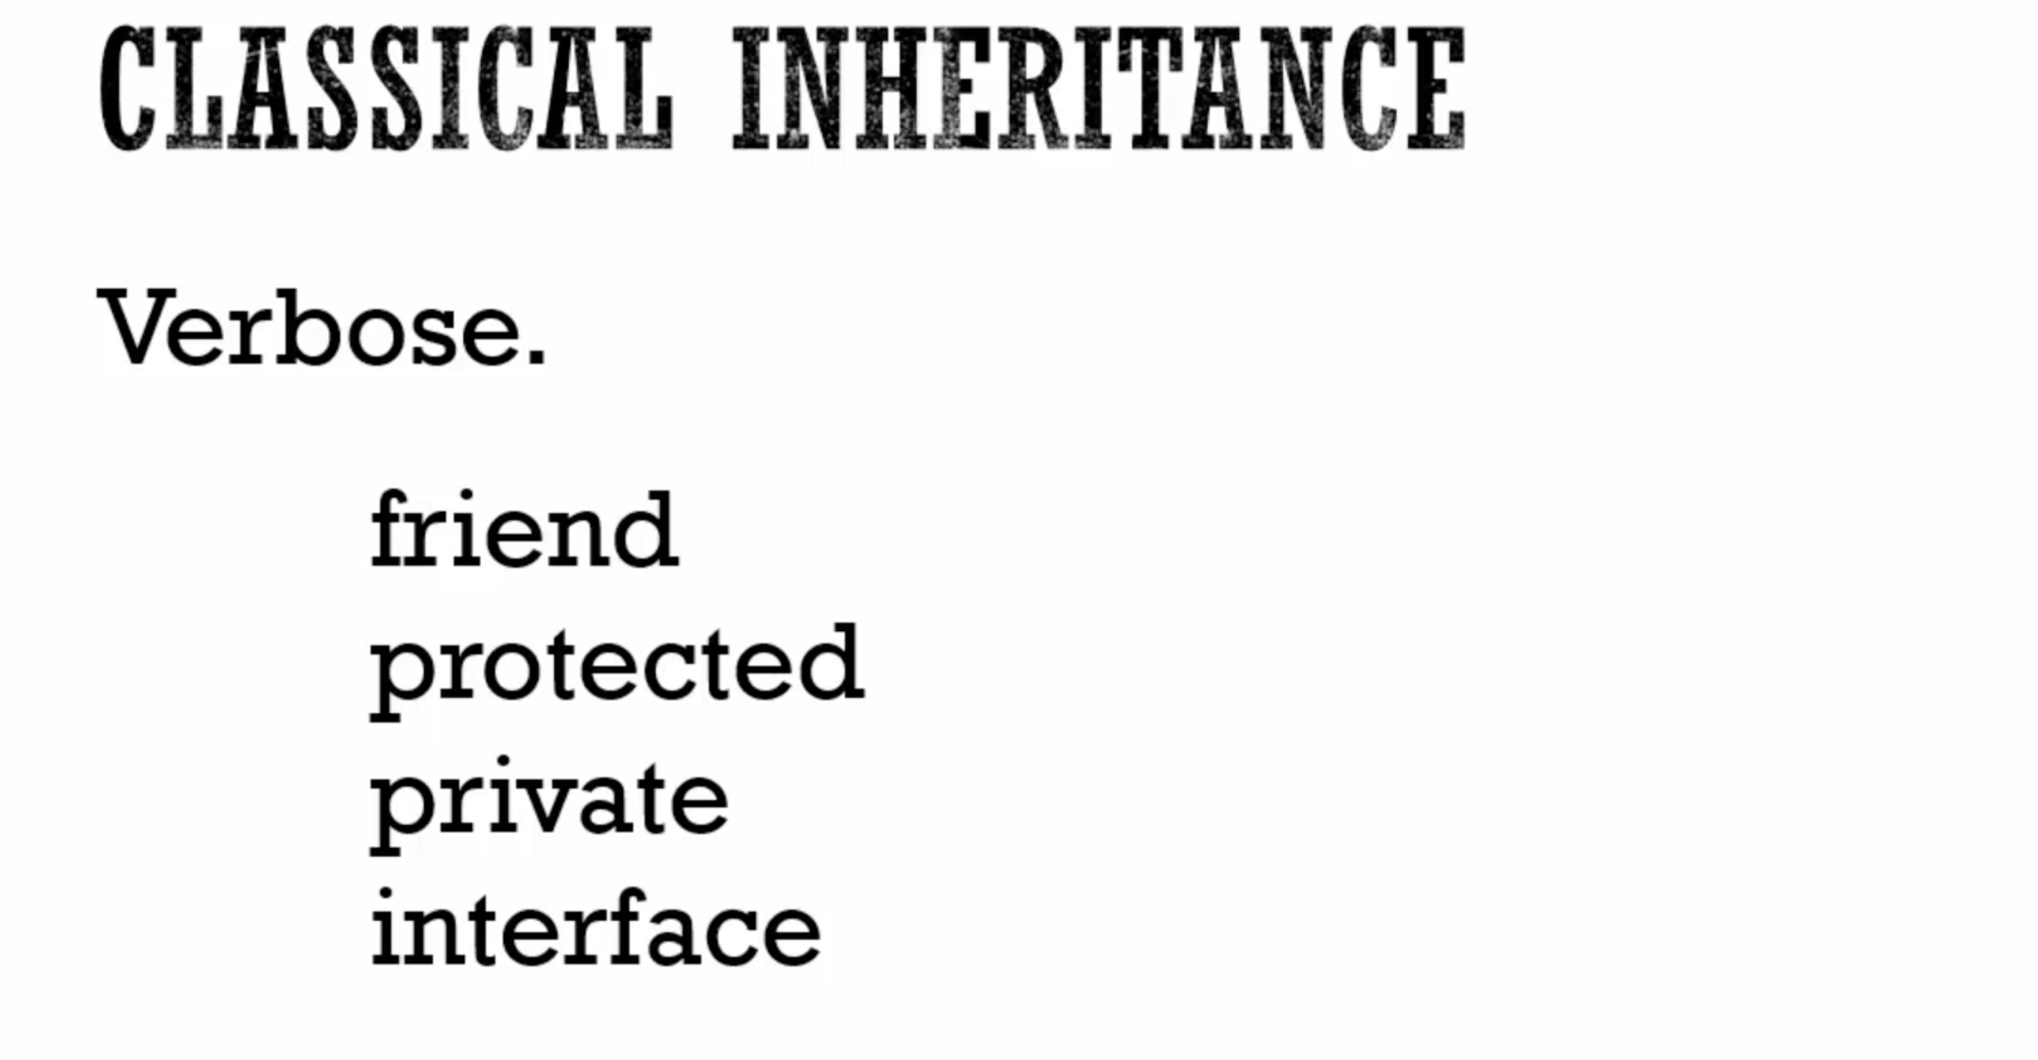

b. Protypal Method:

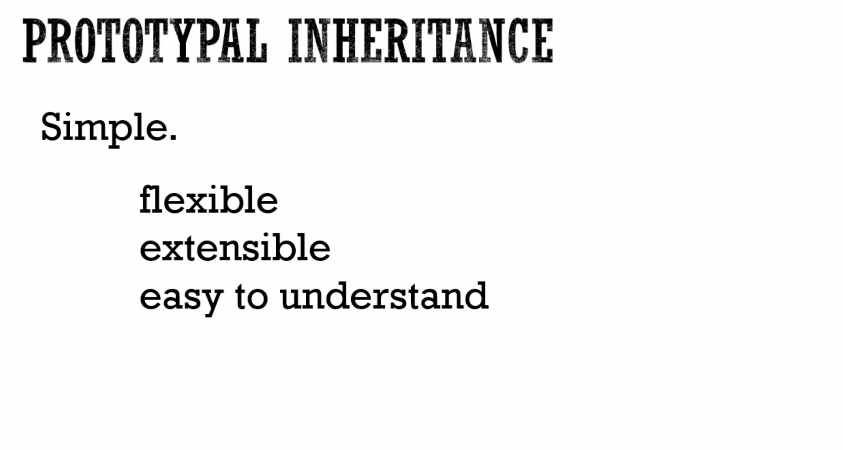43. Understanding the Prototype:

--> Every javascript object has property and proto

--> If some object property is searched and is not found in object, JS searches for it in prototype.

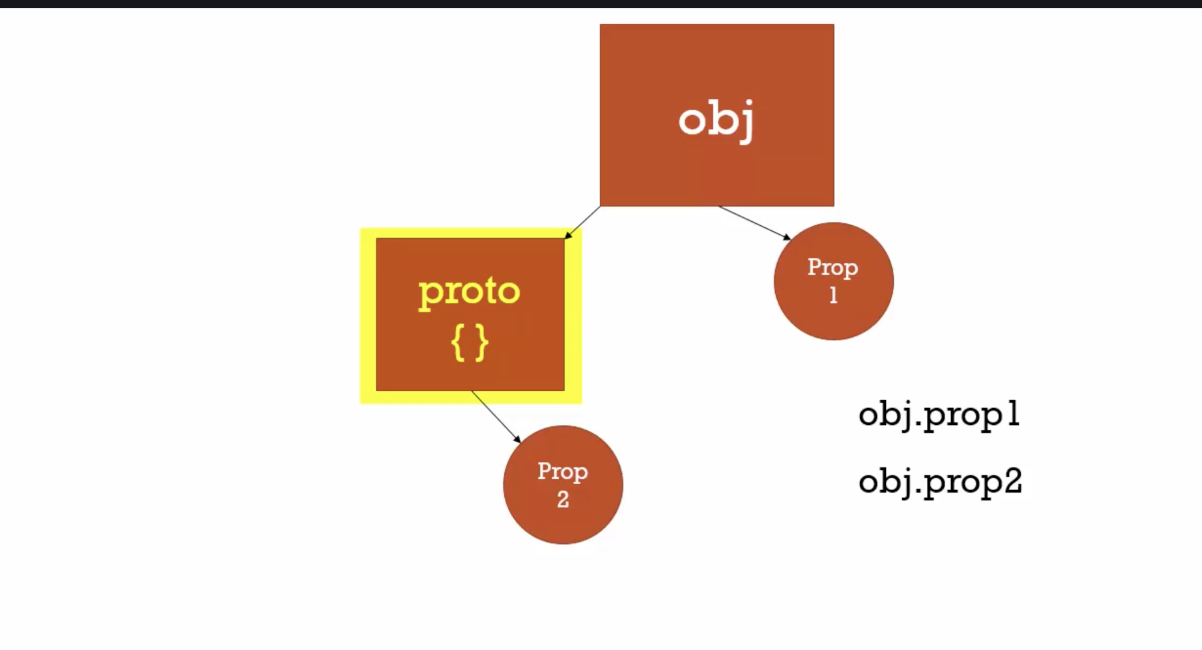

--> Likewise on proto can has its own proto. If property is not found in proto, it is searched in proto’s inner proto and so on.. This searching inside the proto is called **prototype chain**

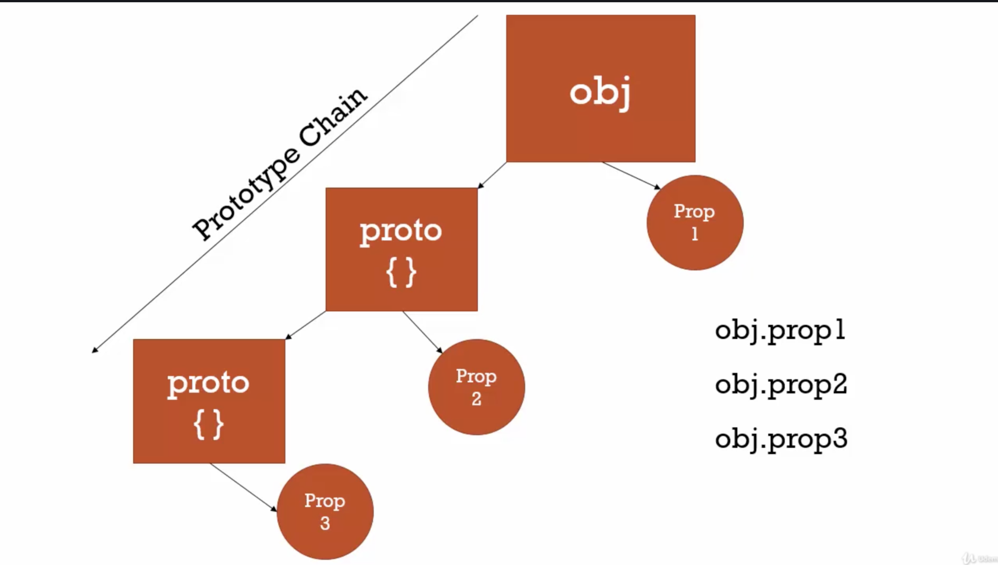.

So prototype chain has to do with properties and methods amongst sequence of objects which are connected via prototype property called proto

--> Also we do not have to write obj.proto.prop2, just writing obj.prop2 is enough, javascript engine does it for us.

--> If there will be other object (say obj2), it will also reference to the same prototype. So **obj2.prop2 = obj.prop2.**

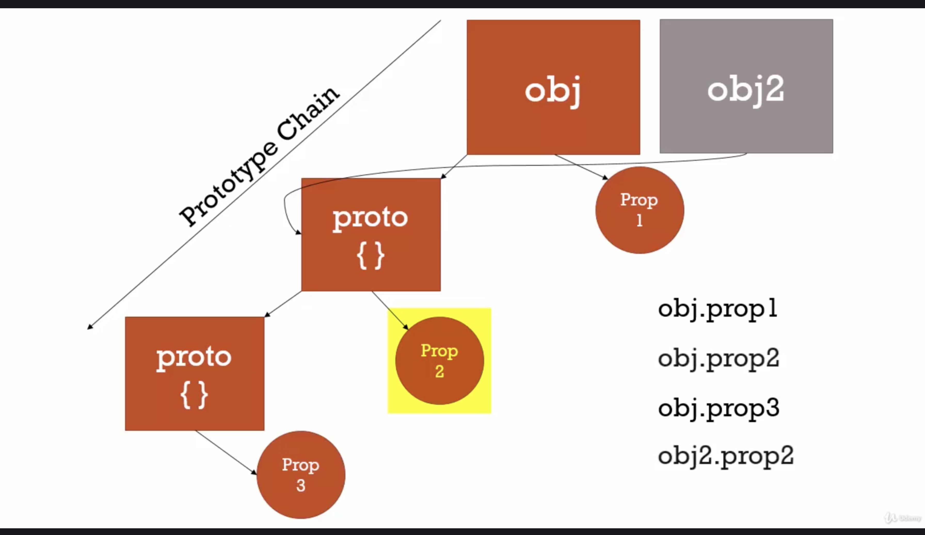.

Eg.

var person = { *// obj1*

firstname: "Default",

lastname: "Default",

age: 27,

**getFullName**: function() {

return this.firstname + " " + this.lastname

}

};

var ana = { *// obj2*

firstname: "Anastesia",

lastname: "Kalaskova"

};

// Do not try below method for assigining prototype, just for demo purpose

ana.__proto__ = person; *// obj2 prototype is set to obj1*

console.**log**(ana.**getFullName**());

console.**log**(ana.firstname); *// Anastesia // first searched john object, then its prototype*

console.**log**(ana.age); *// 27 // first searched john object, then its prototype*

jane = { *// obj3*

firstname: "Jane"

};

jane.__proto__ = person; *// obj3 prototype is set to obj1*

console.**log**(jane.**getFullName**()); *// Jane Default*

Explaination

--> if parent object has that property or methods, it will pick from there otherwise from its assigned prototype

ana.__proto__ = person; // ana = parent obj, person = it’s prototype object

Everything is an object (or a primitive)

Eg2:

var a = {};

var **b** = function() { };

var c = [];

console.**log**(a.__proto__); // base object

console.**log**(**b**.__proto__); // base function – Empty() - has call(), bind(), apply() etc.

console.**log**(c.__proto__); // base object

// Empty object

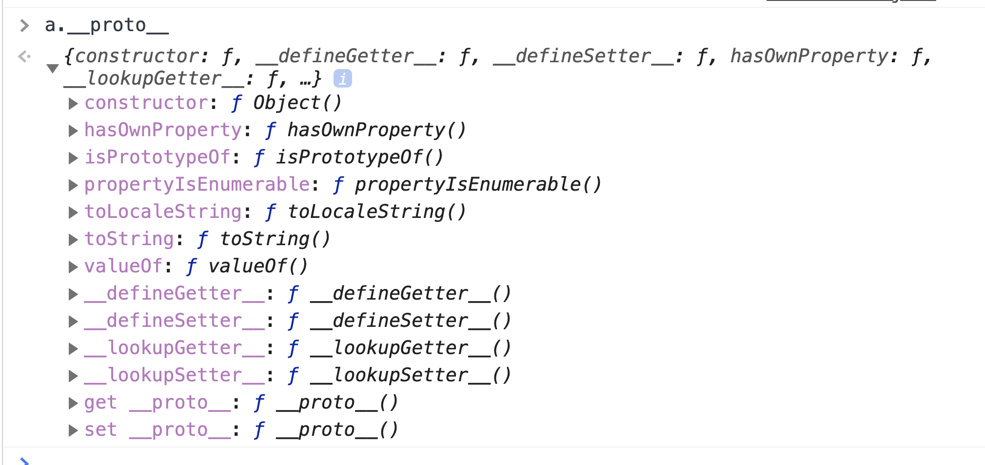.

// Empty Array

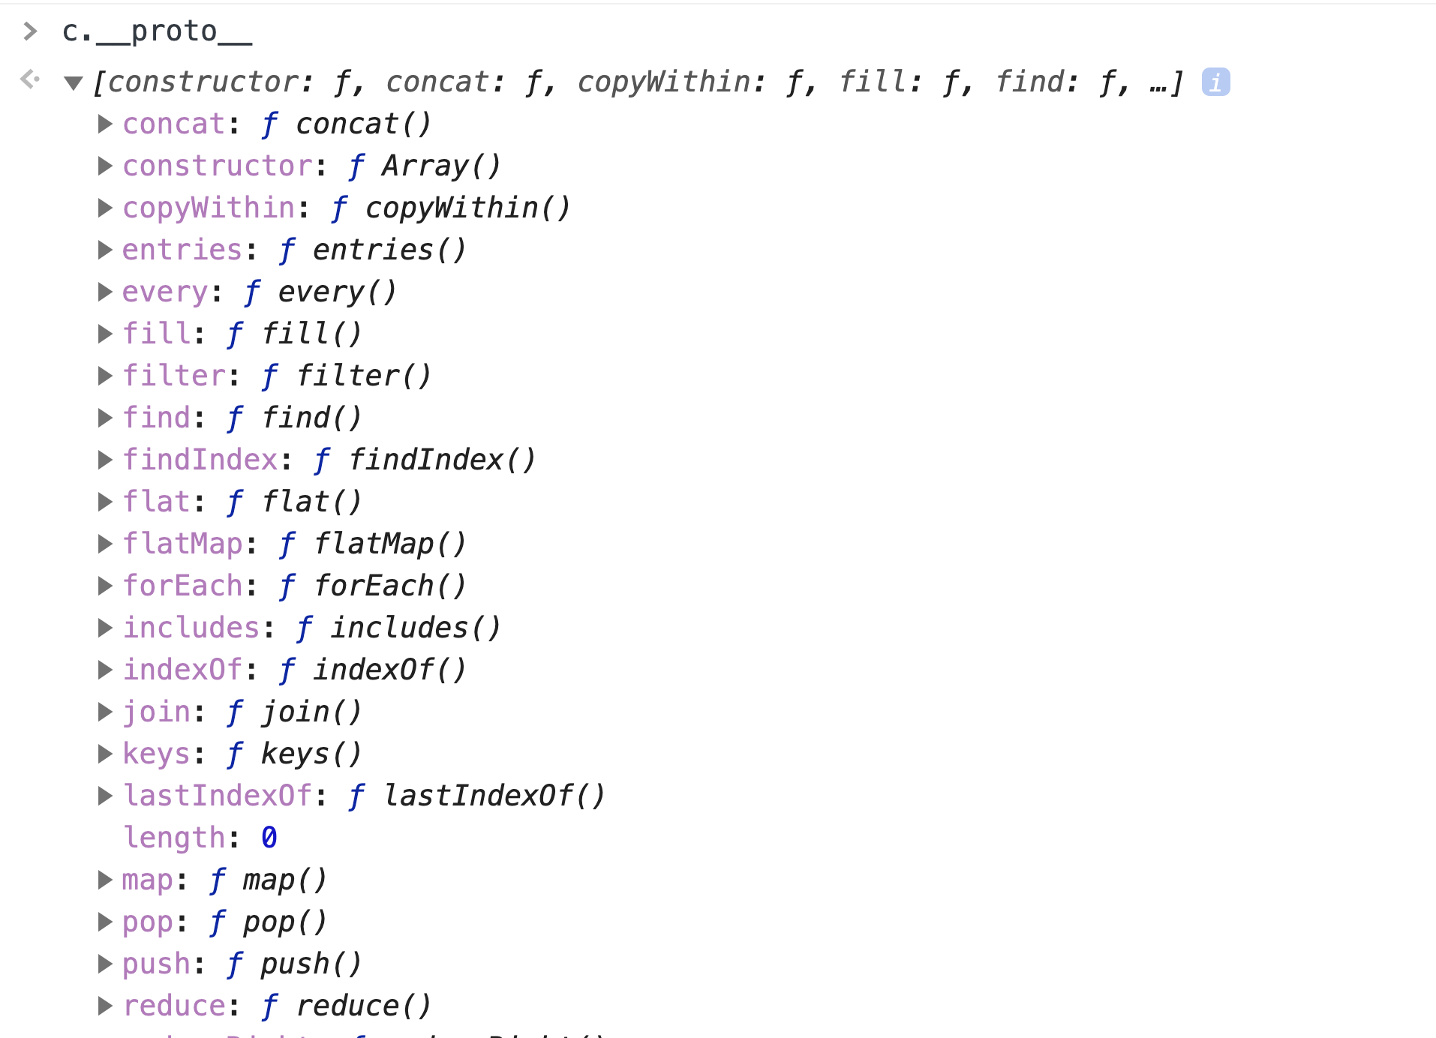.

prototype of prototype – object for all three – array, objects and function

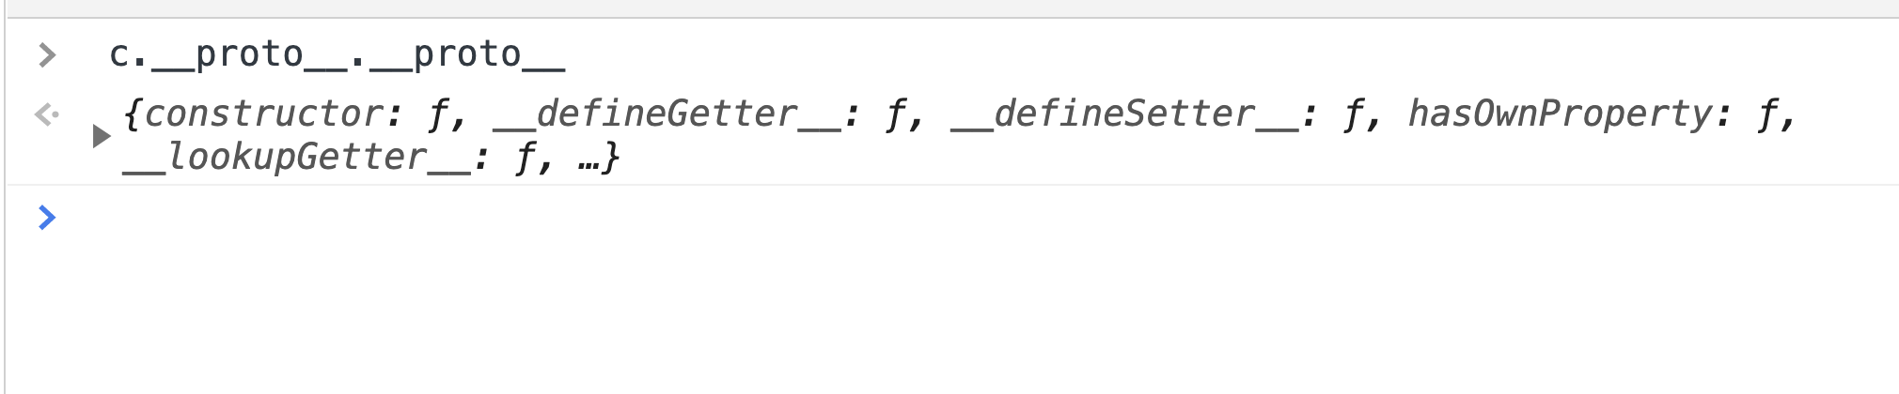.

44. Reflection and Extension:

Reflection: An object can look at itself, listing and changing its properties and methods.

var person = {

firstname: "Default",

lastname: "Default",

age: 27,

**getFullName**: function() {

return this.firstname + " " + this.lastname

}

};

var john = {

firstname: "Anastesia",

lastname: "Kalaskova"

};

john.__proto__ = person;

for(var prop in john) {

console.**log**(prop + ': ' + person[prop]); *// all properties - john + it's prototype properties*

}

for(var prop in john) {

if(john.**hasOwnProperty**(prop)) { *// this ensures property is in john and not prototype*

console.**log**(prop + ': ' + person[prop]);

}

}

So with hasOwnProperty – we are reflecting the object john

Eg2:

var jane = {

address: "Hutton Road",

**getFormalFullName**: function() {

return this.lastname + ' ' + this.firstname;

}

}

var jim = {

**getFirstName**: function() {

return this.firstname;

}

}

*// put properties of jane and jim in john object – underscore lib feature*

_.**extend**(john, jane, jim);

console.**log**(john); *// now john has all properties of jane + jim (physically placed in john obj)*

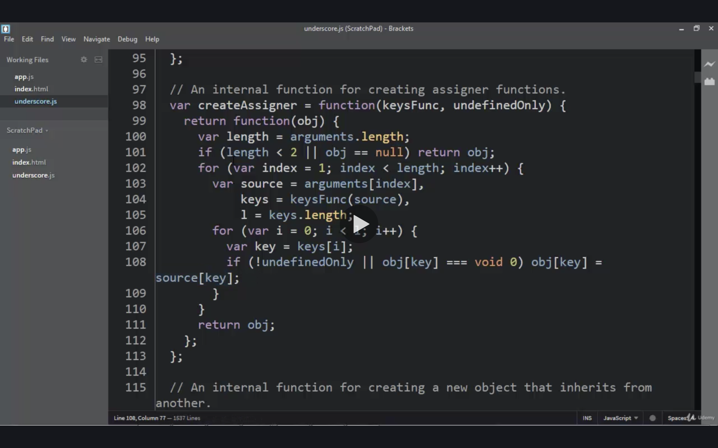.

So this is reflection – we have observed the obj and extended the properties by adding properties of jim and jane in john obj.

_extend is used in many js frameworks – alternate to prototype chain

Conclusion -Reflection – observe current object(hasOwnProperty) + we can change/add more properties (eg. _extend).

45. Function Constructor new and history of objects

Here we will see different ways we can create/construct obj:

a. new – Function constructor:

function **Person**() {

this.firstname = 'John',

this.lastname = 'Doe'

}

var john = new **Person**(); *// object created*

console.**log**(john);

O/P: Person object

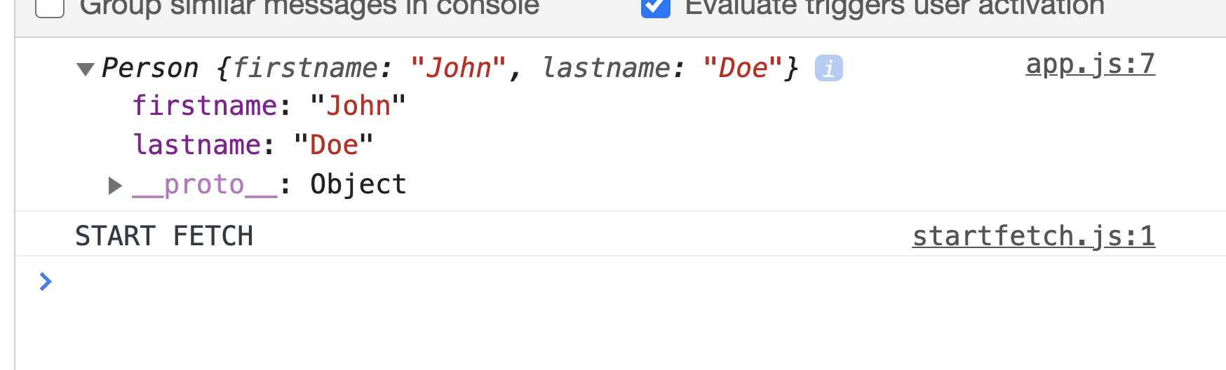.

--> new is the operator and is second in operator precedence table.

NOTE: Normally inside a function **this** obj points to **global execution context**, but with **new** it points to the **object itself.**

**Eg2:** If the function has return in it, return is the Priority 1, but it should be obj only otherwise firstname and lastname will display.

function **Person**() {

this.firstname = 'John',

this.lastname = 'Doe'

return { greeting: "I got in the way!" } // only this will be in obj

}

var john = new **Person**(); *// object created*

console.**log**(john);

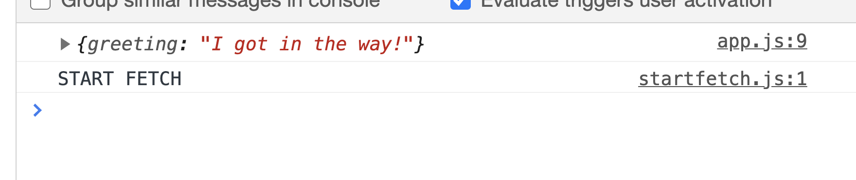.

Eg3: Made dynamic by passing parameters

function **Person**(fname, lname) {

this.firstname = fname;

this.lastname = lname;

}

var john = new **Person**('John', 'Doe'); *// object created*

var jenny = new **Person**('Jenny', 'Wish'); *// object created*

console.**log**(john);

console.**log**(jenny);

Conclusion: Function Constructors:

--> A normal function to construct objects

--> this variable points a new empty obj, and that obj is returned from the function automatically

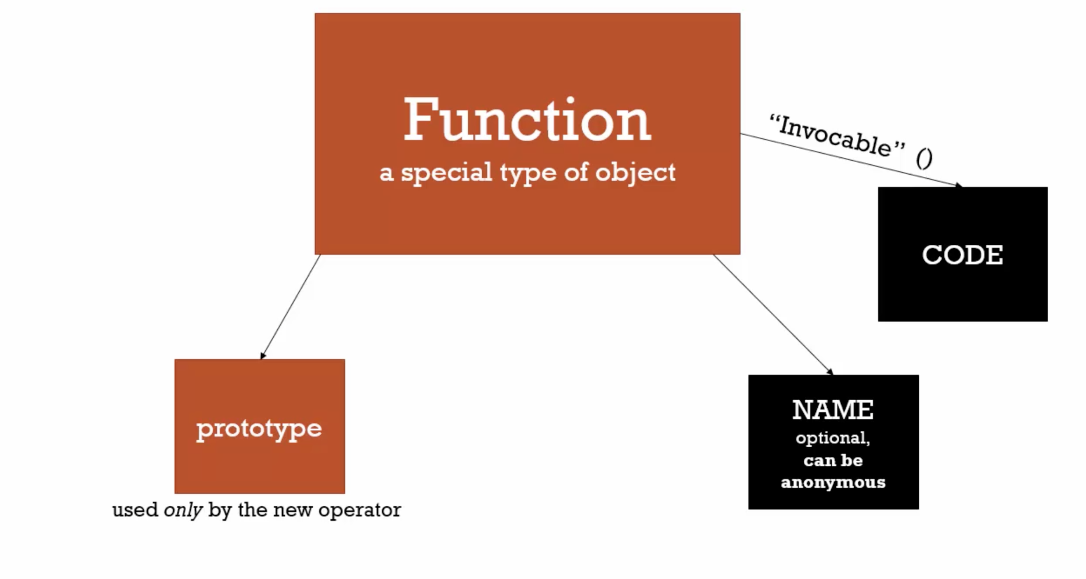.

--> Every function has prototype property which is unused.

--> When a function is invoked by new keyword, its prototype is activated. Its prototype becomes for the object created for function constructor.

Eg.

function **Person**(fname, lname) {

console.**log**(this);

this.firstname = fname;

this.lastname = lname;

}

**Person**.prototype.**getFullName** = function() {

return this.firstname + ' ' + this.lastname;

}

var john = new **Person**('John', 'Doe'); // john and jenny will have getFullName as protytype( or __proto__)

var jane = new **Person**('Jane', 'Parker');

console.**log**(john);

console.**log**(jane);

.

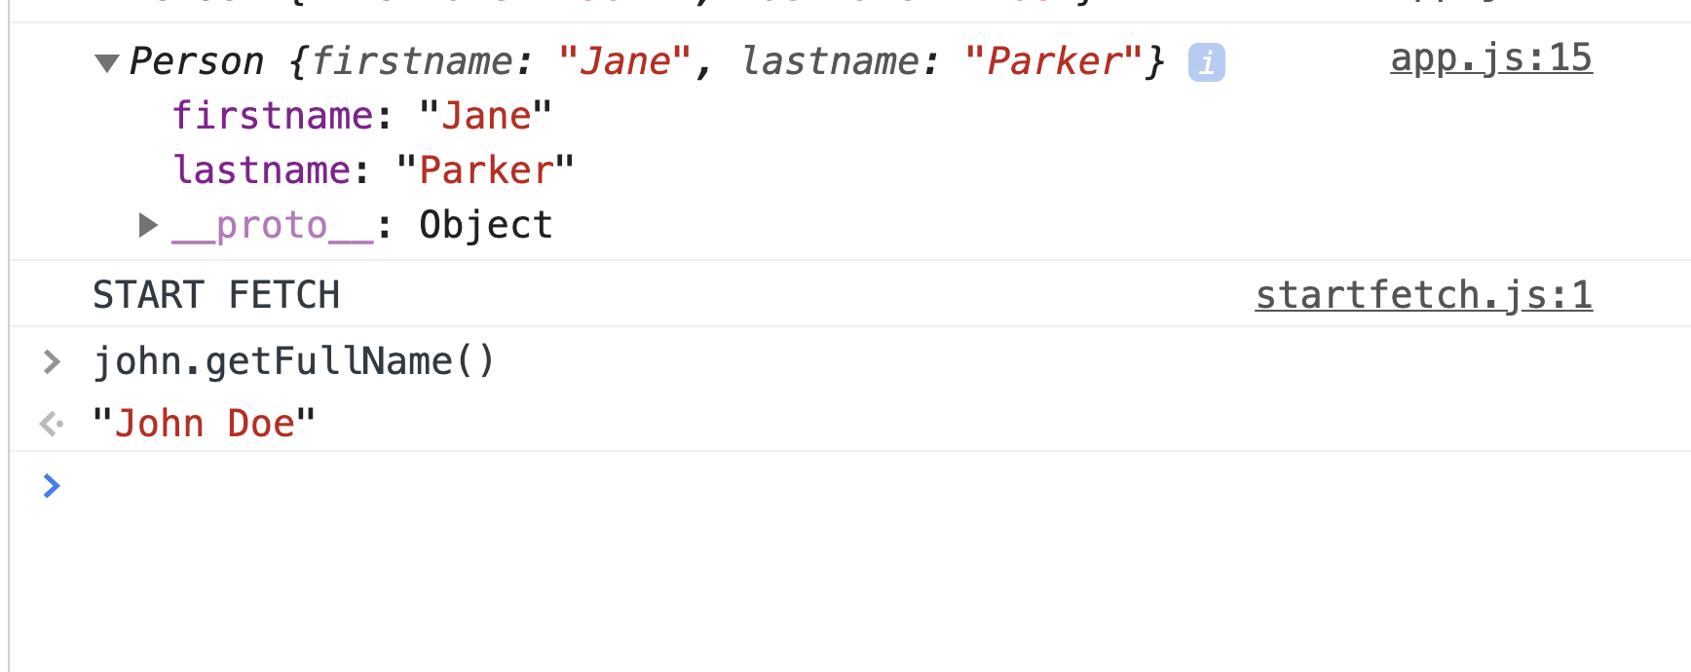.

function **Person**(fname, lname) {

console.**log**(this);

this.firstname = fname;

this.lastname = lname;

}

*// Adding prototype*

**Person**.prototype.**getFullName** = function() {

return this.firstname + ' ' + this.lastname;

}

*// Create objects*

var john = new **Person**('John', 'Doe');

var jane = new **Person**('Jane', 'Parker');

*// We can add prototype even after function call/obj creations*

**Person**.prototype.**getFormalFullName** = function() {

return this.lastname + ', ' + this.firstname;

}

console.**log**(john);

console.**log**(jane);

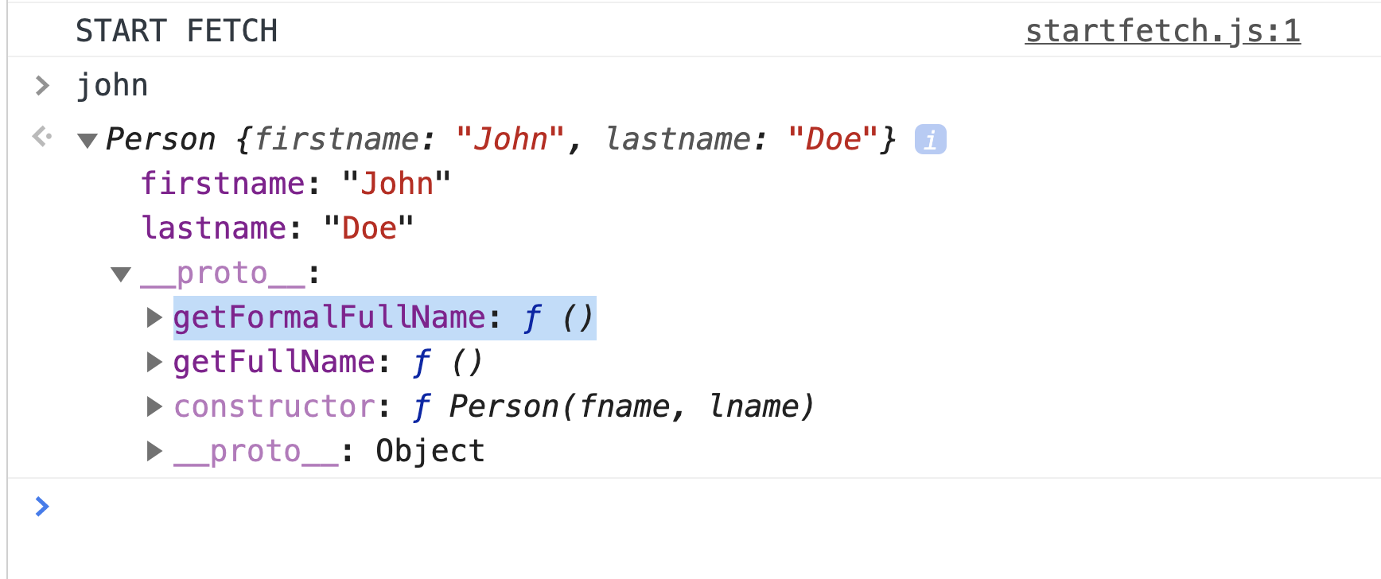.

--> So we can add feature to this prototype method of function constructor when required

--> If we have created thousands objs from function constructors. We can give them all a new prototype method in one go later even after they were created.

NOTE: We have added **method in prototype** and not individual objects as

As one prototype method will take 1 space in memory for n objs.

if method kept in obj method directly, if there will be 1000 objs, it will take 1000 memory spaces per obj. (hence **space complexity increases**)

--> We have seen one of the way to create objects and set prototypes in JS.

46. Dangerous Aside of Function Constructor:

1. if you forget to write new before function constructor, it will be set as **undefined. When you call prototype method --> ERROR**

**2.** TRICK: Always follow a convention. Function to be used as function constructor make it’s first letter capital. So whenever you see a function first letter without new. You can quickly fix it.

47. Built-in Function Constructors

var a = new **Number**('3'); // 1. Number type

console.**log**(a.**toFixed**(2)); *// 3.00*

console.**log**(a); *// Object each character key wise*

*// It’s prototype methods - which lives in Number.prototype.toFixed and*

*// many others i.e. 3.00*

var b = new **String**('Johnaa Snow'); // 2. String type

b.**fontsize**(10);

b.**indexOf**('Sn');

"John".length *// 4*

var c = new **String**('John');

c.length; *// 4*

var z = new **Object**(); *// similar to var z = {}; // 3. Object type*

var d = **Date**();

console.**log**(d);

var e = new **Date**('27/02/2020'); // 4. Date type

console.**log**(e);

var f = new **Date**(); *// returns obj*

var g = **Date**(); *// returns in string*

**Date**.**now**(); *// get timestamp - eg. 1614426280914*

var f = new **Date**(1614426280914); *// Sat Feb 27 2021 17:14:40 GMT+0530 (India Standard Time)*

*// Egs on date:*

var today = new **Date**()

var birthday = new **Date**('December 17, 1995 03:24:00')

var birthday = new **Date**('1995-12-17T03:24:00')

var birthday = new **Date**(1995, 11, 17) *// the month is 0-indexed*

var birthday = new **Date**(1995, 11, 17, 3, 24, 0)

var birthday = new **Date**(628021800000) *// passing epoch timestamp*

*// Ref - https://developer.mozilla.org/en-US/docs/Web/JavaScript/Reference/Global_Objects/Date*

*// We can also add more methods to built in JS methods: (Powerful)*

**String**.prototype.**isLengthGreaterThan** = function(limit) {

return this.length > limit;

}

"AmirMustafa".**isLengthGreaterThan**(2); *// true*

***Number****.prototype.****isPositive****() = function() {*

return this > 0

}

Caution: Do not **overwrite** any existing methods

48. Dangerous Aside – Built-in Function Constructors:

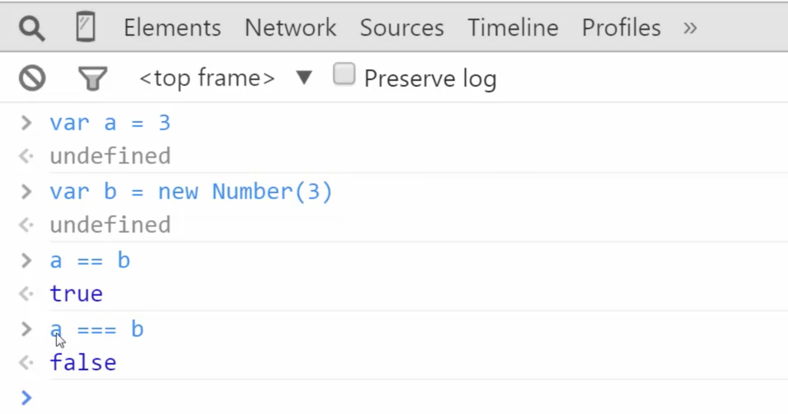.

Try to avoid built in function constructors. Use direct way

eg var b = new Number(3) // Creates object

Instead we can use them as regular functions to convert the number.

eg var b = Number(‘3’) // Converting to number

Note: Use built-in function constructor only wherever necessary.

49. Dangerous Aside – for-in vs regular for loop:

if in a project some developer adds some prototype methods in array – it will also come in for-in.

Use **for-in** only for **non-numeric** case

So avoid using in array

**Array**.prototype.newData = "Rocky Handsome"; *// Someone added a method in prototype*

var arr = ['John', 'Jenny', 'Ana'];

for(var prop in arr) { *// unwanted prototype method will also come here*

console.**log**(prop + ' ' + arr[prop]);

}

for(var i = 0; i< arr.length; i++) { *// Safer to use with regular for-loop*

console.**log**(i + ' ' + arr[i]);

}

48. Object.create and pure protypal inheritance

a. Another easier way to create objects is using Object.create();

Eg1

var person = {

firstname: "Amir",

lastname: "Mustafa",

**getName**: function() {

return 'Hi ' + this.getFullName

}

}

*// Creates empty obj with all properties/methods inside prototype*

var john = **Object**.**create**(person);

O/P: Objects created is empty with every data inside prototype.

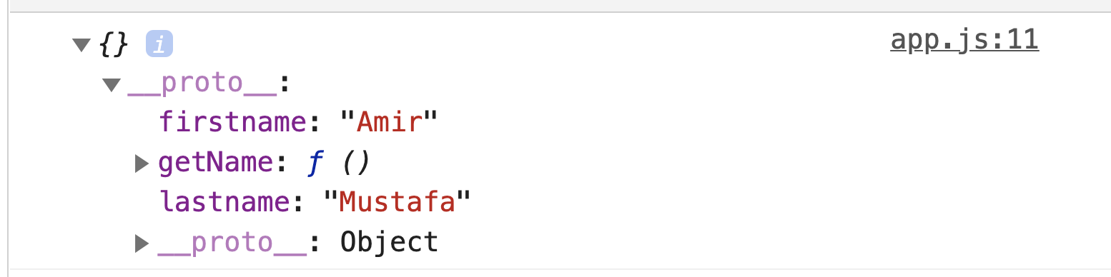.

Eg2:

var person = {

firstname: "Amir",

lastname: "Mustafa",

**getName**: function() {

return 'Hi ' + this.getFullName

}

}

var john = **Object**.**create**(person); *// above data will populate in prototype*

john.firstname = "Emma"; *// this data will populate in object*

john.lastname = "Watson";

console.**log**(john);

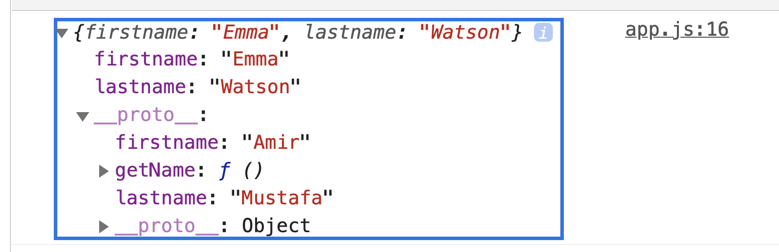.

--> This is the pure way for creating protypes or protypal inheritance

--> This supports in all modern browsers

--> If somehow you were to work in **older projects** which requires **older browsers version**

Solution = polyfills

Polyfills: Code that adds the feature which engine may lack.

*// polyfill*

if (!**Object**.**create**) {

**Object**.**create** = function (o) {

if (arguments.length > 1) {

throw new **Error**('Object.create implementation'

+ ' only accepts the first parameter.');

}

function **F**() {}

**F**.prototype = o;

return new **F**();

};

}

var person = {

firstname: 'Default',

lastname: 'Default',

**greet**: function() {

return 'Hi ' + this.firstname;

}

}

var john = **Object**.**create**(person);

john.firstname = 'John';

john.lastname = 'Doe';

console.**log**(john);

49. ES6 and classes

--> **Classes** in JS behaves differently like other programming languages. **Classes** are **objects in JS**, whereas in other programming lang it is definition and obj is only created with new keyword.

Eg

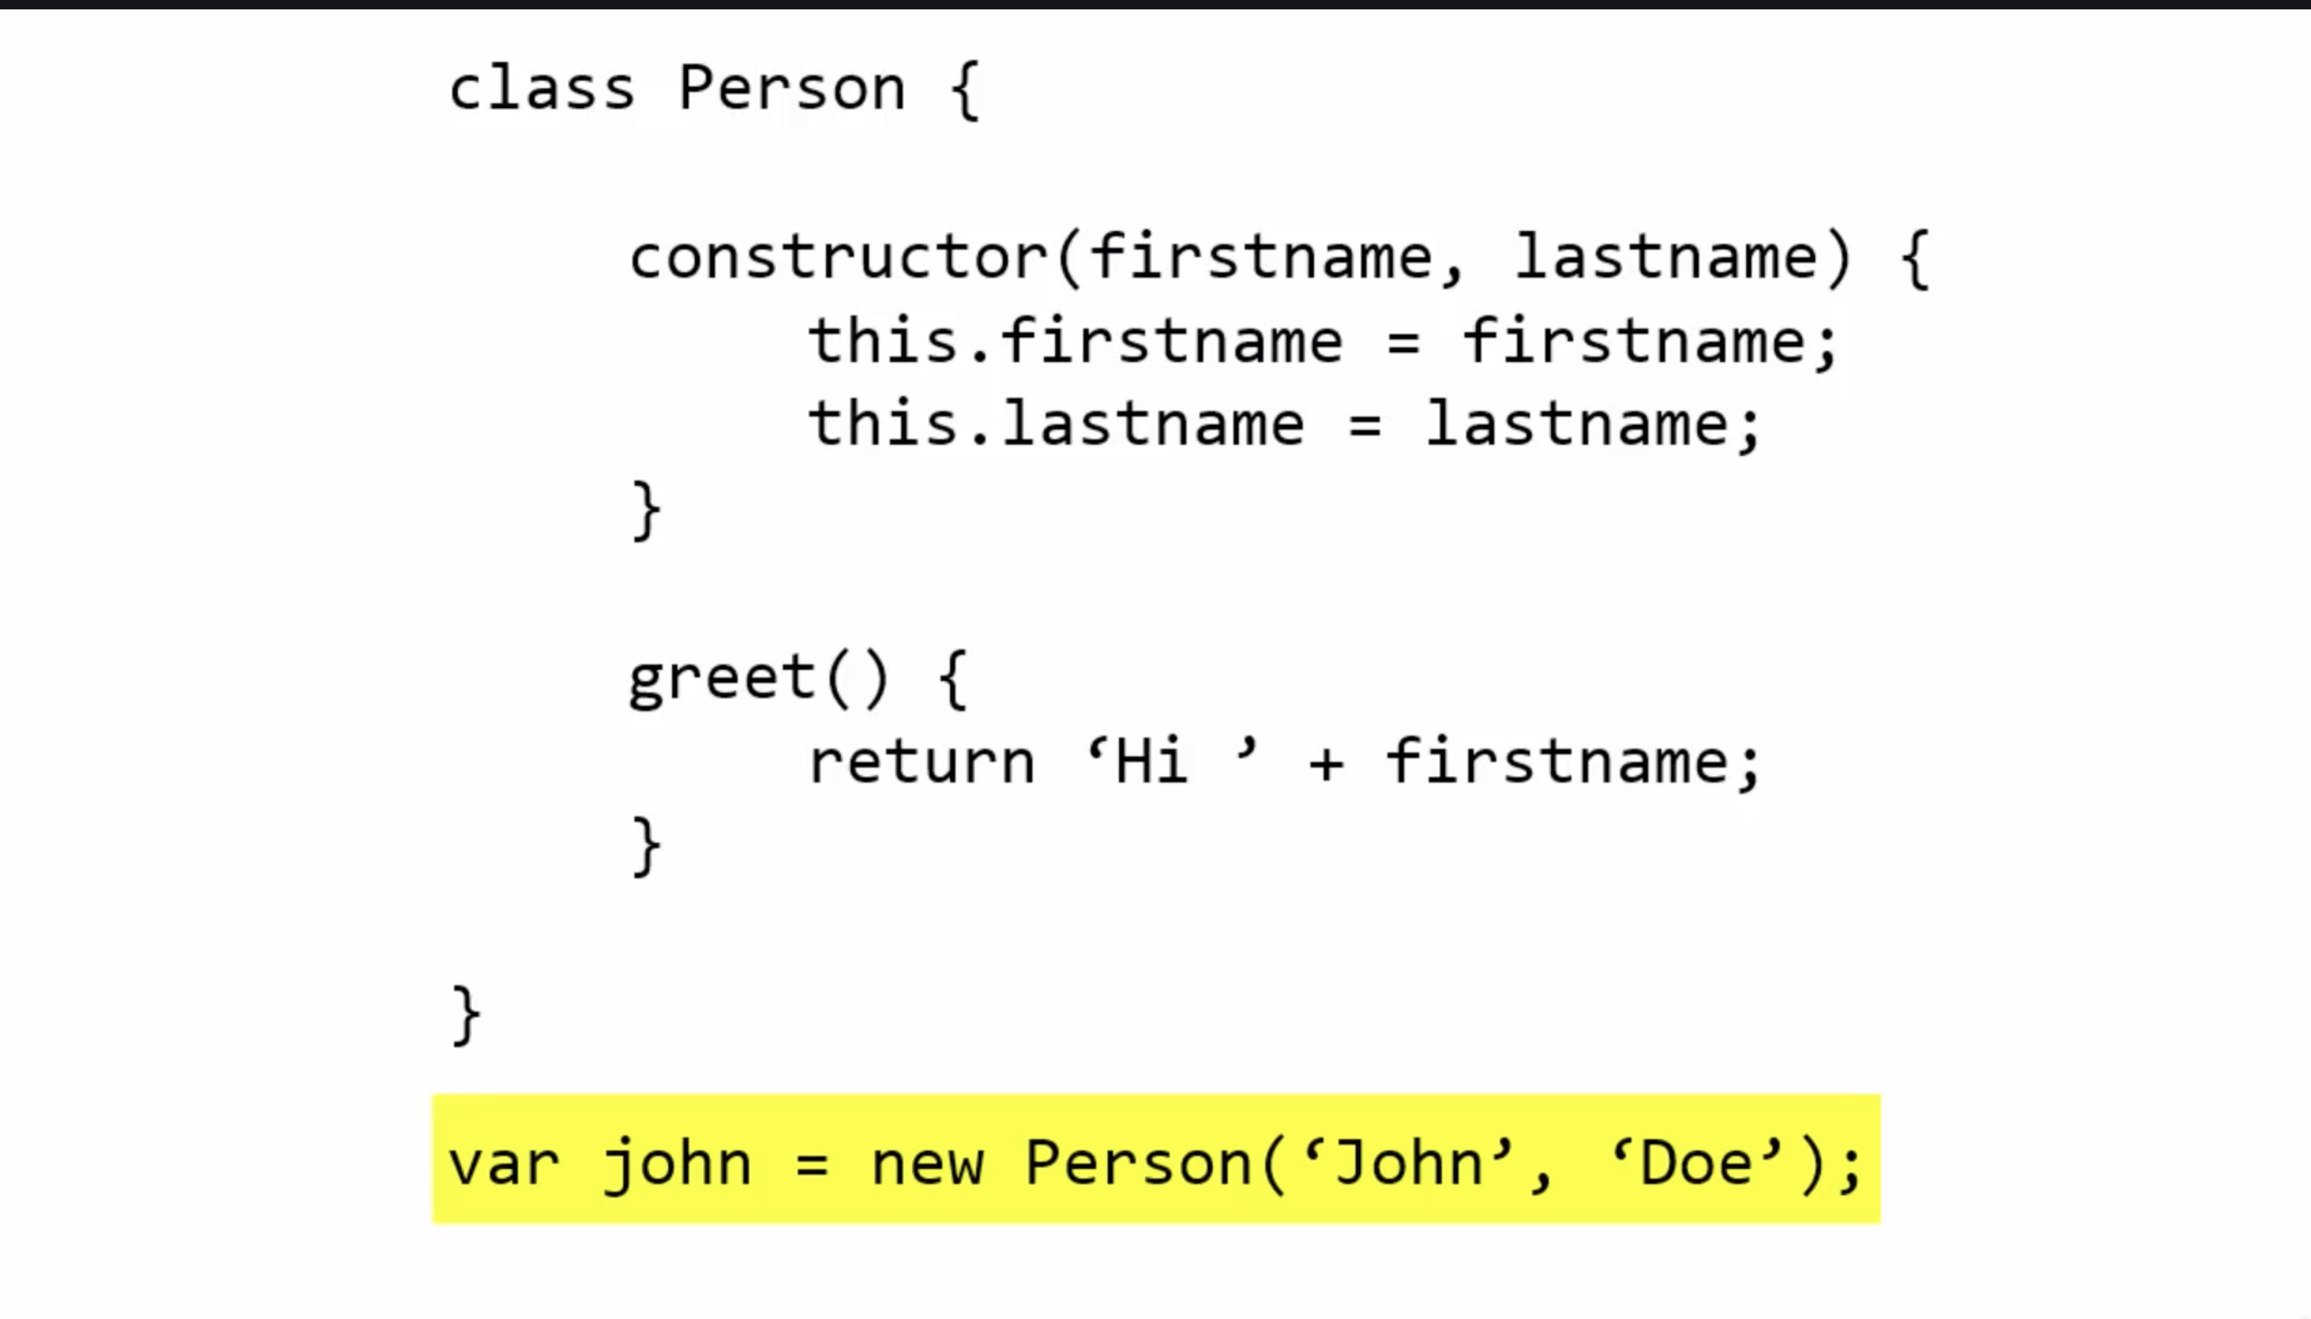.

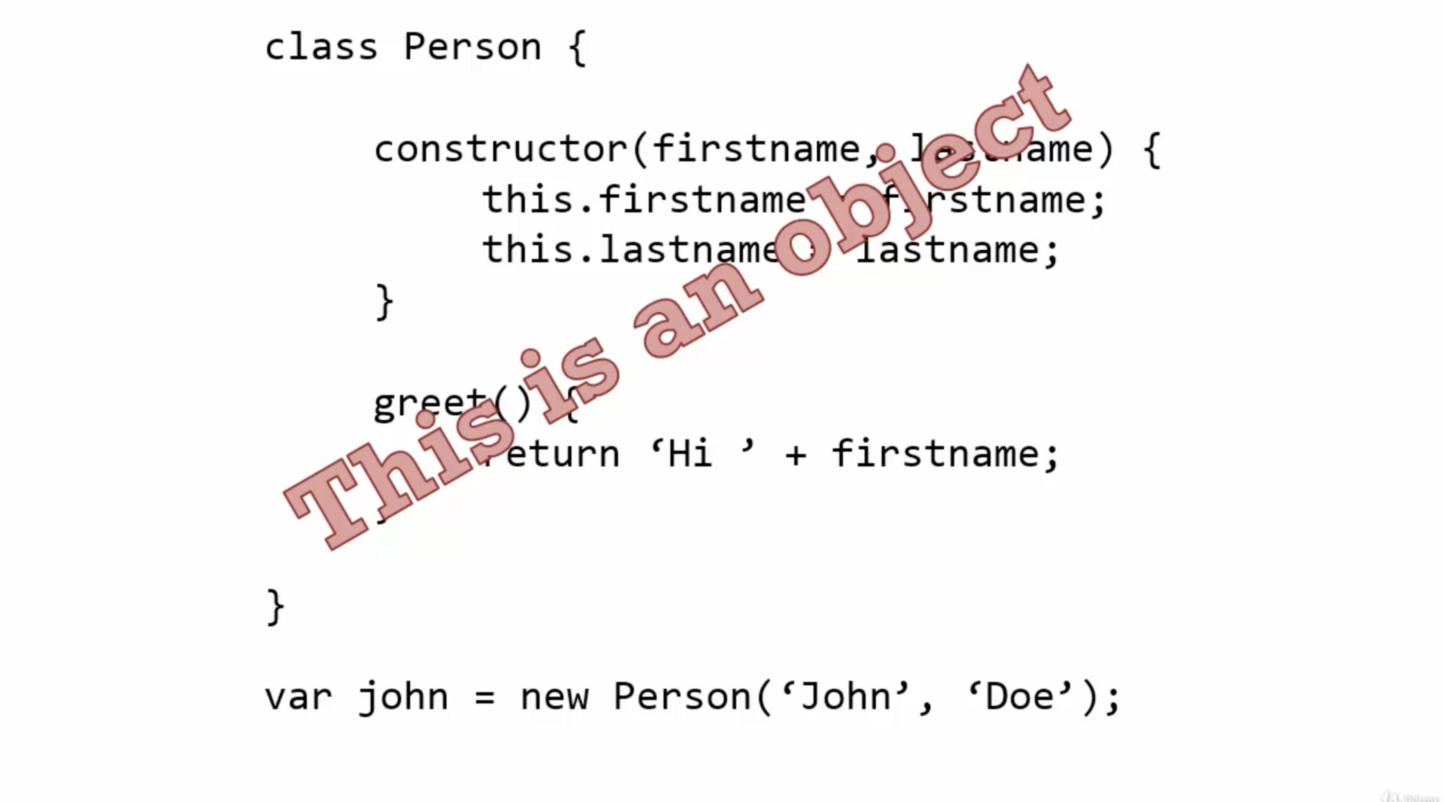.

--> To create prototype inheritance in JS we use **extend** keyword.

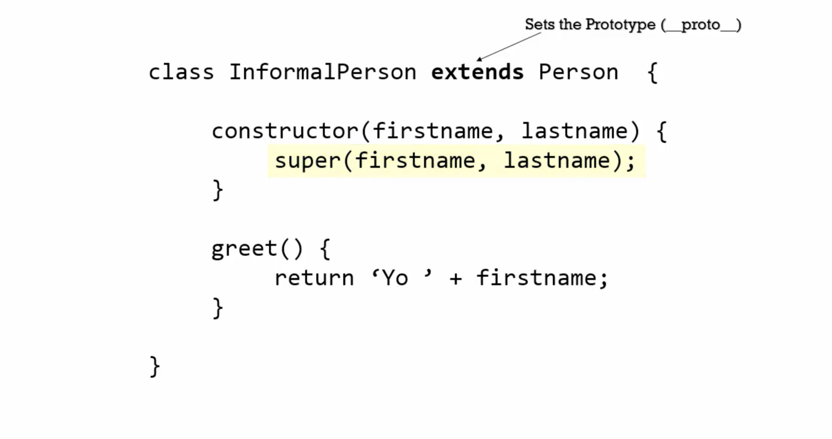.

--> Classes are **syntactic sugar** in JS

**Syntactic Sugar:** A different way to type something that doesn’t change how it works under the hood.

An important difference between**function declarations** and **class declarations**is that function declarations are [hoisted](https://developer.mozilla.org/en-US/docs/Glossary/Hoisting) and class declarations are not. You first need to declare your class and then access it, otherwise code like the following will throw a [ReferenceError](https://developer.mozilla.org/en-US/docs/Web/JavaScript/Reference/Global_Objects/ReferenceError):

const p = new Rectangle(); // ReferenceError

class Rectangle {}

Ref - <https://developer.mozilla.org/en-US/docs/Web/JavaScript/Reference/Classes>

typeof, instanceof

Eg

var a = 3;

console.**log**(typeof a); *// number*

var b = "Hello";

console.**log**(typeof b); *// string*

var c = {};

console.**log**(typeof c); *// object*

var d = [];

console.**log**(typeof d); *// weird! // object*

console.**log**(**Object**.prototype.**toString**.**call**(d)); *// better! [object Array]*

function **Person**(name) { *// Function constructor*

this.name = name;

}

function **Person2**(name) {

this.name = name;

}

var e = new **Person**('Jane');

console.**log**(typeof e); *// object*

console.**log**(e instanceof **Person**); *// true*

console.**log**(e instanceof **Person2**); *// false*

console.**log**(typeof undefined); *// undefined (make sense)*

console.**log**(typeof null); *// object (a bug since, like, forever...)*

var **z** = function() { };

console.**log**(typeof **z**); *// function*

Strict mode

a. without strict mode

var person;

persom = {}; *// both exist in window.person and window.person*

console.**log**(persom);

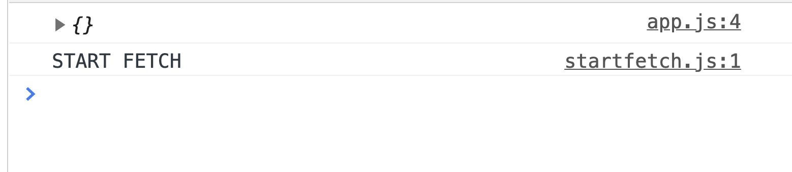

// Passes no error in console – person – undefined and persom = {}

a. with strict mode

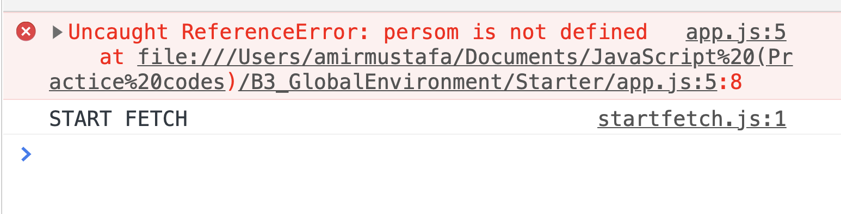.

--> strict mode can be used on top of page or top of a functional

Eg

function **logData**() {

"use strict"; *// this is extra feature, so most use in functions and not throughout app*

var person2;

persom2 = {}; *// both exist in window.person and wondow.person*

console.**log**(persom);

}

var person;

persom = {}; *// both exist in window.person and wondow.person*

console.**log**(persom);

**logData**();

Building a framework/library – GREETR

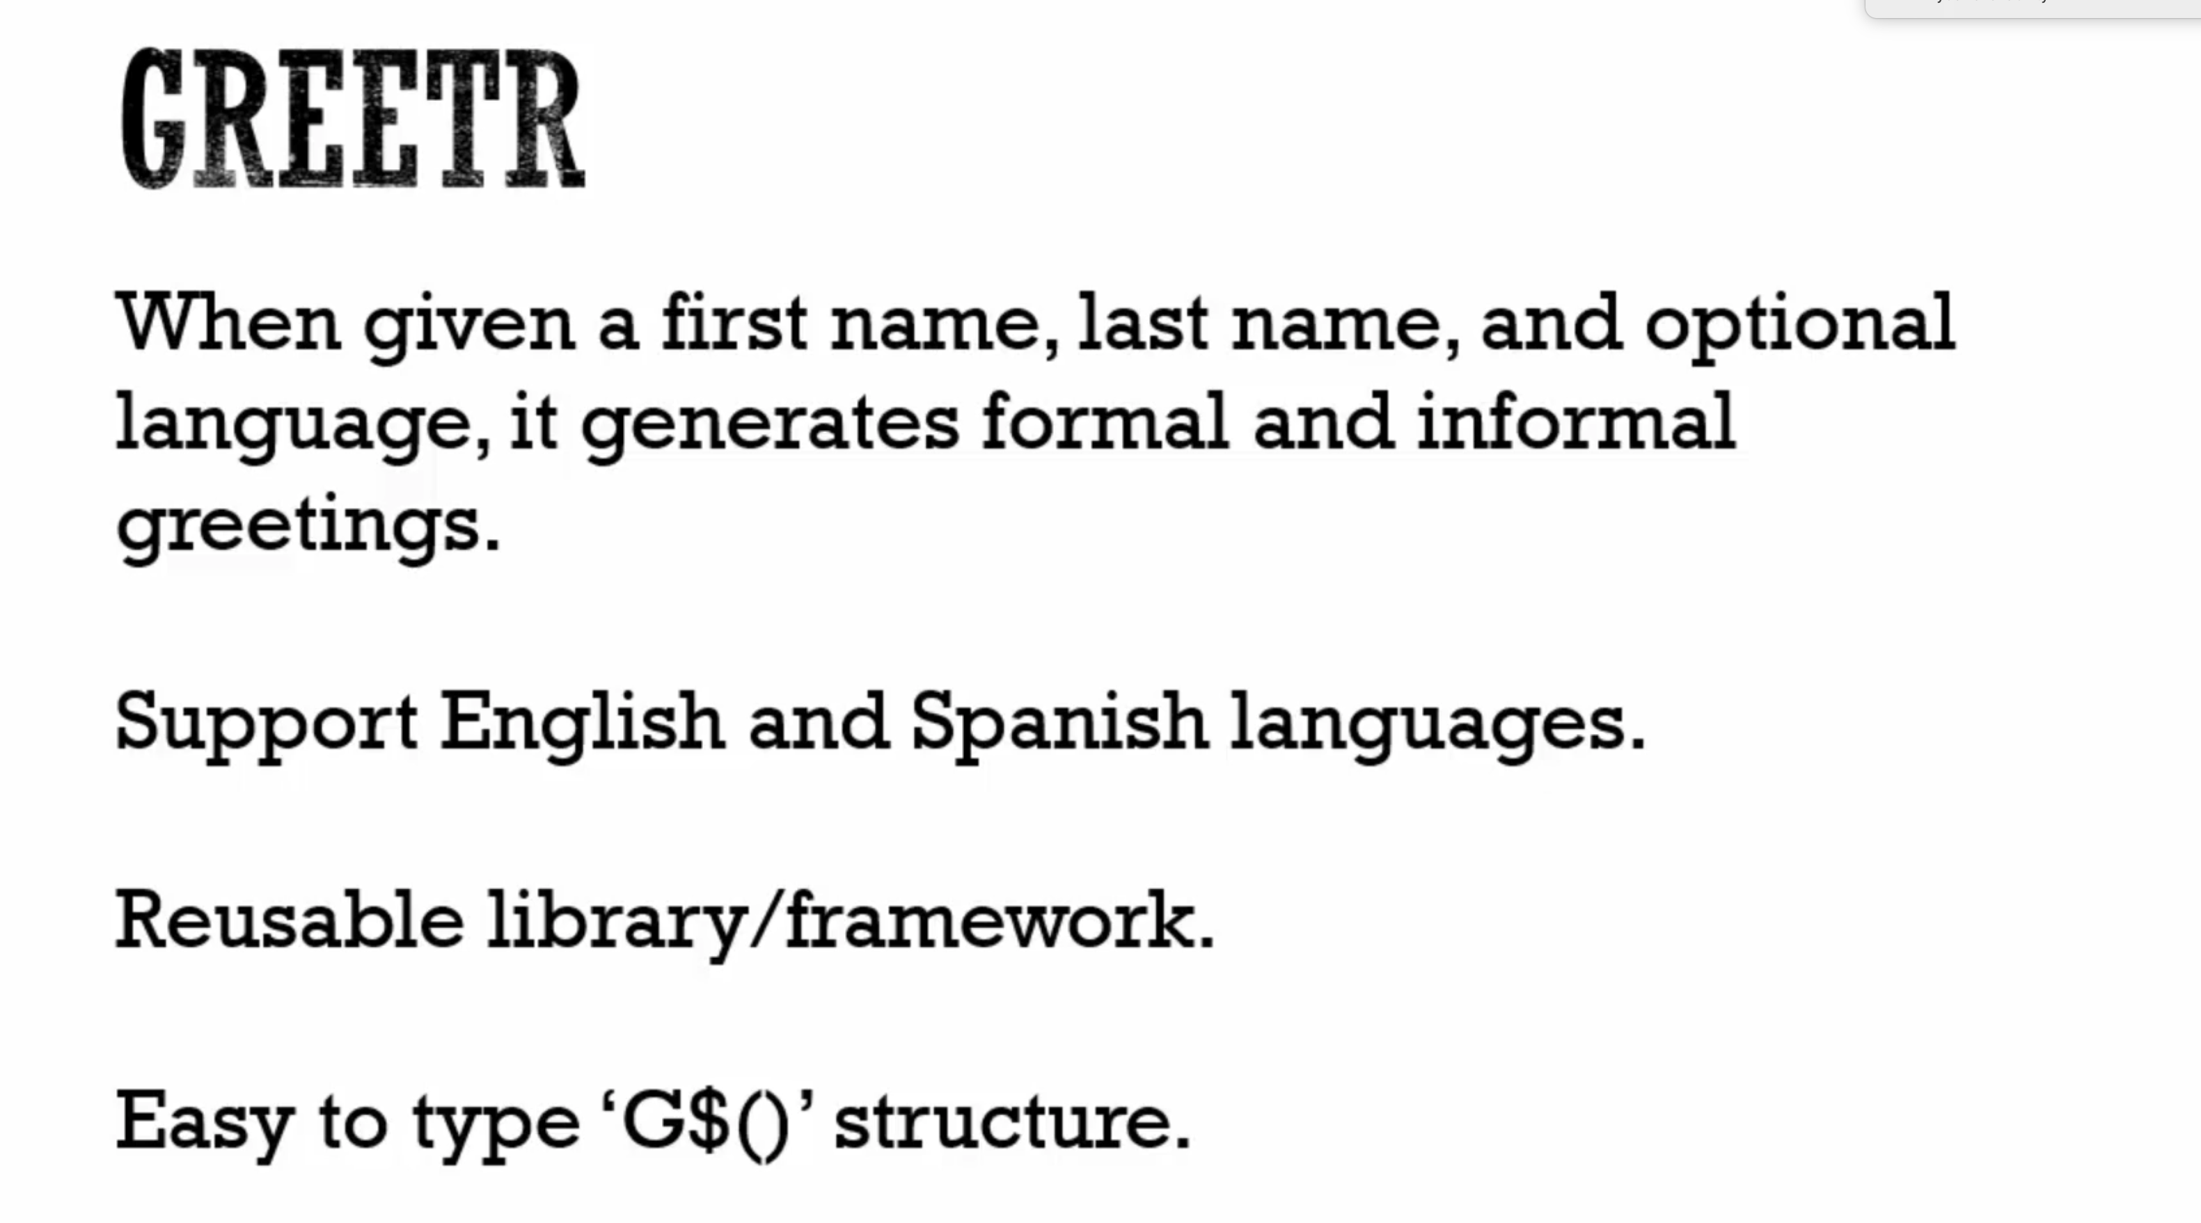.

--> It should also support jQuery

Big Word Alert:

Transpile: Convert the syntax of one programming language to another.

Here language don’t run anywhere, but instead are processed by transpilers that **generate JavaScript**

**EXTRAS**

1. Typescript:  [http://www.typescriptlang.org](http://www.typescriptlang.org/)

2. Typescript code in your browser here: <http://www.typescriptlang.org/Playground>

3. Traceur : <https://github.com/google/traceur-compiler>

4. Traceur realtime : [https://google.github.io/traceur-compiler/demo/repl.html#](https://google.github.io/traceur-compiler/demo/repl.html)

**ES6 Ref -** <https://github.com/lukehoban/es6features>